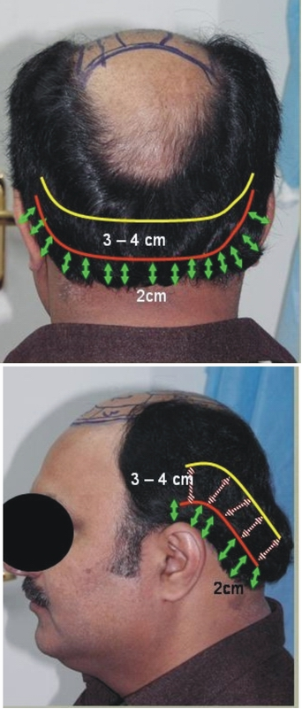
Figure 2 Landmarks in occipital and temporoparietal region.
2.0-2.5cm on inferior margin and harvest from the area left about 3-4cm (Figure 2). And similarly on temporal sides, leaving about 2.0-2.5cm, the hair should be harvested from 3-4cm area.
This method gives the safe harvesting of donor hair to hair restorative surgeons even in the early stages of the career, without the fear of visible scar.
Muhammad Ahmad

Plastic, Reconstructive, Hand & Hair Restorative Surgeon, Hair Transplant Institute
Islamabad, Pakistan

Address for Correspondence
Dr. Muhammad Ahmad
Plastic, Reconstructive, Hand & Hair Restorative Surgeon
Hair Transplant Institute, Islamabad Private Hospital, 2nd Floor, Zahoor Plaza,
E-38, Jinnah Avenue, Blue Area, Block-A, Islamabad, Pakistan
Email: plasticsurgeon999@yahoo.com
Giant zosteriform nevus spilus
Sir, speckled and lentiginous nevi may be viewed as a type of congenital melanocytic lesion which is lentiginous in early childhood and which might develop palpable components at puberty in a ‘speckled’ distribution. Speckled and lentiginous nevus is a relatively uncommon entity. It is postulated that nevus spilus represents a localized defect in neural crest melanoblasts and occurs in fewer than 0.2% of all newborns and 1.2% of white school children. It is comprised of a flat, macular component, subtly darker shade than the surrounding skin, resembling a café-au-lait spot. Within this pale background, there are lentigo-like lesions and also elevated darker-brown nevi. Pathological examination shows, as the clinical appearance suggests, a background macular lesion with a very subtle increase in melanocytes, and lentigines with superimposed individual compound nevi. We are reporting a case of segmental lentiginous and speckled nevus.
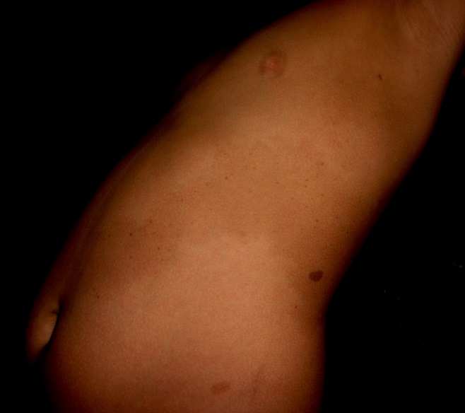
Figure 1 Zosteriform nevus spilus on left side of trunk.
A 9-years-old boy, presented with brownish patch over the left flank since birth. Gradually and progressively, small, darker brownish dots appeared over the patch. These lesions were asymptomatic. There was no family history of similar lesion. On examination he had light brown macule along the distribution of left T8-T9. Within the light brown macule, at places he had multiple dark brown macules measuring 1-4 mm in diameter resembling lentigines (Figure 1). Few café-au-lait macules measuring 0.5-2cm were noted over the lower chest and lower abdomen on the left side. There was neither underlying induration nor any nodular swelling within the lesions. Systemic examination was unremarkable. Routine investigations were within normal limits. Based on the history and clinical findings, diagnosis of segmental speckled and lentiginous nevus was made. Since there are few reports of development of malignant melanoma in segmental nevus spilus,^{1,2,3} we have planned for long term follow-up of this patient.
There are few case reports of nevus spilus associated with other abnormalities like halo nevus,⁵ centrofacial lentiginosis,⁶ bilateral nevus of Ito⁷ etc. but in our case, there is association of café-au-lait macules. In this case report, the patient had macular, papular and plaque form of nevus spilus.⁴ In contrast, our patient had only macular form of nevus spilus. Nevus spilus in a zosteriform distribution has to be differentiated from segmental lentiginosis or zosteriform lentiginous nevus. In nevus spilus, the background pigmentation is present while it is absent in segmental lentiginosis.⁶ There is a case report of segmental neurofibromatosis clinically appearing as nevus spilus.⁸ In this case report, the patient had hyperpigmented band along the distribution of T10 and T11. Numerous, more deeply pigmented macules and papules were scattered within the hyperpigmented band. Histopathological examination of the papules revealed features of ill-defined spindle cell tumor in the deep dermis. Similarly, there is another case report of segmental neurofibromatosis presenting as a giant nevus spilus.⁹ In contrast, in our case, we found a large, brownish macule and multiple, dark brown macules interspersed within the larger macule, the classical feature of nevus spilus. There were no features of neurofibromatosis. Hence we did not consider the possibility of segmental neurofibromatosis. There are few case reports of segmental nevus spilus in the western literature¹⁰ but, to the best of our knowledge, we have not found any case report from Asia. The reason may be that either the condition is rare in Asian countries or it is not reported.
References
- Angit C, Khirwadkar N, Azurdia RM. Malignant melanoma arising in a nevus spilus. Dermatol Online J. 2011;17:10.

Bilgin IZ, Gür S, Aydın O, Ermete M. Melanoma arising in a hairy nevus spilus. Int J Dermatol. 2006;45:1362-4.

Ly L, Christie M, Swain S et al. Melanoma(s) arising in large segmental speckled lentiginous nevi: A case series. J Am Acad Dermatol. 2011;64:1190-3.
- Roma P, Sanjeev H, Bhusan K. Generalized naevus spilus: a rare entity? J Eur Acad Dermatol Venereol. 2000;14:430.
- Hu N, Zhong J, Yang B et al. A case of zosteriform nevus spilus with halo nevus. Int J Dermatol. 2013;52:386-8.
- Kaur TD, Kanwar AJ. Giant nevus spilus and centrofacial lentiginosis. Pediatr Dermatol. 2004;21:516-7.
- Trindade F, Santonja C, Requena L. Bilateral nevus of Ito and nevus spilus in the same patient. J Am Acad Dermatol. 2008;59 (2 Suppl 1):S51-2.
- Finley EM, Kolbusz RV. Segmental neurofibromatosis clinically appearing as a nevus spilus. Int J Dermatol. 1993;32:358-60.
- Selvaag E, Thune P, Larsen TE. Segmental neurofibromatosis presenting as a giant naevus spilus. Acta Derm Venereol. 1994;74:327.
- Elmer KB, George RM. Zosteriform Lentiginous Nevus. Available from: www.ConsultantLive.com. Updated on September 14, 2005

Pradeep Vittal Bhagwat*, Chandramohan Kudligi*, Shashikumar BM**, Mohan Eshwara Rao Shendre*, Suphala B*

*Department of Skin & STD, Karnataka Institute of Medical Sciences, Hubli, Karnataka
** Department of Skin & STD, Mandya Institute of Medical Sciences, Mandya, Karnataka

Address for Correspondence
Dr. PV Bhagwat,
Associate Professor, Department of skin and STD,
Karnataka Institute of Medical Sciences,
Hubli-580022, Karnataka, India
Phone: 09880084769, 09986155070
E-mail: sharadapbagwat@yahoo.com

