d. Lever's Histopathology of the Skin. Philadelphia: Lippincott-Raven; 1997. P.747-804.
- Schweitzer WJ, Goldin HM, Bronson DM, Brody PE. Ulcerated tumor on the scalp. Clear-cell hidradenoma. Arch Dermatol. 1989;125:985-6.
- Biddlestone LR, Mc Laren KM, Tidman MJ: Malignant hidradenoma: a case report demonstrating insidious histological and clinical progression. Clin Exp Dermatol. 1991;16:474-7.
- Wilhelmi BJ, Appelt EA, Philips LG. A rare case of atypical eccrine acrospiroma of the scalp and a literature review. Ann Plast Surg. 1999;42:568-9.
- Thami GP, Kaur S, Mohan H. Atypical clear cell hidradenoma. Indian J Dermatol Venereol Leprol. 2003;69:43-5.

Tulika Rai, Satyendra Kumar Singh

Department of Dermatology and Venereology, I.M.S, B.H.U. Varanasi-221005, U.P. India

Correspondence Address
Dr. Tulika Rai,
C-24, Swastik Towers, Lanka,
Varanasi-221005, U.P. India
E-mail: raitulika@gmail.com
Estimation of safe donor area in hair transplant surgery
Sir, estimation of the donor area for hair transplant surgery is essential to avoid the hair programmed to be lost to male pattern baldness and also to avoid the improper position of the resultant scar. It becomes more important when the donor area is limited. The shape and size of the donor area varies from person to person depending on the age, type of baldness and available area. The potential donor area must be assessed on logical and scientific basis. The careful history and examination of the patient is of utmost importance. Age of the patient is a key factor in planning the hair transplantation. Pattern of baldness determines the planning for hair transplantation.
As a guide, donor hair should not be harvested above the line joining the both ears (Figure 1). As the baldness also affects the inferior margin of the hair, therefore, at least 1.5cm of hair must also be left intact. This leaves us about 3-5cm of the area available for harvesting.
Similarly, the anterior limit is the vertical line from the external auditory canal. At least 2cm should be left on inferior portion and about 2cm on the superior border. This leaves us 3-5cm of donor area.
In practice, the above information is simplified. While planning for donor area, one must leave
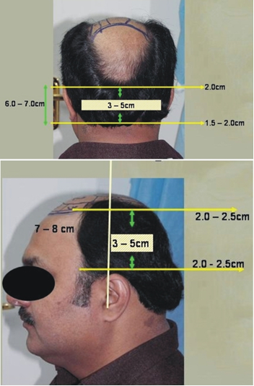
Figure 1 Landmarks in occipital and temporoparietal areas.

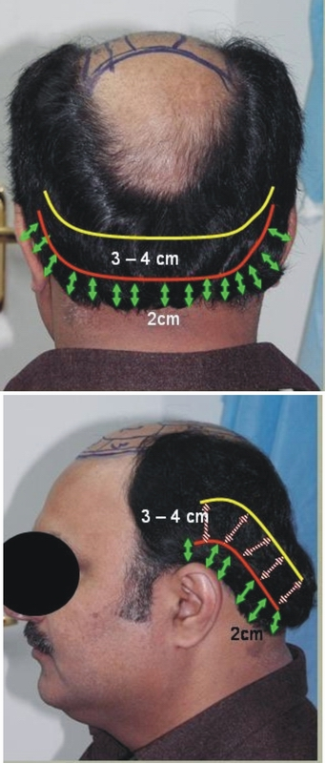
Figure 2 Landmarks in occipital and temporoparietal region.
2.0-2.5cm on inferior margin and harvest from the area left about 3-4cm (Figure 2). And similarly on temporal sides, leaving about 2.0-2.5cm, the hair should be harvested from 3-4cm area.
This method gives the safe harvesting of donor hair to hair restorative surgeons even in the early stages of the career, without the fear of visible scar.
Muhammad Ahmad

Plastic, Reconstructive, Hand & Hair Restorative Surgeon, Hair Transplant Institute
Islamabad, Pakistan

Address for Correspondence
Dr. Muhammad Ahmad
Plastic, Reconstructive, Hand & Hair Restorative Surgeon
Hair Transplant Institute, Islamabad Private Hospital, 2nd Floor, Zahoor Plaza,
E-38, Jinnah Avenue, Blue Area, Block-A, Islamabad, Pakistan
Email: plasticsurgeon999@yahoo.com
Giant zosteriform nevus spilus
Sir, speckled and lentiginous nevi may be viewed as a type of congenital melanocytic lesion which is lentiginous in early childhood and which might develop palpable components at puberty in a ‘speckled’ distribution. Speckled and lentiginous nevus is a relatively uncommon entity. It is postulated that nevus spilus represents a localized defect in neural crest melanoblasts and occurs in fewer than 0.2% of all newborns and 1.2% of white school children. It is comprised of a flat, macular component, subtly darker shade than the surrounding skin, resembling a café-au-lait spot. Within this pale background, there are lentigo-like lesions and also elevated darker-brown nevi. Pathological examination shows, as the clinical appearance suggests, a background macular lesion with a very subtle increase in melanocytes, and lentigines with superimposed individual compound nevi. We are reporting a case of segmental lentiginous and speckled nevus.

