ointment.³ Localized contact urticarial to lidocaine-tetracaine peel has also been reported.⁴
Tetracaine has got an inherent property of vasodilatation which is responsible for the erythema and occasional wheals which develop due to usage of the tetracaine- lidocaine eutectic mixture under occlusion.
Our patient had applied tetracaine- lidocaine eutectic mixture twice daily instead of fusidic acid resulting in prolonged contact time of the same with the skin. This prolonged contact of the tetracaine-lidocaine eutectic mixture may account for the erythema and erythematous papules noticed in our patient. There were no wheals in our patient and hence we considered a diagnosis of contact dermatitis. Whether the contact dermatitis in our patient due to the prolonged contact was allergic or irritant could not be ascertained as the patient refused patch testing even at a later date.
References
- Tetralid [package insert]. Mumbai: Ajantha Pharma; 2012.
- Prilox [package insert]. Mumbai: Neon Laboratories limited;2012
- Vij A, Markus R. Immediate vesicular eruption caused by topical 23% lidocaine 7% tetracaine ointment in a patient scheduled for laser therapy: a new adverse drug reaction. J Cosmet Dermatol. 2011;10:307-10.
- Channual J, Wu JJ, Zachary CB. Localized contact urticaria caused by lidocaine/tetracaine peel. Arch Dermatol. 2009;145:499-500.

Sudhir Nayak UK, H Sripathi

Department Of Dermatology, Kasturba Medical College, Manipal, Manipal University, India

Correspondence Address
Dr. Sudhir Nayak U.K. MD, DDVL
Assistant Professor, Department of Dermatology,
Kasturba Medical College, Manipal University, Manipal-576104, India
Phone number: 9900412394
Email-sudhirnayakuk@yahoo.com
Recurrent noduloulcerative growth on the face
Sir, clear cell hidradenoma (CCH) is an uncommon, benign, slowly growing cutaneous tumor of the sweat glands.¹ It is mostly seen in adults and is characterized clinically by solitary and firm intradermal nodule. Women are affected more often than men.² Presence of malignant change is suggested clinically by a rapid growth and cutaneous ulceration and histologically by an increased number of mitotic figures, nuclear atypia and angiolymphatic or perineural invasion.³ We present a case of fifty year old female who had recurrent noduloulcerative hidradenoma even after complete excision over a span of three years.
The patient presented with an asymptomatic noduloulcerative lesion on the right pre-auricular area which started as a small nodule one year back and slowly increased in size and then ulcerated. The size of the noduloulcerative lesion was 3cm X 3cm, the margin was well-defined but irregular and slightly raised above the surrounding skin surface with pigmentation at places. The center was ulcerated with exuberant granulation tissue. The lesion was not fixed to the underlying structures. There was no regional lymphadenopathy. The patient gave history of similar lesion twice over a span of three years and it was excised completely each time to recur again at the same site. Previous histopathology reports showed features suggestive of hidradenoma. There were no atypical or malignant changes in the previous
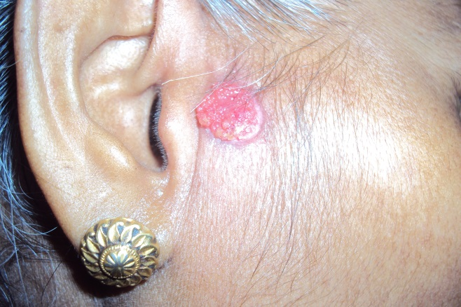 Figure 1 Clinical photograph showing the noduloulcerative growth on the right pre-auricular region.

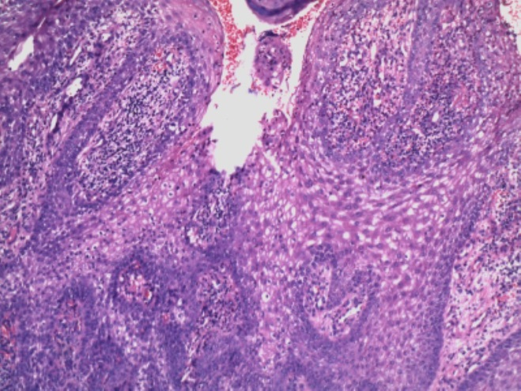
Figure 2 Histopathology showing well-circumscribed epithelial neoplasm connected to surface epidermis at places, with ductal differentiation and cystic changes seen at places within the nodule (H&E X400).
biopsy reports. We suspected basal cell carcinoma and performed a punch biopsy. Histopathology revealed epithelial neoplasm, well-circumscribed and connected with surface epidermis at multiple points. The neoplasm consisted of interconnected nodules of epithelium. The neoplastic cells were monomorphous though several of them showed abundant pale or clear cytoplasm. At several places within the neoplasm, ductular differentiation was seen whereas at a couple of places nodules showed central cystic change with necrosis en masse. The stroma showed thickening and hyalinization of collagen next to the epithelial nodule. We have referred the patient to general surgery for complete surgical excision.
Clear cell hidradenomas are usually seen in 4th to 8th decade of life and are twice more common in females. The tumor appears as asymptomatic, usually solitary, 0.5 to 1 cm sized, skin colored intradermal nodule, slightly elevated above the surrounding skin.⁴ Clinical differential diagnosis includes basal cell and squamous cell carcinoma, melanoma, metastatic tumor, dermatofibroma, pyogenic granulomas, hemangioma, and other cutaneous adnexal tumors.^{1,4} Histopathology helps in the diagnosis. Histopathology shows both solid and cystic components in varying proportions. The tumor has tubular lumina which are lined by cuboidal or columnar cells and variably sized cystic spaces. The solid portions contain two types of cells - polyhedral cells with basophilic cytoplasm, glycogen containing clear cells with a clear cytoplasm and a round nucleus.¹ Criteria for assessing malignancy include overt nuclear atypia, readily observed mitotic figures, infiltrative patterns, lymphatic or perineural invasion and areas of necrosis. Malignant CCH usually arise de novo and malignant transformation of benign CCH has rarely been reported.^{1,3} Treatment of benign, atypical and malignant CCH is surgical excision with adequate margins to minimize the risk of recurrence followed by histologic confirmation of adequacy of excision.³ In view of reported malignant transformation, howsoever rare, even the histologically benign lesions should be promptly diagnosed followed by surgical excision and histologic confirmation of clearance.⁵
References
- Elder D, Elentisas R, Ragsdale BD. Tumors of the epidermal appendages. In: David E, ed. Lever's Histopathology of the Skin. Philadelphia: Lippincott-Raven; 1997. P.747-804.
- Schweitzer WJ, Goldin HM, Bronson DM, Brody PE. Ulcerated tumor on the scalp. Clear-cell hidradenoma. Arch Dermatol. 1989;125:985-6.
- Biddlestone LR, Mc Laren KM, Tidman MJ: Malignant hidradenoma: a case report demonstrating insidious histological and clinical progression. Clin Exp Dermatol. 1991;16:474-7.
- Wilhelmi BJ, Appelt EA, Philips LG. A rare case of atypical eccrine acrospiroma of the scalp and a literature review. Ann Plast Surg. 1999;42:568-9.
- Thami GP, Kaur S, Mohan H. Atypical clear cell hidradenoma. Indian J Dermatol Venereol Leprol. 2003;69:43-5.

Tulika Rai, Satyendra Kumar Singh

Department of Dermatology and Venereology, I.M.S, B.H.U. Varanasi-221005, U.P. India

Correspondence Address
Dr. Tulika Rai,
C-24, Swastik Towers, Lanka,
Varanasi-221005, U.P. India
E-mail: raitulika@gmail.com
Estimation of safe donor area in hair transplant surgery
Sir, estimation of the donor area for hair transplant surgery is essential to avoid the hair programmed to be lost to male pattern baldness and also to avoid the improper position of the resultant scar. It becomes more important when the donor area is limited. The shape and size of the donor area varies from person to person depending on the age, type of baldness and available area. The potential donor area must be assessed on logical and scientific basis. The careful history and examination of the patient is of utmost importance. Age of the patient is a key factor in planning the hair transplantation. Pattern of baldness determines the planning for hair transplantation.
As a guide, donor hair should not be harvested above the line joining the both ears (Figure 1). As the baldness also affects the inferior margin of the hair, therefore, at least 1.5cm of hair must also be left intact. This leaves us about 3-5cm of the area available for harvesting.
Similarly, the anterior limit is the vertical line from the external auditory canal. At least 2cm should be left on inferior portion and about 2cm on the superior border. This leaves us 3-5cm of donor area.
In practice, the above information is simplified. While planning for donor area, one must leave
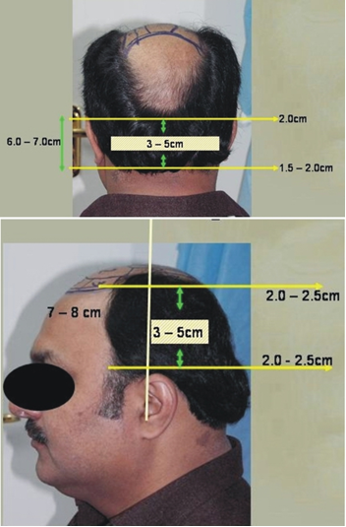
Figure 1 Landmarks in occipital and temporoparietal areas.

