Short Communication

Papular eruption secondary to prolonged application of tetracaine-lidocaine cream
Sir, a 34-year-old female presented with a history of itchy red lesions on the neck since 2 days. The patient had undergone radiofrequency ablation for dermatosis papulosa nigra and acrochordons 2 days back. The procedure was done after applying Tetralid^{R} (tetracaine-lidocaine) cream under occlusion for 20 minutes. The procedure was uneventful and patient was prescribed fusidic acid ointment for topical application. Subsequently after two days, the patient presented again to the dermatology department with itchy red raised lesions over the treated areas. While eliciting the history, it was found that the patient had applied tetracaine-lidocaine cream instead of fusidic acid ointment for 2 days. There was no previous history of sensitivity to any topical medications or any other known drug allergies in the past. There was no history suggestive of angioedema or wheals. Cutaneous examination revealed erythema and erythematous papules over the neck (Figure 1). No wheals were noted. The patient refused further investigations like patch testing or skin biopsy.
Tetracaine-lidocaine cream is one of the most popular topical anesthetic agents used for obtaining anesthesia locally and is a 1:1 eutectic mixture of 7% tetracaine and 7% lidocaine in emulsion formulation. Tetracaine is an ester-type local anesthetic whereas lidocaine is an amide-type local anesthetic.¹ This eutectic mixture is often used as an alternative to the
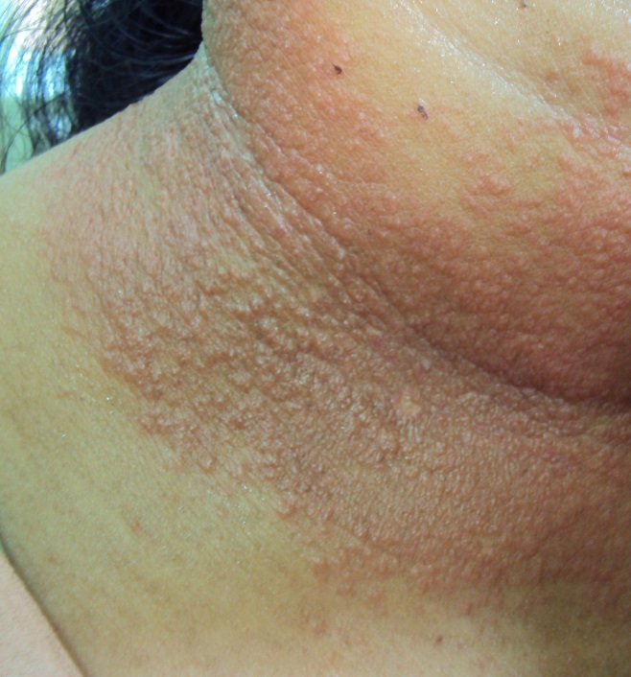 Figure 1 Papules and erythema on the neck
previously used prilocaine-lidocaine eutectic mixture of local anesthetics. The advantage of tetracaine- lidocaine mixture is the relative quicker onset of anesthesia in comparison to prilocaine-lidocaine eutectic mixture which contains prilocaine and lidocaine in a ratio of 1:1.² The tetracaine-lidocaine mixture usually achieves good topical anesthesia after 20 to 30 minutes of occlusion and minor surgical procedures can be performed subsequently. This is in contrast to the prilocaine-lidocaine eutectic mixture which usually requires a time of one hour occlusion to achieve adequate anesthesia. Because of early onset of action, there is increased usage of tetracaine- lidocaine eutectic mixture in dermatosurgical procedures these days.
The commonly seen local adverse effects of tetracaine-lidocaine eutectic mixture include erythema, edema and blanching.¹ Occurrence of vesicular eruption has been reported with a mixture of 23% lidocaine and 7% tetracaine ointment.³ Localized contact urticarial to lidocaine-tetracaine peel has also been reported.⁴
Tetracaine has got an inherent property of vasodilatation which is responsible for the erythema and occasional wheals which develop due to usage of the tetracaine-lidocaine eutectic mixture under occlusion.
Our patient had applied tetracaine- lidocaine eutectic mixture twice daily instead of fusidic acid resulting in prolonged contact time of the same with the skin. This prolonged contact of the tetracaine-lidocaine eutectic mixture may account for the erythema and erythematous papules noticed in our patient. There were no wheals in our patient and hence we considered a diagnosis of contact dermatitis. Whether the contact dermatitis in our patient due to the prolonged contact was allergic or irritant could not be ascertained as the patient refused patch testing even at a later date.
References
- Tetralid [package insert]. Mumbai: Ajantha Pharma; 2012.
- Prilox [package insert]. Mumbai: Neon Laboratories limited;2012
- Vij A, Markus R. Immediate vesicular eruption caused by topical 23% lidocaine 7% tetracaine ointment in a patient scheduled for laser therapy: a new adverse drug reaction. J Cosmet Dermatol. 2011;10:307-10.
- Channual J, Wu JJ, Zachary CB. Localized contact urticaria caused by lidocaine/tetracaine peel. Arch Dermatol. 2009;145:499-500.

Sudhir Nayak UK, H Sripathi

Department Of Dermatology, Kasturba Medical College, Manipal, Manipal University, India

Correspondence Address
Dr. Sudhir Nayak U.K. MD, DDVL
Assistant Professor, Department of Dermatology,
Kasturba Medical College, Manipal University, Manipal-576104, India
Phone number: 9900412394
Email-sudhirnayakuk@yahoo.com
Recurrent noduloulcerative growth on the face
Sir, clear cell hidradenoma (CCH) is an uncommon, benign, slowly growing cutaneous tumor of the sweat glands.¹ It is mostly seen in adults and is characterized clinically by solitary and firm intradermal nodule. Women are affected more often than men.² Presence of malignant change is suggested clinically by a rapid growth and cutaneous ulceration and histologically by an increased number of mitotic figures, nuclear atypia and angiolymphatic or perineural invasion.³ We present a case of fifty year old female who had recurrent noduloulcerative hidradenoma even after complete excision over a span of three years.
The patient presented with an asymptomatic noduloulcerative lesion on the right pre-auricular area which started as a small nodule one year back and slowly increased in size and then ulcerated. The size of the noduloulcerative lesion was 3cm X 3cm, the margin was well-defined but irregular and slightly raised above the surrounding skin surface with pigmentation at places. The center was ulcerated with exuberant granulation tissue. The lesion was not fixed to the underlying structures. There was no regional lymphadenopathy. The patient gave history of similar lesion twice over a span of three years and it was excised completely each time to recur again at the same site. Previous histopathology reports showed features suggestive of hidradenoma. There were no atypical or malignant changes in the previous

