PhotoDermDiagnosis
Multiple annular erythematous lesions in a young adult
Projna Biswas, Saugato Biswas, Anusree Gangopadhyay, Sanchaita Bala, Atul Jain, Sumit Sen

Department of Dermatology, IPGMER & SSKM Hospital, Kolkata, India

A 23-year-old male presented to our OPD with multiple large annular plaques at different sites of his body for last two months. Lesions were mildly itchy and not associated with any systemic symptoms. Lesions started as a small papule and gradually increased in size with the largest lesion of about 10-12 cm in diameter. On examination, there were multiple large erythematous plaques with relatively central clearing over upper back, extensor surface of right upper extremities, groin and buttock (Figure 1). Characteristic scales were found in every lesion which were situated between the clear centre and peripheral erythema. He gave history that few lesions had healed spontaneously giving rise to new lesions elsewhere. Skin scrapings for fungal elements were negative. Mantoux test and ANA profile were normal. Routine blood examination revealed no abnormalities. We did a skin biopsy.
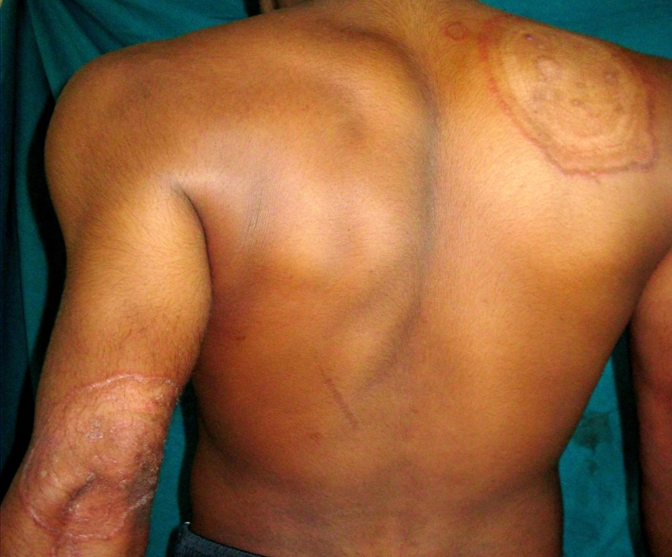
Figure 1
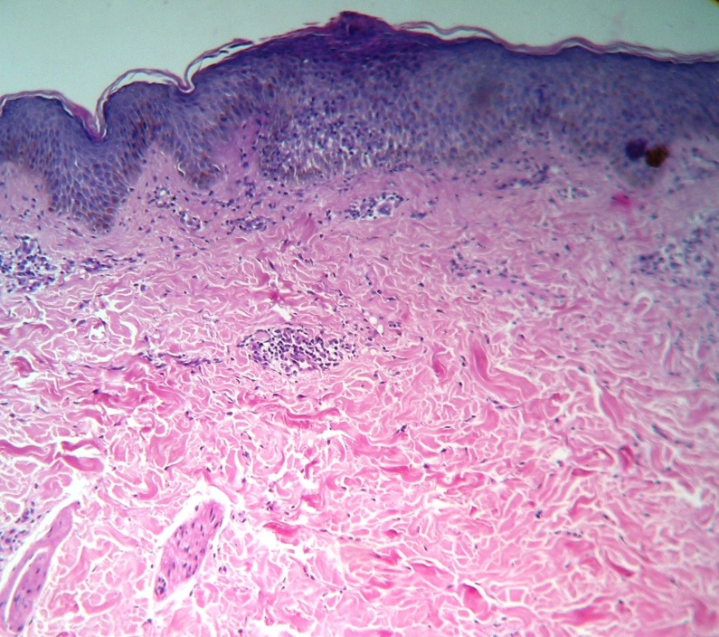
Figure 2.

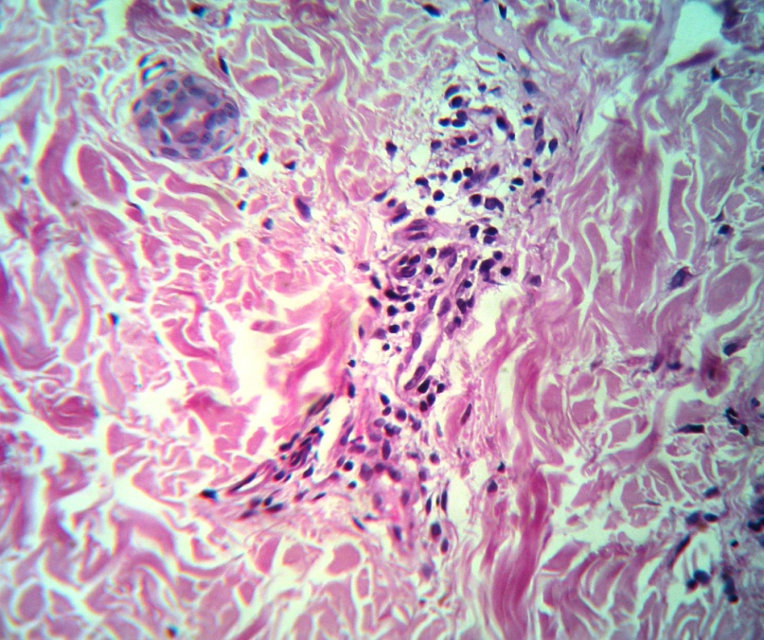
Figure 3.
On light microscopic examination, epidermis was normal with mild lymphohistiocytic cells infiltrates in mid and lower dermis which closely aggregated. Few eosinophils were found (Figures 2 and 3).
What is the diagnosis?
Diagnosis
Erythema annulare centrifugum.
Discussion
The term ‘Erythema Annulare Centrifugum’ (EAC) was first introduced by Darier in 1916. EAC is a group of disorders with similar clinical pictures and histological findings. Etiology is unknown but many associations have been described like fungal infection, drug, malignancy but large portion of the cases are idiopathic.¹ Another mechanism of the pathogenesis of EAC has been proposed which is a Th1-mediated reaction with elevated levels of TNF-α and other proinflammatory cytokines.² EAC commonly occurs in young and middle-aged adults with no sex predilection. Lesions are asymptomatic, start as small erythematous macule or urticarial papule which extends peripherally to form a ringed, arcuate or polycyclic figure with central clearing. Lesions may increase in size several millimeters in a day. With time, one lesion can disappear and new lesion appears in another site. Sometimes annual recurrence can be seen. There are two type of EAC described; one is superficial which has a indistinct border and trailing scales and mildly pruritic, second type is the deep type which is firm and indurated with border without scaling and is non pruritic.³ However, superficial type is more commonly seen. Our patient complained of mild pruritus and lesions had characteristic trailing scales. It has been reported that EAC can be associated with stressors of the patient’s life like emotional stress, malignancy, pregnancy surgery etc.⁴ Some foods, appendicitis, systemic sarcoidosis, hypereosinophilic syndrome, Graves’ disease etc. also have been reported to be associated with EAC. Histopathological examination of superficial EAC is non-specific. There may be mild spongiosis, focal parakeratosis. Few lymphohistiocytic inflammatory cells form a fairly tight aggregate around vessels, which is called ‘coat sleeve’. Rarely, eosinophils are also found in the infiltrate. The advancing edge shows edema in the papillary dermis and central clear area may contain dermal melanophages. In deep variant epidermis is normal with perivascular mononuclear cell infiltrates in the mid- and deep dermis. In our case we found normal epidermis with focal parakeratosis and coat sleeve arrangement of perivascular lymphohistiocytic infiltrates.⁵ EAC usually is a self limiting condition but topical or systemic steroids can hasten the healing progress but cannot prevent the occurrence of new lesions. Some other treatment modalities are also reported like hyaluronic acid, calcipotriol, metronidazole, etanercept etc.^{6,7} but the most effective treatment is to treat the underlying cause.
References
- Cox NH, Coulson IH, Systemic Disease and the Skin In: Burns T, Breathnach S, Cox N, Griffith C, editors. Rook’s Textbook of Dermatology. 8th edn. Singapore: Wiley-Blackwell; 2010. P. 62.1-113.
- Minni J, Sarro R. A novel therapeutic approach to erythema annulare centrifugum. J Am Acad Dermatol. 2006;54:S134-5.
- Burgdorf WHC. Erythema annulare centrifugum and other figurate erythemas. In: Wolff K, Goldsmith LA, Katz SI et al., editors. Fitzpatrick’s Dermatology in General Medicine. 8thed. New York: McGraw-Hill; 2012. p. 366-8.
- Ibrahim SF, Pryor J, Tausk FA. Stress-induced erythema annulare centrifugum. Dermatol Online J. 2009;15(4):15.
- España A. Figurate erythemas. In: Bolognia J, Jorizzo J, Rapini RP, editors. Dermatology. 2nd ed. Spain: Mosby Elsevier; 2008. P. 277-83.
- Ioannidou D, Krasagakis K, Stefanidou M, Tosca A. Erythema annulare centrifugum and osteoarthritis treated with hyaluronic acid. Clin Exp Dermatol. 2002;27:720-2.

Mir A, Terushkin V, Fischer M, Meehan S. Erythema annulare centrifugum. Dermatol Online J. 2012;18(12):21.

