Case Report
A rare case of isolated eyelid myxoma
Vijaya Pai. H*, Prathvi Pai M*, Mary Mathew**

* Department of Ophthalmology, Kasturba Medical College, Manipal University, Manipal, India
** Department of Pathology, Kasturba Medical College, Manipal University, Manipal, India

Abstract | Myxoma is a benign neoplasm derived from primitive mesenchyme usually occurring in heart but can arise rarely in orbit, eyelid and conjunctiva. A 9-year-old boy presented with a history of right eye lower lid lesion of two year duration. The patient had undergone excision of the lesion at a private hospital. Two months later patient developed a recurrence. Examination showed a soft non tender multinodular skin coloured lesion of 1.25 x1 cm dimension on the medial aspect of the right lower eyelid extending on to the conjunctival side without any involvement of the lower fornix or the lacrimal punctum. Visual acuity was 6/6, N6. Rest of the anterior segment was within normal limits. Wide excision of the lesion along with lid margin and lid reconstruction with direct closure a lateral cantholysis was done. Histopathology of the excised lesion showed features suggestive of myxoma with a prominent vasculature. Detailed cardiac and dermatological evaluation did not show other components of Carney’s complex. Isolated eyelid myxoma is an extremely rare condition with a tendency towards local recurrence following incomplete excision.  Key words  Eyelid myxoma.

Introduction
Myxoma is a benign neoplasm which usually occurs in heart. Myxomas which occur in the head and neck region have prominent vasculature and have a high rate of recurrence. Myxomas are due to excessive production of glycosaminoglycans by fibroblasts.¹ We report a rare case of isolated eyelid myxoma without Carney’s complex.
Case report
A 9-year-old boy presented to us in June 2010 with a history of right eye lower lid lesion of two year duration. The patient had undergone excision of the lesion at a private hospital. Two months later, lesion recurred at the same site. The lesion was slowly increasing in size. There was no history of any impairment of vision. There was no history of pain or bleeding from the swelling on the lid. On examination a soft non tender multinodular skin coloured lesion of 1.25cm x1cm dimension was present on the medial aspect of the right lower eyelid involving the lid margin, and extending on to the conjunctival side (Figure 1). There was no involvement of the lower fornix or the lacrimal punctum. Visual acuity was 6/6, N6 in both eyes. Rest of the ophthalmic examination was unremarkable. Systemic examination was within normal limits. A provisional diagnosis of papilloma/molluscum contagiosum was made. A wide excision of the lesion along with lid margin was performed and lid was reconstructed by direct closure with lateral cantholysis under general anaesthesia. Histopathology on gross section showed a grey-white mass with focal
Address for correspondence
Dr. Prathvi Pai M,
Department of Ophthalmology,
Kasturba Medical College, Manipal University,
Manipal-576104, India
Phone: 9742501030
Email: prathvipai@gmail.com
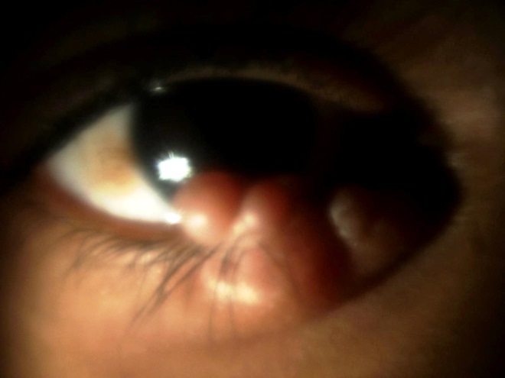 Figure 1 Multinodular lesion on the medial aspect of the right lower eyelid involving the lid margin.

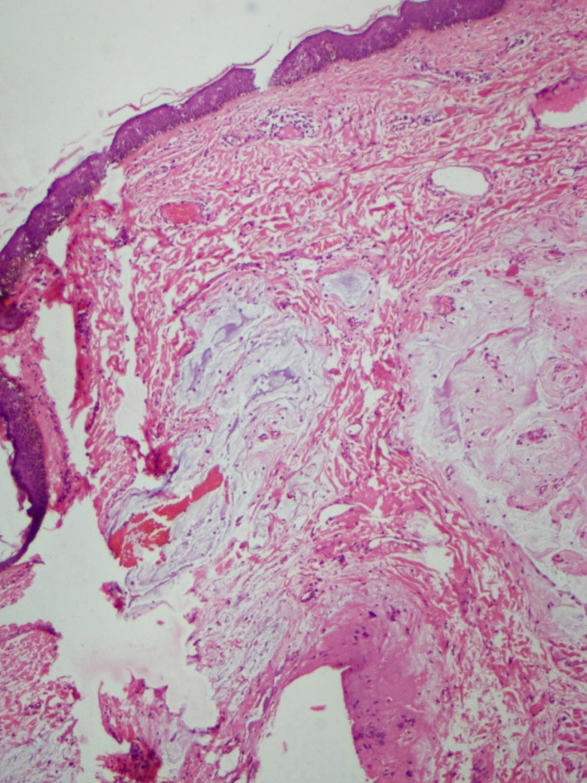 Figure 2 Prominent myxoid stroma and thin walled blood vessels in dermis (H&E x 50).
myxoid areas. On microsection atrophic epidermis was overlying a poorly circumscribed hypocellular mass with prominent myxoid stroma and thin walled blood vessels (Figure 2). Tissue also showed alcian blue positivity (Figure 3). On the basis of this a diagnosis of cutaneous myxoma with prominent vascular component was made. Cardiology evaluation
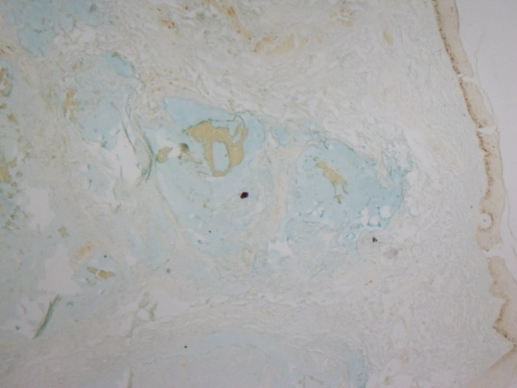 Figure 3 Alcian blue positivity for mucin.
including echocardiogram was done to rule out cardiac myxoma. There was no evidence of cardiac myxoma.
Discussion
Cutaneous myxomas usually form a part of syndromes like NAME syndrome (nevi, atrial myxoma, myxoid neurofibromata and ephelides) and the LAMB syndrome (lentigines, atrial myxoma, mucocutaneous myxoma, and blue nevi). Histologically they are ovoid to globular tumours with prominent mucoid material and small amount of stellate cells. Allen et al. preferred to use the terminology superficial angiomyxomas for cutaneous myxomas with prominent vascularity.²
Carney’s complex is the term used if myxomas are associated with spotty pigmentation and endocrine overactivity.³ Ophthalmic manifestations of Carney’s complex are eyelid lentigines, conjunctival or caruncular pigmentation and eyelid myxoma.⁴ Solitary myxomas are frequently noted in skeletal and cardiac muscle, intestine, conjunctiva and subcutaneous tissue.⁵ Eyelid myxomas are reported to occur in 10% of cases with Carney’s complex and are usually associated with cardiac myxomas and isolated eyelid myxomas are very rare.^{5,6} However, our patient had an eyelid myxoma with no periorbital pigmentation. A detailed cutaneous and cardiac evaluation was within normal limits thus negative for Carney’s complex.
Recurrence following surgery has been reported in 38% of cases. It is usually due to incomplete excision or subcutaneous extension of the tumour. Our patient presented with recurrence of the lesion following the previous history of surgery for the same, thus indicating the recurrence due to incomplete excision. Yeun et al. reported a case of solitary superficial angiomyxoma in the eyelid with a similar presentation but follow up was not performed.⁶
We report a rare case of isolated eyelid myxoma without any associated features of Carney’s complex or NAME and LAMB syndromes.
References
- Craig NM, Putterman AM, Roenigk RK et al. Multiple periorbital cutaneous myxomas progressing to scleromyxedema. J Am Acad Dermatol. 1996;34:927-30.
- Allen PW, Dymock RB, MacCormac LB. Superficial angiomyxomas with and without epithelial components. Report of 30 tumors in 28 patients. Am J Surg Pathol. 1988;12:519-30.
- Grossniklaus HE, McLean IW, John J Gillespie JJ. Bilateral eyelid myxomas in Carney's complex. Br J Ophthalmol 1991;7:251-2.
- Chen CL, Tai MC, Chen JT et al. A rare case of conjunctival myxoma and a review of the literature. Ophthalmologica. 2008;222:136-9.
- Wilk M, Schmoeckel C, Kaiser HW et al. Cutaneous angiomyxoma: A benign neoplasm distinct from cutaneous focal mucinosis. J Am Acad Dermatol. 1995;33:352-5.
- Yuen HKL, Cheuk W, Luk FOJ et al. Solitary superficial angiomyxoma in the eyelid. Am J Ophthalmol. 2005;139:1141-2.
- Kennedy RH, WaIler RR, Carney JA. Ocular pigmented spots and eyelid myxomas. Am J Ophthalmol. 1987;104:533-8.

