Case Report
Mycobacterium fortuitum-induced surgical wound infection - a case report
Kritika Singhal*, Vikrant Saoji*, Sandhya V Saoji**

*Department of Dermatology, Venereology & Leprosy, J.N.M.C. Sawangi-Wardha, India
** Consultant Microbiologist, Nagpur

Abstract | A 53-year-old healthy lady who underwent a planned laparoscopic surgery for the removal of gall stones presented with mildly tender fluctuant swelling along the line of surgical scar which did not respond in spite of various antibiotics. Gram smear and bacterial culture did not yield any organism. Diagnosis of atypical mycobacteria rapid grower (Mycobacterium chelonae-fortuitum complex) was made which was confirmed later to be M. fortuitum. This case highlights the importance of strict aseptic precautions even during the minor procedures.  Key words  Mycobacterium fortuitum, Lowenstein-Jansen medium.

Introduction
Mycobacteria are acid-fast bacilli which are classified as: 1) Mycobacterium tuberculosis which causes tuberculosis; 2) M. leprae which causes leprosy and 3) Nontuberculous mycobacteria (NTM) which include all other mycobacteria. Nontuberculous mycobacteria are also called as atypical mycobacteria and are classified into: 1) Photochromogens 2) Scotochromogen 3) Nonchromogens 4) Rapid growers. Rapid grower NTM include closely related M. chelonae and M. fortuitum.^{1.}These rapid grower mycobacteria are widely distributed in nature and contaminate water supplies including reagents and wash solutions used in hospitals. If such contaminated water is used to clean the catheters, surgical instruments and scopes surgical wound infection may occur. These mycobacterial infections have been reported after surgical procedures,² like liposuction,³ silicon injection,⁴ pedicures⁵ and subcutaneous injections.⁶ A case of post-surgery skin infection due to M. fortuitum is presented.
Case report
Gall stones were detected during an executive routine health check up in a 53-year-old healthy lady. A planned laparoscopic surgery for the removal of gall stones proved unsuccessful due to adhesions hence open surgery was carried out. 4-5 weeks post-surgery, patient developed fluctuant swelling along the surgical scar which was unresponsive to various antibiotics. Patient’s blood sugar was normal and HIV was negative. Repeated gram smear and bacterial culture did not yield any organism. Hence patient was referred to a dermatologist. Patient was afebrile and stable. There were a few fluctuant abscesses along the surgical scar. There was one ulcer with clean granulomatous base in the vicinity. The abscesses were relatively painless hence possibility of cutaneous tuberculosis was considered. Gram smear and
Address for correspondence
Dr. Kritika Singhal,
8 H.I.G.
Priyadarshani Nagar,
Itarsi (M.P.)-461111
Madhya Pradesh, India
Phone- 91-7572-230696, 07415299166
E-mail: drkritikasinghal@gmail.com
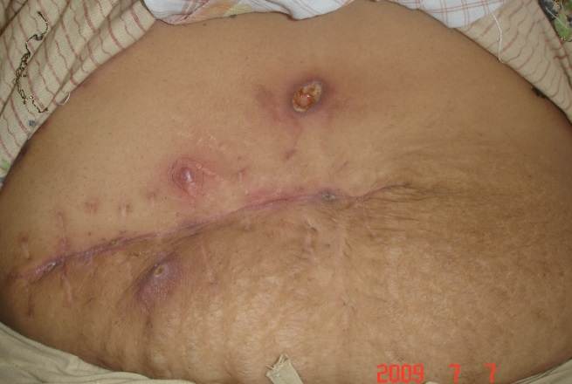
Figure 1 Mildly tender swelling along the surgical scar.

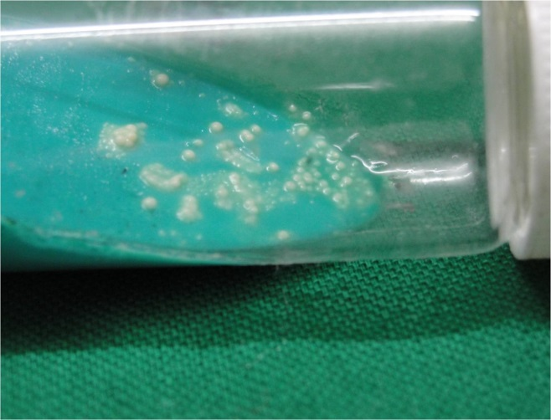
Figure 2 L-J medium showing growth of acid fast organisms in 3 days suggestive of Mycobacterium fortuitum-chelonae complex.

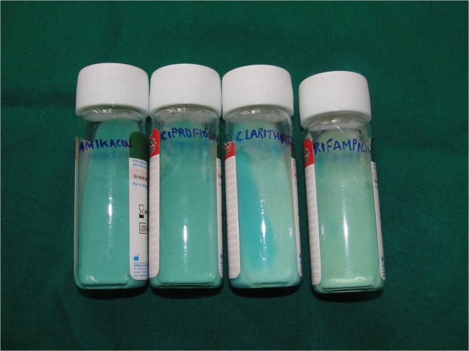
Figure 3 Culture and antibiotic sensitivity test revealed sensitive only to ciprofloxacillin and amikacin. Turbidity indicates growth of organism.

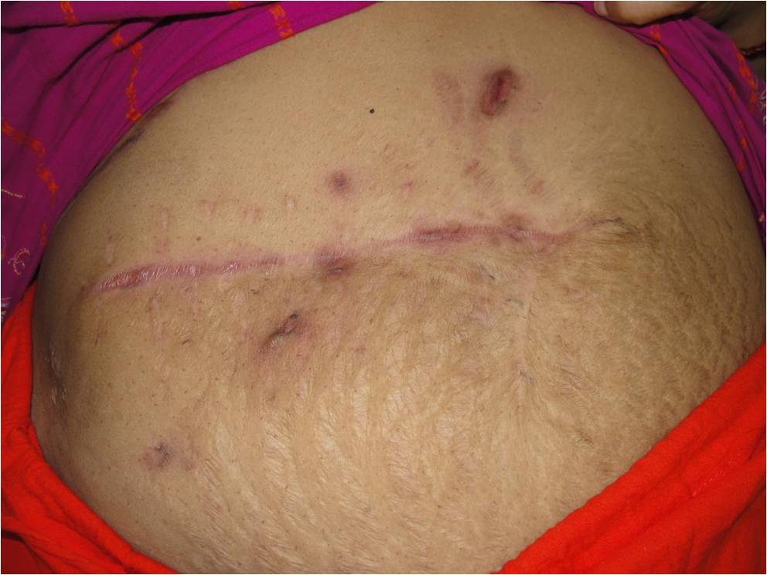
Figure 4 Healing of all lesions after 2 months of treatment.
Ziehl-Neelsen smear were negative. Bacterial and mycobacterial cultures were taken. Patient was put on Cap ampicloxacillin. Patient returned on 3rd day with new lesions. Repeat Gram and Z-N smear were negative for organisms. Bacterial culture taken on first day was negative but Lowenstein-Jensen medium showed growth of acid fast organisms on 3rd day (Figure2). Diagnosis of atypical mycobacteria rapid grower (M. chelonae-fortuitum complex) was made. Further study carried out in the higher centre showed buffy coloured colony with positive urease, hot catalase, nitrate reductase tests. Growth on 5% NaCl, MacConkey agar was present. Niacin test and PNB sensitivity was negative. On the basis of all these tests the diagnosis of M. fortuitum was made. Drug sensitivity was carried out. The organism was resistant to all routinely used anti-tubercular drugs and sensitive only to ciprofloxacillin and amikacin (Figure 3). Patient was started on Tab Ciprofloxacillin 500mg BD and Injection Amikacin 750mg BD. By seven days patients started showing improvement and within 6 weeks all the lesions healed (Figure 4). Antibiotics continued for further 2 weeks. After receiving ciprofloxacin and amikacin for a total of 2 months the treatment was discontinued. There was no recurrence during 6 months of follow up.
Discussion
M. chelonae-fortuitum complex are closely related rapid grower atypical mycobacteria. Exact differentiation of these two organisms requires specialised facility and many times this is not done.
These atypical mycobacteria are distributed widely in the environment and contaminate municipal water supply and are resistant to sterilizers, antiseptics and standard disinfectants. These organisms can cause surgical wound infections and post-injection abscesses due to improperly sterilized instruments and endoscopes. It usually causes localised infection hence systemic symptoms are often absent. Dissemination may occur in immunosuppressed patient. Surgical wound infection caused by M. fortuitum resembles the pyogenic infections but do not responds to routinely used antibiotics. Since the mycobacterial culture is not routinely done for surgical wound infection the diagnosis is usually delayed. These NTM organisms are probably transmitted by aerosol, soil, dust, water, injection or by skin inoculation but person to person spread is rare.⁶ The median time of onset of symptoms after surgery is around 5 weeks (range1-20 weeks). Persistent pus discharged from surgical wound in spite of broad-spectrum antibiotics and failure to grow any organism on routine culture should arouse the possibility of atypical mycobacterial infection. The abscess may be relatively painless like cold abscess and this was an important clue which made us suspect mycobacterial infection. There is no clear-cut guideline regarding the treatment of atypical mycobacterial infection. These organisms are highly resistant organisms and routine antitubercular drugs are usually not useful. Hence, susceptibility testing of clinically significant rapidly growing mycobacteria should be performed with antibacterial drugs like amikacin, doxycycline, imipenem, fluorquinolones, sulphonamides, cefoxitin and clarithromycin along with the conventional antitubercular drugs.⁷ Duration of treatment is also unclear. But continuation of treatment for two weeks after healing of all the skin lesions seems logical as done in our case. Because of the early diagnosis of M. fortuitum in our patient, 2 month treatment proved to be curative. Long-standing infection may need longer treatment. Palwade et al.⁸ used antibiotics for over 8 month in their patient of atypical mycobacterial infection. Many times in addition to medical treatment, incision and drainage of abscess may be required.
The aim of presenting this uncommon case is to make the physician aware of this simple looking but serious mycobacterial disease and the need to follow the strict aseptic precautions even during the minor procedures.
References
- Bhambri S, Bhambri A, Del Rosso JQ. Atypical mycobacterial cutaneous infections. Dermatol Clin. 2009;27:63-73.
- Rajini M, Prasad SR, Reddy RR et al. Postoperative infection of laparoscopic surgery wound infection due to Mycobacterium chelonae. Indian J Med Microbiol. 2007;25:163-5.
- Behroozan DS, Christian MM, Moy RL. Mycobacterium fortuitum infection following neck liposuction: A case report. Dermatol Surg. 2000;26:588-90.
- Fox LP, Geyer AS, Husain S, Della-Latta P, Grossman ME. Mycobacterium abscessus cellulites and multifocal abscesses of the breasts in a transsexual from illicit intramammary injection of silicon. J Am Acad Dermatol. 2004;50:450-4.
- Winthrop KL, Albridge K, South D et al. The clinical management and outcome of nail salon-acquired Mycobacterium fortuitum skin infection. Clin Infect Dis 2004;38:38-44.
- Devi DR, Indumathi VA, Indira S et al. Injection site abscess due to Mycobacterium fortuitum: A case report. Indian J Med Microbiol. 2003;21:133-4.
- Wallace RJ, Glassroth J, Griffith EF et al. Diagnosis and treatment of disease caused by NTM. Am J Respir Crit Care Med. 1997;156:S1-25.
- Palwade PK, Dhurat RS, Tendolkar UM et al. Chronic cutaneous disease caused by the rapid growers Mycobacterium fortuitum and chelonae. Br J Dermatol. 2006;154:774-5.

32nd PAD Conference 2013
13-15th December, 2013
Venue: Sheraton Karachi Hotel, Karachi
Theme: Aesthetics and Dermatology
Organizing Chairman: Dr. Manzoor H. Memon
E-mail: 32padconference2013@gmail.com
Website: www.pad.org.pk
Ph: 0333-3614284

