Case Report
Lupus miliaris disseminatus faciei: A case report
Madiha Sanai, Muhammad Nadeem, Shahbaz Aman, Atif Hasnain Kazmi

Department of Dermatology Unit-I, KEMU/ Mayo Hospital, Lahore

Abstract | Lupus miliaris disseminatus faciei is an uncommon, chronic, inflammatory dermatoses characterized by multiple, monomorphic, symmetrical, reddish-brown papules on chin, forehead, cheeks and eyelids that show a characteristic granulomatous histology. Lesions may cluster around the mouth and eyes or may be widely disseminated on the face. The exact pathogenesis is unknown. Tuberculin test is usually negative. Active disease generally lasts for 1-3 years and resolves spontaneously. We report a case of this disorder along with review of literature.  Key words  Lupus miliaris disseminatus faciei, granulomatous histology, tuberculin test

Introduction
Lupus miliaris disseminatus faciei (LMDF), is a rare skin disease that usually occurs in young adults of either gender.¹⁻³ It presents as discrete, symmetrical, reddish-brown to pink, dome-shaped papules on the face and elsewhere.¹⁻³ This eruption tends to be self-limiting, resolving completely over a few months to two years.^{1,2} The scars left after healing are superficial, fine and smooth. Diascopy of larger lesions often reveals an apple-jelly nodule-like appearance indicating their granulomatous histology.^{2,3}
Initially described by Tilbury Fox in 1878 as Disseminated Follicular Lupus, it is now known by the title of acne agminata, from its close resemblance to grouped acne lesions.⁴ Nevertheless, because the currently used name may be confusing, Skowron et al. proposed, in 2000, a name change from LMDF to FIGURE (facial idiopathic granulomas with regressive evolution) to date, this name change does not appear to have been widely accepted.^{1,5}
Previously thought to be a tuberculid but now believed to be a variant of granulomatous rosacea.⁶ Actually, LMDF may be considered a distinct entity.^{5,6} The etiology remains unknown.^{1-3,6} Although, it is a self-limiting disease, the treatment options are tetracyclines, isotretinoin, dapsone and prednisolone.¹⁻³ Clofazimine 100 mg three times weekly for 8 weeks has also shown successful results.¹⁻³
Case report
A 25-years-old male presented in the outpatient Department of Dermatology, Mayo Hospital, Lahore with the complaint of multiple reddish-brown papules on chin and upper lips for the last 4 months. Initially papules were pinhead to small pea size, then gradually over a period of 2 months, they enlarged to form nodules involving the forehead, cheeks, nose, ears, scalp and neck. History of photosensitivity was present and there was mild to moderate itching on the lesions. The lesions on the ears were painful. There was no history of fever, weight loss or chest infection in our patient, but history of contact with tuberculosis in the family was present. There were no systemic complaints. Past history was insignificant. Patient had been taking anti-tubercular therapy for one and a half months with no improvement.
Address for correspondence
Dr. Madiha Sanai
House # 3/ 16-Lajpat Street
Nicholson Road, Lahore.
Email: madihasanai@hotmail.com
Physical examination revealed multiple, small, symmetrical pink or reddish-brown monomorphic papules and nodules on chin, forehead and cheeks (Figure 1). The surface was smooth with mild scaling. Ears were swollen with tender, erythematous and scaly nodules mostly on pinna. Parietofrontal regions of the scalp were also involved. On the neck, larger nodules were seen. There was no lymph node enlargement. Diascopy of large nodules revealed apple-jelly like appearance. Rest of the physical examination was normal and no systemic abnormality was detected.
On laboratory investigations, complete blood count, ESR, serum calcium, serum ACE levels and X-ray chest were all normal. Mycodot, PCR for mycobacterial DNA, slit skin and Leishman-Donovan bodies (LD bodies) smears were negative. Skin biopsy revealed dermal granulomas composed of epithelioid histiocytes. Focal central necrosis was seen with few foamy histiocytes especially around the adnexae.
The patient was given oral prednisolone 25 mg and dapsone 100 mg daily with topical clindamycin for one and a half years. Regular follow up was done and the disease resolved itself with pitted scars remaining (Figure 2).
Discussion
Lupus miliaris disseminatus faciei (LMDF), also termed acne agminata or acnitis, is a rare granulomatous skin disease mainly affecting the central area of the face.⁷ It shows a characteristic tendency to involve the lower eyelids.¹⁻³ Lesions may occur singly or in crops.⁶ In the early lesions,
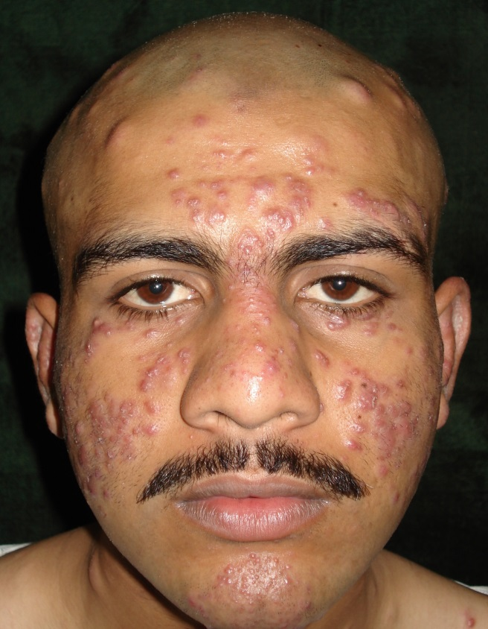
Figure 1 Before treatment.

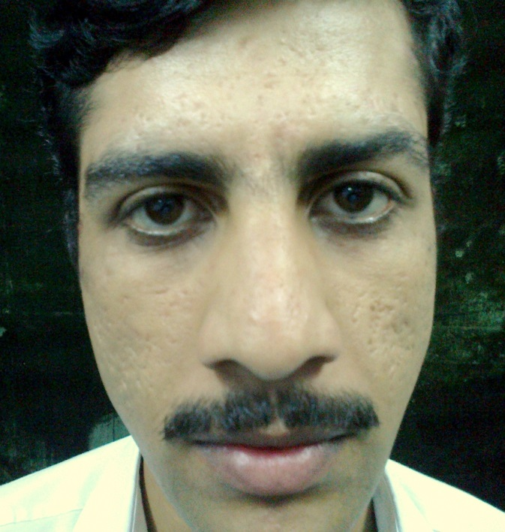
Figure 2 After treatment
there is perivascular and periappendageal lymphomononuclear cell infiltration. In fully developed lesions, there is rupture of hair follicles and perifollicular epithelioid cell granulomas with Langhans and foreign body type of giant cells. Central caseation-like necrosis is seen in 20-100% cases, while in old lesions there is extensive perifollicular fibrosis.^{3,8} This chronic disease involutes spontaneously with pitted scars.^{1-3,6,7} Many drugs like antitubercular, antibiotics, steroids, dapsone and vitamins have variable efficacy.²
The condition has to be differentiated from similar clinical entities like acne, lupus vulgaris, granulomatous rosacea, sarcoidosis and histoid leprosy.
Acne is a polymorphic disease that shows comedones, inflammatory lesions, scars and pigmentary disturbances.⁹ In acnitis, there are monomorphic, symmetrical, reddish-brown papules and nodules on the face but no comedones with a granulomatous histology. Moreover, in acnitis the lesions are not consistently related to hair follicles.²
LMDF was also considered to be a variant of lupus vulgaris because of the histology, but there has been no evidence to date supporting a link to tuberculosis.^{1,2} Evidence against this association includes a variable cutaneous hypersensitivity response to tuberculin, the absence of bacilli in lesions, failure to respond to antituberculous therapy in many cases and failure to demonstrate the DNA of M. tuberculosis in lesional skin by PCR.¹
LMDF has frequently been regarded as a variant of granulomatous rosacea (GR).^{1,2,6} The predominance in young adults, involvement of extrafacial sites and areas typically spared by rosacea (lower eyelids), and the absence of erythema, flushing and telangiectasia argue against LMDF being a form of rosacea.^{1,10,11} Furthermore, LMDF has variable response to oral tetracyclines, an occasional response to oral steroids and a self-limited course with scarring, inconsistent with the diagnosis of rosacea.^{1,10} Although dermal epithelioid cell granulomas are observed histologically in both diseases, caseation necrosis is rarely observed in GR.^{1,10,11}
The clinical features, histopathology (sarcoidal-type granulomas) and course of LMDF are often similar to cutaneous sarcoidosis. However, sarcoidosis can generally be excluded by the physical examination, chest X-ray and laboratory test (serum calcium, ACE levels).^{1,12} The non-caseating epithelioid granulomas is also diagnostic of sarcoidosis.¹²
Histoid leprosy is a variant of lepromatous leprosy, which develops as a result of resistance to dapsone monotherapy.¹³ Histoid lepromas are sudden eruptions of dome-shaped papules and nodules having characteristic epidermal grenz zone and dermal spindle-shaped histiocytes.¹³ Moreover, no acid fast bacilli are seen in slit skin smear in our case.
Conclusion
The diagnosis of acnitis should be considered in every case where papular eruption is encountered on the face with a tuberculoid histology but without any evidence of M. tuberculosis.
References
- Esteves T, Faria A, Alves R et al. Lupus miliaris disseminatus faciei; A case report. Dermatol Online J. 2010;16(5): 1-5.
- Berth-Jones J. Rosacea, perioral dermatitis and similar dermatoses, flushing and flushing syndromes. In: Burns T, Breathnach S, Cox N, Griffiths C, eds. Rook’s Textbook of Dermatology, 7th edn. London; Blackwell Science; 2004. P.44.11
- Sehgal VN, Srivastava G, Aggarwal AK et al. Lupus miliaris disseminatus faciei. Part II: an overview. Skinmed. 2005; 4:234-8.
- Dawson GW. Acne agminata. Proceedings of the Royal Society of Medicine. Dermatology Sect. 1909;2:45-8.
- Skowron F, Causeret AS, Pabion C et al. FIGURE: facial idiopathic granulomas with regressive evolution. Is lupus miliaris disseminatus faciei still an acceptable diagnosis in the third millennium? Dermatology. 2000;201:287-9.
- Meffert J. Lupus Miliaris Disseminatus Faciei. [online] 2011 [cited July 13]. Available from: http://emedicine.medscape.com/artical/1070740-overview#a0104.
- Mullan E, Green P, Pasternak S. Lupus miliaris disseminatus faciei with extrafacial involvement in a 17-year-old white girl. J Cutan Med Surg. 2011; 15(6): 340-3.
- Punia RP, Kumar S, Thami GP et al. Acne agminata. Report of 3 cases. Indian J Dermatol. 2000; 45(4): 213-5.
- Kubba R, Bajaj AK, Thappa DM et al. Acne in India: Guidelines for management. Indian J Dermatol Venereol Leprol. 2009; 75: 513-25.
- Kaur S, Kanwar AJ, Thami GP et al. Granulomatous Rosacea: is it a variant of lupus miliaris disseminatus faciei? Indian J Dermatol Venereol Leprol. 2003; 69: S58-60.
- Elder DE, Elenitsas R, Johnson B et al. Perivascular, diffuse and granulomatous infiltrates of the reticular dermis. In: Atlas and Synopsis of Lever’s Histopathology of the Skin, 2nd edn. Philadephia; Lippincott Wiliam & Wilkins; 2007. P. 185-274.
- Kim KJ, Bae GY, Suh HS et al. A case of micropapular Sarcoidosis. Korean J Dermatol. 2002; 40(5): 589-91.
- Annigeri SR, Metgud SC, Patil JR. Lepromatous leprosy of histoid type. Indian J Med Microbiol. 2007;25:70-1.

