Case Report
Linear punctate porokeratosis with ipsilateral solitary actinic porokeratosis: an unusual coexistence
Sanchaita Bala, Anusree Gangopadhyay, Biswanath Naskar, Mitra Pradip Kumar, Nidhi Choudhary, Supriya Pal

Department of Dermatology Venereology & Leprosy, IPGMER & SSKM Hospital, Kolkata

Abstract | Punctate porokeratosis is a rare variant of porokeratosis. Linear distribution of this entity has been described in very few cases. Herein, we report a case of rare coexistence of unilateral linear punctate porokeratosis and ipsilateral solitary actinic porokeratosis in an 18-year-old male.  Key words  Punctate porokeratosis, linear porokeratosis, actinic porokeratosis.

Introduction
Punctate porokeratosis and actinic porokeratosis are variants of porokeratosis. Punctate porokeratosis is characterised by asymptomatic, tiny, punctate lesions presenting over palms and soles. Histopathology shows parakeratotic column which differentiates it from other types of punctate palmoplantar keratoderma. Porokeratoses are classified as disseminated superficial actinic porokeratosis, disseminated superficial porokeratosis, porokeratosis of Mibelli, punctate porokeratosis, porokeratosis palmaris et plantaris disseminate, syndromic form and linear porokeratosis.¹ Actinic porokeratosis appears as double edged typical lesion with atrophic centre over sun exposed areas of body and on histopathology a characteristic cornoid lamella is found .We want to focus over the unusual coexistence of both variants of porokeratosis.
Address for correspondence
Dr. Sanchaita Bala,
Rajpur Govt. Colony,
PO: South Jagaddal
Dist: 24 Parganas (South), Kolkata, Pin:743379,
West Bengal, India.
Mob No: 8013969521.
Email: doc.sanchaita@gmail.com
Case report
An eighteen year old male patient presented with asymptomatic multiple punctate papular lesions over thenar eminence of left hand for 1year which gradually spread in a linear fashion to involve the flexor aspect of left thumb. The lesions were close set very small shiny punctate papules arising from a normal surrounding skin (Figure 1).In addition he had an asymptomatic, solitary, mildly pigmented papule with a double edged margin of six months duration on left side of nose (Figure 2).There was no history of similar lesion in any of his family members. Histopathological examination of one of the lesion from left palm and lesion over face revealed similar changes in the form of hyperkeratosis and a parakeratotic column overlying an absent granular cell layer resembling cornoid lamella (Figure 3a, 3b and 4). Based on the above clinical and histopathological changes a diagnosis of unilateral linear punctate porokeratosis along with ipsilateral facial actinic porokeratosis was made.
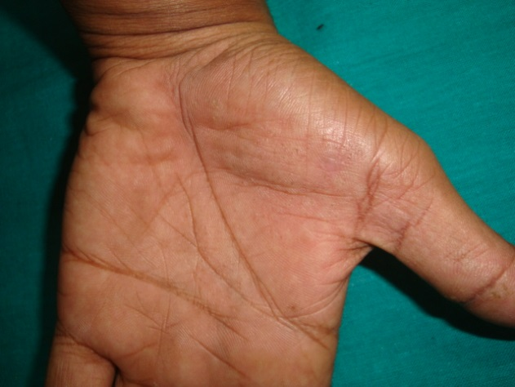
Figure 1 Punctate, shiny papules presenting over thenar eminence and flexor aspect of left thumb in linear fashion.

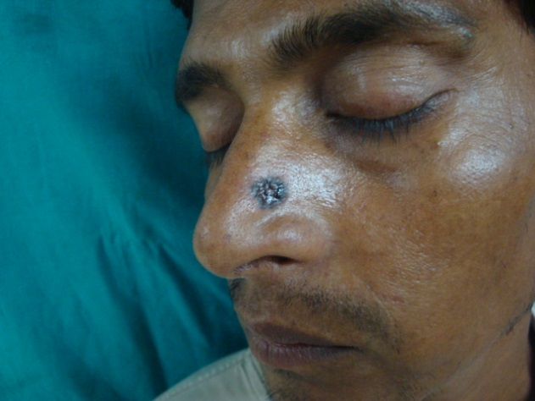
Figure 2 Solitary pigmented double edged papule over left side of nose.

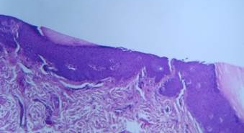
Figure 3a Histopathology of punch biopsy from palmar lesion showing two parakeratotic column (H&E 100x).
Discussion
Porokeratoses are characterized by marginate scaling lesions, histologically showing a column of parakeratotic keratinocytes.² It appears at childhood and boys are more affected. Loci at chromosome bands 12q23.2-24.1 and 15q25.1-26 have been reported in familial disseminated superficial actinic
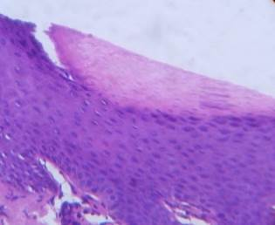
Figure 3b Histopathology of punch biopsy from palmar lesion showing a cup shaped parakeratotic column overlying an absent granular cell layer (H&E 400x).

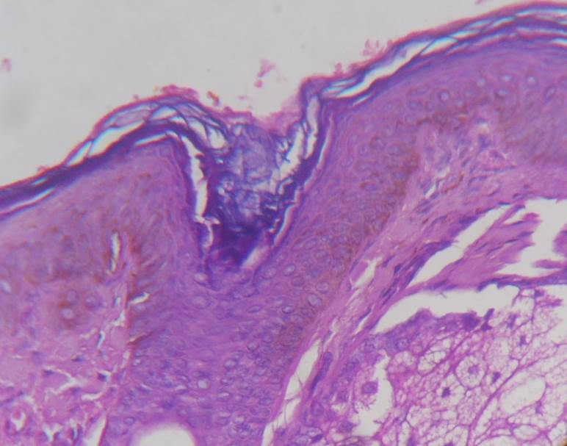
Figure 4 Histopathology of punch biopsy from facial lesion showing column of parakeratosis overlying an absent granular cell layer (H&E 400x).
porokeratosis.³ Early and faulty apoptosis of keratinocytes and dysregulated keratinisation is thought to be behind the pathogenesis.⁴ Malignant transformation may occur but chances are least in punctate porokeratosis.⁵ The disease should be differentiated from arsenical keratosis, porokeratotic eccrine ostial and dermal duct nevus, porokeratosis palmaris et plantaris disseminate and punctate porokeratotic keratoderma which may have same presentation. Porokeratosis of Mantoux is a variant of punctate palmoplantar keratoderma which shows parakeratotic histology.⁶ In our patient histological findings like parakeratotic column along with absent granular layer resembling cornoid lamella suggests the diagnosis of porokeratosis. Shiny punctate seed like lesions characteristic of punctate porokeratosis were present in the case. Various treatment modalities like topical 5-fluorouracil, calcipotriol, retinoids and oral retinoids are found to be effective along with surgical procedures like cryotherapy, dermabrasion and CO₂ laser ablasion.⁵ The patient is treated here with topical retinoids and sun protective measures.
Our patient presented with unilateral linear punctate porokeratosis over left palm along with ipsilateral actinic porokeratosis over face. The latter presenting as single lesion is very unusual. To the best of our knowledge this is a rare association. Actinic porokeratosis presenting as single lesion is very unusual. Although actinic porokeratosis may present with other variants in a single patient but rarely with punctate porokeratosis.⁷ Coexistence of these two was an interesting observation.
References
- O’Regan GM, Irvine AD. Porokeratosis. In: Wolff K, Goldsmith LA, Katz SI et al., editors. Fitzpatrick’s Dermatology in General Medicine, 7th edn. New York: McGraw-Hill; 2008. P.442-6.
- Judge MR, McLean WHI, Munro CS. Disorder of keratinisation. In: Burns T, Breathnach S, Cox N, Griffiths C, editors. Rook’s Textbook of Dermatology, 8th edn. London: Willey-Blackwell; 2010. P.19.1-122.
- Wu LQ, Yang YF, Zheng D et al. Confirmation and refinement of a genetic locus for disseminated superficial actinic porokeratosis (DSAP1) at 12q23.2-24.1. Br J Dermatol. 2004;150:999-1004.
- Shen CS, Tabata K, Matsuki M et al. Premature apoptosis of keratinocytes and the deregulation of keratinization in porokeratosis. Br J Dermatol. 2002;147:498-502.
- Vaishnani JB, Bosamiya SS, Sapariya BJ, Udhreja PR. Linear porokeratosis with follicular involvement. Indian J Dermatol. 2011;56:460-1.
- Friedman SJ, Herman PS, Pittelkow MR. Punctate porokeratotic keratoderma. Arch Dermatol. 1988;124:1678-82.
- Dover JS, Phillips TJ, Burns DA, Krafchik BR. Disseminated superficial actinic porokeratosis, coexistence with other porokeratotic variants. Arch Dermatol. 1986;122:887.

