Case Report
Familial aplasia cutis congenita
Sajad Ahmad Salati

Department of Surgery, Qassim College of Medicine, Qassim University, Saudi Arabia

Abstract | Aplasia cutis is a disorder characterized by developmental absence of portion of skin. Scalp is the most commonly involved site. The etiopathogenesis of the disease is not fully understood and multiple theories have been proposed for explanation. The disorder occurs sporadically and cases with familial occurrence are very rarely mentioned in literature. One such case with familial aplasia cutis of scalp is reported in this article.  Key words  Aplasia cutis congenita, familial, sporadic, graft, bleeding.

Introduction
Aplasia cutis is a developmental error characterized by absence of portion of skin over a particular area.^{1,2} The disease may involve any part of the body but manifests as scalp defect in more than 70% of cases and may occur as a solitary defect or as multiple lesions.¹ Cases are generally sporadic and familial occurrences are very rarely reported in literature. The rarity of this lesion makes the author to report this case of familial aplasia cutis affecting the scalp of the father and his son.
Case report
A newborn male baby was brought with the absence of skin over the scalp (Figure 1). The neonate was a product of nonconsanguineous marriage, first in birth order and there was insignificant antenatal history. The baby was 3.1 kg in weight and was born at full-term (gestation – 40 weeks) by normal spontaneous labor. Local examination revealed absence of scalp over the vertex (7cms x 9cms) with dura at the base of the lesion. Imaging of neonate by cranial ultrasound and plain radiographs did not reveal any intracranial or calvarial defect nor did systemic evaluation reveal any other anomalies. In the family, father (27-year-old) had suffered from a similar lesion at birth .He had been managed by honey based dressings and had residual alopecia (Figure 2). The parents were counseled and option of conservative/surgical management and possibilities of known complications were explained. The parents opted for conservative line of management as the father had history of successful nonsurgical treatment. Wound care was provided with silver sulfadiazine dressings. The defect got well-demarcated, margins started epithelialization and base was covered with minimal eschar (Figure 3). However after two weeks, two episodes of self-limiting bleeding from parietal margins occurred. Hence patient was transferred to pediatric plastic surgeon in a tertiary care center. There were further episodes of bleeding and ultimately at 18 days of age, scalp reconstruction with bilateral temporal based flaps and split-thickness skin grafting was done with no complications.
Address for correspondence
Dr. Sajad Ahmad Salati
Department of Surgery,
Qassim College of Medicine,
Qassim University, Saudi Arabia
E mail: docsajad@yahoo.co.in
Mobile: 00966530435652
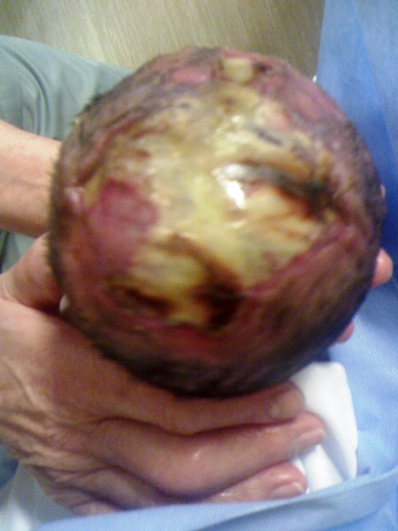
Figure 1 Aplasia cutis congenita of scalp in a newborn.

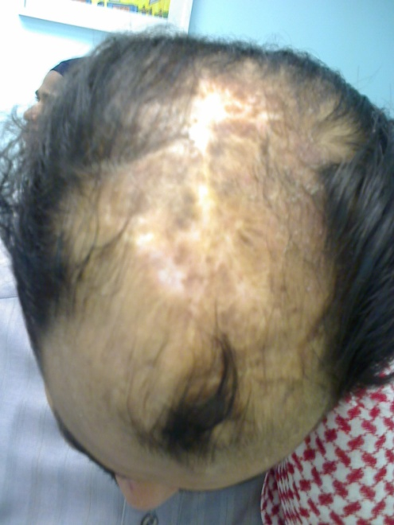
Figure 2 Post-aplasia cutis congenita of scalp with residual hypopigmentation in father.
Discussion
Aplasia cutis congenita (ACC) is an uncommon heterogeneous group of conditions characterized by a congenital absence of skin.^{1,2} This condition was first described by Cordon in 1767 in an extremity. In scalp it was first reported by Campbell in 1826, and Billard in 1828, reported scalp involvement with an underlying skull
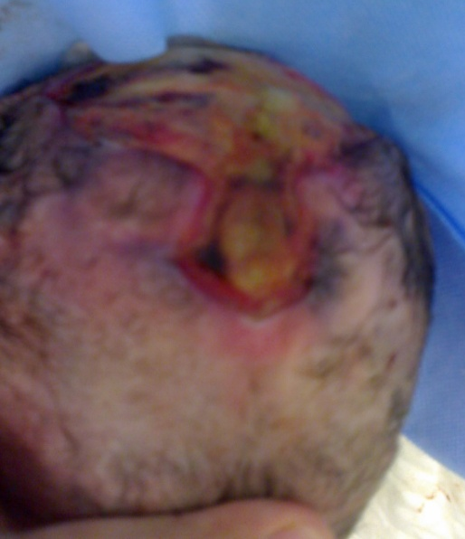
Figure 3 Same patient as in Figure 1 at 12 days of age with well demarcated lesion over vertex.
defect and since then approximately 500 cases have been reported with an estimated incidence of 3 in 10,000 births.² Underlying bone defects are also found in approximately 20% of cases, and this probability increases as the size of lesion increases.²
Etiology remains uncertain and there is no single definite theory that can account for all the lesions of ACC and it is likely that multiple factors may be involved.² Hereditary factor seems to be one of the possible mechanisms as multiple reports of clusters or cases in the same family pedigree are found in literature.³⁻⁶ The disease may be transmitted in an autosomal dominant or recessive manner or on occasion as an X-linked disease. Other proposed etiologies include teratogenic effect of drugs like methimazole,⁷ carbimazole, misoprostol, methotrexate, angiotensin-converting enzyme inhibitors benzodiazepines, low molecular weight heparin⁸ and sodium valproate, arrested skin development in embryonic life, an intrauterine vascular compromise (e.g. by placental infarcts or solitary umbilical artery), intrauterine trauma, premature rupture of amniotic membranes or amniotic bands. Fetus papyraceous is also associated with bilaterally symmetric aplasia cutis. The patient may have other associated anomalies⁹ which include cleft lip and/or palate, abnormal ears, hydrocephalus, cranial/spinal malformations, microphthalmus, congenital heart disease, tracheo-esophageal fistula, omphalocele, anorectal malformation, renal malformation (agenesis, polycystic kidneys), duplication of cervix or uterus, vascular anomalies, nail aplasia or dysplasia, digital anomalies, simian creases, Goltz syndrome (focal dermal hypoplasia), trisomy 13, intestinal lymphangiectasia and pyloric atresia.
Familial variants of ACC may occur as an isolated defect or in association with other physical anomalies. Yagci-Kupeli et al.³ reported autosomal dominant aplasia cutis in three generations and one of the cases (last generation) had preaxial polydactyly. Tan and Tay⁴ reported three cases of ACC of the scalp affecting two siblings and their mother but none of the cases had any associated anomaly like the presented case report. Baselga et al.⁵ reported six families in whom more than one member had non-membranous aplasia cutis congenita of the scalp located along the vertex. Dallapiccola et al.⁶ reported aplasia cutis congenita (ACC) in the midline of the scalp vertex in mother and son with associated coarctation of the aorta.
The diagnosis is usually made by clinical assessment. Histopathological features are distinct¹⁰ and include absent/thin epidermis, weak dermis consisting of loosely arranged collagen bundles and thin subcutis. Dermal papillae and elastic fibers are absent and blood vessels are maldeveloped. The diagnosis can also be suspected in antenatal period if ultrasonography is normal in presence of the raised α-fetoprotein level in amniotic fluid and maternal blood or a positive acetyl -cholinesterase test.⁹ Differential diagnoses include epidermolysis bullosa, focal dermal hypoplasia syndrome, neonatal herpes, fetal varicella and transient bullous dermolysis of the newborn. These lesions might be mistakenly attributed to birth trauma secondary to vacuum extraction, forceps or fetal scalp monitor electrodes and there is need of proper counseling of the parents to avoid litigations.
Management depends on the size, location and depth of the lesion over the scalp. Small superficial lesions are managed conservatively¹⁰ by moist dressings (povidone-iodine, bacitracin, or silver sulfadiazine) and recovery is usually uneventful, with gradual epithelialization over several weeks and formation of a hairless, atrophic scar. Small underlying bony defects usually close spontaneously by the end of first year of life. However, various complications can occur during conservative treatment which can lead to mortality of 20-30%.⁹ These include life-threatening hemorrhage, meningitis, secondary infections, and electrolyte disturbances. After spontaneous healing, the area may be left with cosmetic defects like hypertrophy/atrophy, hyper/hypopigmentation, alopecia, scars and contractures. Larger lesions with dural or bony involvement require plastic surgical reconstruction with various methods include skin and bone grafts, flaps (local/free), or tissue expansion.⁹
Acknowledgement
I express my gratitude to the father of the patient for allowing me to use the case history and images for academic purposes.
References
- Zhou J, Zheng L, Tao W. Systemic aplasia cutis congenita: A case report and review of the literature. Pathol Res Pract. 2010;206:504-7
- Moros Pena M, Labay Matias M, Valle Sanchez F et al. Aplasia cutis congenita in a newborn: etiopathogenic review and diagnostic approach. An Esp Pediatr. 2000;52:453-6.
- Yagci-Kupeli B, Çaglar K, Buyuk S, Balci S. Autosomal dominant aplasia cutis in three generations and one case with preaxial polydactyly in the last generation. Genet Couns. 2011;22:55-61.
- Tan HH, Tay YK. Familial aplasia cutis congenita of the scalp: a case report and review. Ann Acad Med Singapore. 1997;26:500-2.
- Baselga E, Torrelo A, Drolet BA et al. Familial nonmembranous aplasia cutis of the scalp. Pediatr Dermatol. 2005;22:213-7.
- Dallapiccola B, Giannotti A, Marino B et al. Familial aplasia cutis congenita and coarctation of the aorta. Am J Med Genet. 1992;43:762-3.
- Karg E, Bereg E, Gaspar L et al. Aplasia cutis congenita after methimazole exposure in utero. Pediatr Dermatol. 2004;21:491-4
- Sharif S, Hay CR, Clayton-Smith J. Aplasia cutis congenita and low molecular weight heparin. BJOG 2005;112:256-8.
- Işçimen A, Yardımcı G. Aplasia cutis congenita. J Turk Acad Dermatol 2010;4(2):04201r.
- Skoufi G, Lialios G, Plachouras N et al. Aplasia cutis congenita: Successful conservative treatment. Pediatr Int. 2006;48:507-9.

