PhotoDermDiagnosis
A brownish red facial plaque
Shahbaz A. Janjua

Specialist Dermatologist, Ayza Skin & Research Center, Lalamusa

A middle-aged woman presented with an asymptomatic large brownish red plaque on the right side of the face, and the right ear lobe which developed from a small papule over a period of ten years. Physical examination revealed a large well demarcated brownish red plaque involving the right side of the face, angle of the jaw, the submandibular area, and the pinna of the right ear (Figure 1). On palpation, the plaque was smooth surfaced, non-tender and soft in consistency. There was no family history of similar dermatosis. The patient had been prescribed multiple drugs including oral antibiotic and topical steroids for the treatment of the lesion by a few GPs but the lesion did not respond and kept on slowly progressing and extending to involve the adjacent area over time. Histopathologic examination of a biopsy specimen revealed multiple granulomas surrounded by chronic inflammatory cells and central necrosis.

Address for correspondence
Dr. Shahbaz Janjua
Teledermatology Unit,
Ayza Skin & Research Center, Lalamusa, Pakistan 50200
Email: shahbaz.janjua@telederm.org

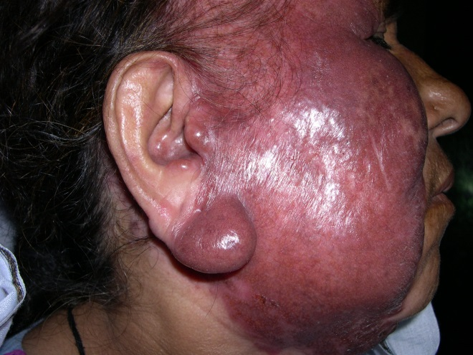Figure 1 A large brownish red smooth surfaced plaque involving the right side of the face, ear, and the submandibular area.
Considering the clinical and histopathologic findings, what is your diagnosis?

Diagnosis
Lupus vulgaris
Discussion
Lupus vulgaris (LV) is the most common form of cutaneous tuberculosis (CT) that develops in individuals with moderate immunity but high tuberculin sensitivity.¹ LV is a paucibacillay form of postprimary tuberculosis which develops from an endogenous source by hematogenous or lymphatic route. Females are affected two to three times more often than males. The lesions are usually solitary in most of the cases, but multiple sites may be involved especially in patients with active pulmonary tuberculosis. LV most commonly affects the head and neck areas.² It starts as a small brownish macule or a smooth surfaced soft papule and progresses extremely slowly to form a plaque.³ On diascopy, a typical apple jelly colour is characteristic. A gyrate outline pattern is because of involution in one area and progression in another. The plaque may ulcerate. The cartilages of the nose or ear may also be affected with subsequent destruction and mutilation.^{4,5} The adjacent mucosa may get involved because of the extension of the primary lesion.
The histopathologic examination reveals typical tubercles but acid fast bacilli are usually absent. Secondary changes include epidermal thinning and atrophy or acanthosis with hyperkeratosis and pseudoepitheliomatous hyperplasia.¹
The diagnosis is based on characteristic clinical presentation, apple jelly nodules on diascopy, and strongly positive tuberculin test. Bacterial cultures may be negative but PCR results for Mycobacterium tuberculosis are positive.¹
LV may run an extremely chronic course without therapy. Longstanding LV may become complicated with squamous or basal cell carcimomas.^{6,7} About 10 to 20 percent of the patients have active pulmonary tuberculosis or tuberculosis of bones and joints.¹
LV is treated with antituberculous drugs similar to tuberculosis of any other organ. Localized forms of LV with no evidence of internal tuberculosis have been treated with Isoniazid alone for 12 months. Small lesions of LV may be excised. Corrective measures and plastic surgery are required for the mutilation caused by longstanding LV.^{1,4}
References
- Wang H, Wu Q, Lin L, Cui P. Cutaneous tuberculosis: a diagnostic and therapeutic study of 20 cases. J Dermatolog Treat. 2011;22:310-4.
- Kaimal S, Aithal V, Kumaran MS, Abraham A. Cutaneous tuberculosis of the pinna: a report of two cases. Int J Dermatol. 2013;52:714-7.
- Neila J, Ferrandiz L, Moreno-Ramirez D, Camacho Martinez F. Lupus vulgaris diagnosed 62 years after onset. Eur J Dermatol. 2011;21:995-6.
- Ghosh SK, Bandyopadhyay D, Ghoshal L. Facial swelling and ulceration with nasal destruction. Cleve Clin J Med. 2011;78:289-90.
- Behera B, Devi B, Patra N. Mutilating lupus vulgaris of face: an uncommon presentation. Indian J Dermatol Venereol Leprol. 2010;76:199-200.
- Kate MS, Dhar R, Borkar DB, Ganbavale DR. Longstanding lupus vulgaris with basal cell carcinoma. Indian J Pathol Microbiol. 2009;52:588-90.
- Ljubenovic MS, Ljubenovic DB, Binic II et al. Cutaneous tuberculosis and squamous-cell carcinoma. An Bras Dermatol. 2011;86:541-4.

