consistent with psoriasis. We prescribed clobetasol-salicylic acid 6% ointment to the patient along with levocetirizine. After two months of treatment, the thickness has subsided and the itching has stopped.
Some consider nevoid psoriasis to be either synonymous with inflammatory linear verrucous epidermal nevus (ILVEN) or an invasion of pre-existing epidermal nevus by psoriasis due to koebnerisation.^{1,2,3} In linear psoriasis and nevoid psoriasis, lesions are clinically and histologically similar in appearance but the former is present as linear configuration, the latter is distributed in specific band like zones of the skin (the lines of Blaschko).⁴ Nevoid psoriasis probably reflects mosaicism for a gene responsible for psoriasis. In our patient, there was no seasonal variation the size of the lesion, no psoriasiform scaling was present but Auspitz sign was positive. There was no response with the application of mid-potent topical steroids alone but there was response to application of clobetasol-salicylic acid ointment. The lesion clinically looked like ILVEN but histopathology was consistent with psoriasis. We are reporting the case because of its rarity.
References
- Bondi EE. Psoriasis overlying an epidermal nevus. Arch Dermatol. 1979;115:624-5.
- Bolognia JL, Orlow SJ, Glick SA. Lines of Blaschko. J Am Acad Dermatol. 1994;31:157-90.
- Goujon C, Pierini AM, Thivolet J. Does linear psoriasis exist? Ann Dermatol Venereol. 1981;108:643-50.
- Atherton DJ, Kahana M, Russel Jones R. Naevoid psoriasis. Br J Dermatol. 1989;120:837-41.
Satyendra Kumar Singh, Tulika Rai

Department of Dermatology and Venereology, I.M.S, B.H.U. Varanasi-221005, UP, India

Correspondence Address
Dr. Tulika Rai,
Department of Dermatology and Venereology, I.M.S, B.H.U. Varanasi-221005, U.P. India
E-mail: raitulika@gmail.com

Xeroderma pigmentosum associated with unusual squamous cell carcinoma-report of two cases
Sir, xeroderma pigmentosum (XP) is a rare autosomal recessive disease characterized by photosensitivity, pigmentary changes, premature skin ageing, neoplasia and abnormal DNA repair. There may be neurological abnormalities in some cases. Malignant tumors may develop as early as third or fourth year. We report two cases of XP associated with squamous cell carcinoma (SCC).
A 35-year-old housewife, born of second degree consanguineous marriage, presented with history of photosensitive skin disorder since early childhood associated with photophobia, blurring of vision and history of painless mass over the inner side of the right eye since one year. Her general physical examination and systemic examination were unremarkable. Cutaneous examination revealed poikilodermatous changes involving almost entire skin surface. Examination of her right eye revealed a reddish, non-ulcerated, firm to hard mass, fixed to the underlying structures, arising from the medial aspect of bulbar conjunctiva measuring five centimeters (Figure 1) in diameter. It was associated with foul smelling yellowish purulent discharge. Cornea of the left eye was opaque. There was complete loss of vision in the right eye and the visual acuity in the left eye was
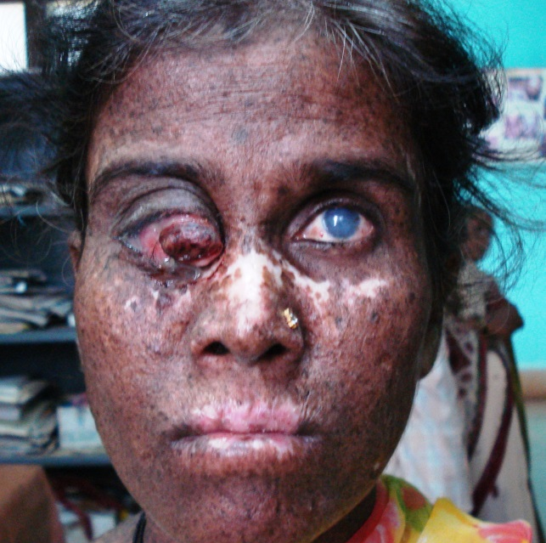
Figure 1 Mass in the right eye and corneal opacity in the left eye (case 1).

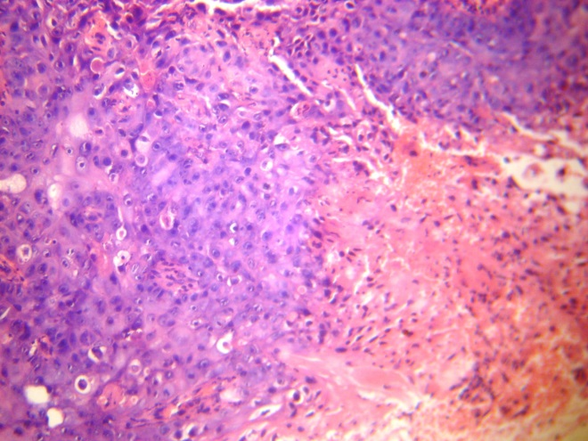
Figure 2 Photomicrograph showing moderately differentiated squamous cell carcinoma.

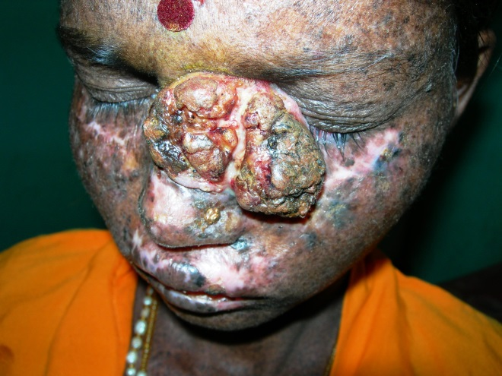
Figure 3 Mass over the left cheek and nose (case 2).
6/36. There was no lymph node enlargement. Routine investigations were normal. Histopathological examination of the biopsy revealed moderately differentiated SCC (Figure 2).
Our second case, a thirty year old, housewife, borne of second degree consanguineous marriage, presented to us with history of photosensitive disorder and photophobia since early childhood and a mass over the inner aspect of the left cheek extending to the nose and left eye since six months. Patient complained of difficulty in opening the left eye. Her general physical examination and systemic examinations were normal. Cutaneous examination revealed poikilodermatous changes over most of the body surface. There was a hard, fixed, brownish to skin coloured, verrucous plaque, measuring 10x8 cm, extending from right side of the upper part of the nose to maxillary prominence on the left cheek horizontally and midpoint of the nose to the left eye brow vertically (Figure 3). There was no ulcer over the surface of the mass. The margin was smooth and not rolled out. There was no tenderness or bleeding on touch. There was no lymph node enlargement. Histopathological examination of the biopsy revealed well differentiated SCC.
The mass was excised in both of our patients and they were advised sunscreen, avoidance of sunlight exposure and wearing protective clothing and goggles. They were put on isotretinoin capsules 1mg/kg/day after proper counseling.
Photophobia is the earliest symptom of XP which is due to keratitis, exposure keratitis, vascularization, ulceration, nodular dystrophy and uveitis.² In a Turkish case series, nine out of 12 patients had SCC.³ In another study, 33.9% of 120 patients with XP had SCC and ocular tumors were seen in 25.8% of patients.⁴ Our first patient had SCC arising from the bulbar conjunctiva which must be very rare. In a case report, a seven year old boy with XP and a large SCC of the cheek received a combination of isotretinoin (1 mg/kg/day) and chemotherapy for a period of 3 months and showed complete remission of the tumor.⁵ We resorted to surgical treatment in our cases because there were no secondaries and initiated isotretinoin therapy (1mg/kg/day) for prevention of development of fresh tumors. Our patients did not have metastasis probably because they presented to us early in the course of the malignancies.
References
- Harper JI. Genetics and genodermatoses. In: Champion RH, Burton JL, Burns DA, Breathnach SM, editors. Rook’s Textbook of Dermatology, 6th edn. London: Blackwell Science; 1998. P.407-11.
- Pathy S, Naik KK, Suman B et al. Squamous cell carcinoma of the face with xeroderma pigmentosa - a case report. Indian J Med Paediatr Oncol. 2005;26:47-9.
- Gul U, Kilic A, Gonul M et al. Xeroderma pigmentosum: a Turkish case series. Int J Dermatol. 2007;46:1125-8.
- Moussaid L, Benchikhi H, Boukind EH et al. Cutaneous tumors during xeroderma pigmentosum in Morocco: study of 120 patients. Ann Dermatol Venereol. 2004;131:29-33.
- Saade M, Debahy ESN, Houjeily S. Clinical remission of xeroderma pigmentosum-associated squamous cell carcinoma with isotretinoin and chemotherapy: case report. J Chemother. 1999;11:313-7.

Pradeep Vittal Bhagwat*, Chandramohan Kudligi*, BM Shashikumar**, Mohan Eshwara Rao Shendre*, B Suphala*

*Department of Skin & STD, Karnataka Institute of Medical Sciences, Hubli, Karnataka
**Department of Skin & STD, Mandya Institute of Medical Sciences, Mandya, Karnataka

Address for correspondence
Dr. PV Bhagwat,
Associate Professor, Department of Skin & STD, Karnataka Institute of Medical Sciences, Hubli, Karnataka, India
E-mail: sharadapbhagwat@yahoo.com
Phone: 09880084769, 09986155070

Trichostasis spinulosa: case report
A 46-year-old female patient presented to our clinic for itching and ulcers under her breast. On dermatological examination, there were two erythematous, papulonodular lesions 1 cm diameter under the breast and multiple, slightly raised and slightly pigmented follicular lesions (Figure 1). Otherwise her medical and family history was unremarkable. Systemic examination was normal. Her hemogram, urea, creatinine and urine tests were normal. ESR was 26mm/hour and CRP 0.79mg/dl. Fasting blood glucose (155mg/dl), AST (54 U/L), ALT (94 U/L) levels were raised. She was diagnosed as a case of trichostasis spinulosa along with pyoderma.
Since the patient had no complaints in terms of trichostasis spinulosa lesions, treatment was not advised. Local treatment was started for pyoderma.
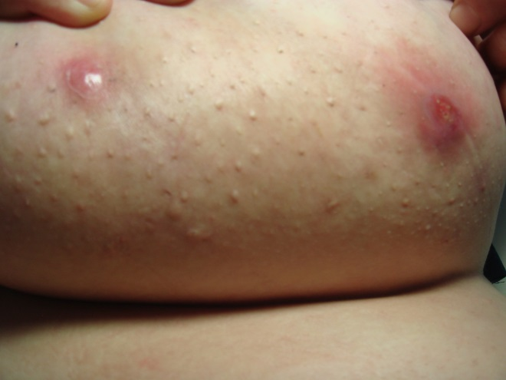
Figure 1 Multiple skin-coloured papules and two ulcerated papulonodules under the left breast.

