Short Communication

A rare case of nevoid psoriasis
Sir, a 16-year-old boy presented in skin OPD with an itchy, plaque on the dorsal aspect of right hand on the lateral side for a duration of twelve years. The lesion started as a small, raised, thick plaque which gradually increased in size to acquire the present size. The patient had applied mid-potent topical corticosteroids in the past but there was no relief. There was no seasonal variation on the growth of the lesion. On examination, brown-coloured, verrucous plaque involving the dorsal aspect of index finger and thumb extending to involve the lateral part of dorsum of hand up to the wrist joint was present. There was mild scaling on the plaque and Auspitz sign was positive (Figure 1). There was no similar lesion elsewhere on the body. Nail and mucosae examination were within normal limit. We kept the differential diagnosis of inflammatory linear verrucous epidermal nevus and linear psoriasis and sent a skin biopsy for histopathologic examination.
Skin biopsy showed moderately dense superficial perivascular infiltrate of lymphocytes
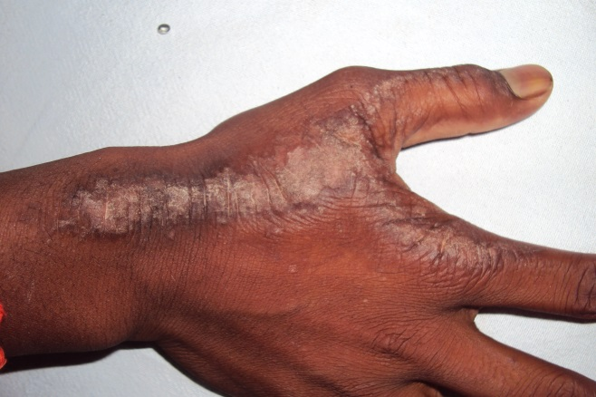Figure 1 Clinical photograph showing the verrucous plaque on the dorsal aspect of right hand.
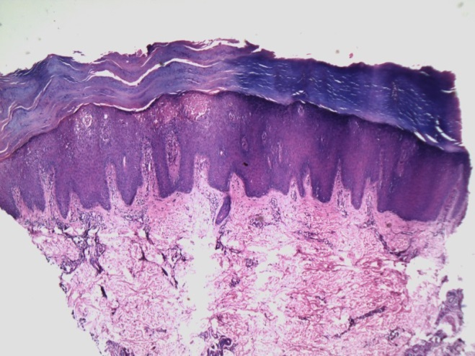 Figure 2 Histopathology showing thick stratum corneum, with foci of parakeratosis and collections of neutrophils, dense superficial perivascular infiltrate of lymphocytes and neutrophils with psoriasiform changes in the epidermis, edematous papillary dermis with dilated and tortuous vessels [H & E X100].

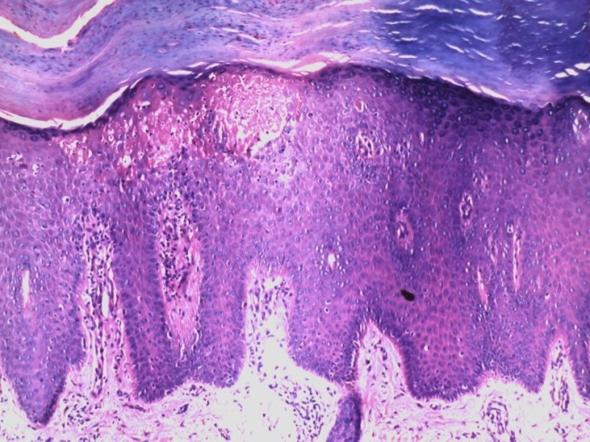 Figure 3 Histopathology showing thick stratum corneum, with foci of parakeratosis and collections of neutrophils, dense superficial perivascular infiltrate of lymphocytes and neutrophils with psoriasiform changes in the epidermis, edematous papillary dermis with dilated and tortuous vessels [H & E X400].
and neutrophils with moderate psoriasiform changes in the overlying epidermis. The papillary dermis was edematous and showed dilated and tortuous vessels. The granular layer was thinned in places. The stratum corneum was thick and compact with foci of parakeratosis in tiered pattern with collections of neutrophils (Figure 2 and 3). The histopathology was consistent with psoriasis. We prescribed clobetasol-salicylic acid 6% ointment to the patient along with levocetirizine. After two months of treatment, the thickness has subsided and the itching has stopped.
Some consider nevoid psoriasis to be either synonymous with inflammatory linear verrucous epidermal nevus (ILVEN) or an invasion of pre-existing epidermal nevus by psoriasis due to koebnerisation.^{1,2,3} In linear psoriasis and nevoid psoriasis, lesions are clinically and histologically similar in appearance but the former is present as linear configuration, the latter is distributed in specific band like zones of the skin (the lines of Blaschko).⁴ Nevoid psoriasis probably reflects mosaicism for a gene responsible for psoriasis. In our patient, there was no seasonal variation the size of the lesion, no psoriasiform scaling was present but Auspitz sign was positive. There was no response with the application of mid-potent topical steroids alone but there was response to application of clobetasol-salicylic acid ointment. The lesion clinically looked like ILVEN but histopathology was consistent with psoriasis. We are reporting the case because of its rarity.
References
- Bondi EE. Psoriasis overlying an epidermal nevus. Arch Dermatol. 1979;115:624-5.
- Bolognia JL, Orlow SJ, Glick SA. Lines of Blaschko. J Am Acad Dermatol. 1994;31:157-90.
- Goujon C, Pierini AM, Thivolet J. Does linear psoriasis exist? Ann Dermatol Venereol. 1981;108:643-50.
- Atherton DJ, Kahana M, Russel Jones R. Naevoid psoriasis. Br J Dermatol. 1989;120:837-41.
Satyendra Kumar Singh, Tulika Rai

Department of Dermatology and Venereology, I.M.S, B.H.U. Varanasi-221005, UP, India

Correspondence Address
Dr. Tulika Rai,
Department of Dermatology and Venereology, I.M.S, B.H.U. Varanasi-221005, U.P. India
E-mail: raitulika@gmail.com

Xeroderma pigmentosum associated with unusual squamous cell carcinoma-report of two cases
Sir, xeroderma pigmentosum (XP) is a rare autosomal recessive disease characterized by photosensitivity, pigmentary changes, premature skin ageing, neoplasia and abnormal DNA repair. There may be neurological abnormalities in some cases. Malignant tumors may develop as early as third or fourth year. We report two cases of XP associated with squamous cell carcinoma (SCC).
A 35-year-old housewife, born of second degree consanguineous marriage, presented with history of photosensitive skin disorder since early childhood associated with photophobia, blurring of vision and history of painless mass over the inner side of the right eye since one year. Her general physical examination and systemic examination were unremarkable. Cutaneous examination revealed poikilodermatous changes involving almost entire skin surface. Examination of her right eye revealed a reddish, non-ulcerated, firm to hard mass, fixed to the underlying structures, arising from the medial aspect of bulbar conjunctiva measuring five centimeters (Figure 1) in diameter. It was associated with foul smelling yellowish purulent discharge. Cornea of the left eye was opaque. There was complete loss of vision in the right eye and the visual acuity in the left eye was

