Case Report
Wells syndrome in a diabetic patient
Eapen Thomas, Sheela Kuruvila, Satyaki Ganguly

Department of Dermatology, Venereology & Leprosy, Pondicherry Institute of Medical Sciences, Kalapet, Pondicherry, India

Abstract | Wells syndrome or eosinophilic cellulitis is a rare condition, primarily a disease of adults. It is characterized by edematous and erythematous plaques with violaceous borders persisting for weeks. Here, we describe a rare case of Wells syndrome occurring in a 51-year-old diabetic lady associated with a dental abscess. She was admitted with complaints of recurrent episodes of raised skin lesions on the body for the last two years. Patient also gave history of toothache with swelling of gums on and off since the last 2 years A skin biopsy was done from a raised lesion on the back which was consistent with eosinophilic cellulitis The patient was put on prednisolone 40mg daily along with ranitidine, calcium and oral hypoglycemics. She underwent tooth extraction for recurrent dental abscesses in the dental OPD. Our patient had dental abscess, a known predisposing factor. The association with diabetes mellitus is another unique feature, rarely reported before.  Key words  Wells syndrome, eosinophilic cellulitis.

Introduction
Wells syndrome or eosinophilic cellulitis is a rare condition, primarily a disease of adults. It is characterized by edematous and erythematous plaques with violaceous borders persisting for weeks. Here, we describe a rare case of Wells syndrome occurring in a diabetic lady associated with a dental abscess.
Case report
A 51-year-old lady was admitted with complaints of recurrent episodes of raised skin lesions on the body for the last two years. She developed tingling sensation over the fingers and toes of both hands and feet two years back, which gradually progressed to involve the palms and soles, associated with itching. Later she noticed swelling of the face and scalp along with raised lesions on the upper limb, trunk and abdomen. These were asymptomatic, persisted for several days and subsided only after taking some injections form local hospital. Episodes of these lesions continued for 2 years. Patient also gave history of toothache with swelling of gums on and off for the last 2 years.
Patient gave history of taking native medications six months back following which she developed blackish discoloration over the face, neck and to a lesser extent over the trunk. There was no history of fever or pain associated with the skin lesions.
On examination, there was diffuse edema over the face, more prominent over the periorbital regions. Multiple erythematous, infiltrated, well-defined, asymmetrical plaques with normal sensation were seen over the neck, forearms, arms, chest, abdomen,
Address for correspondence
Dr. Eapen Thomas
Department of Dermatology Venereology & Leprosy,
Pondicherry Institute of Medical Sciences, Kalapet, Pondicherry, 605014 India
E mail- eapenthomas10@gmail.com
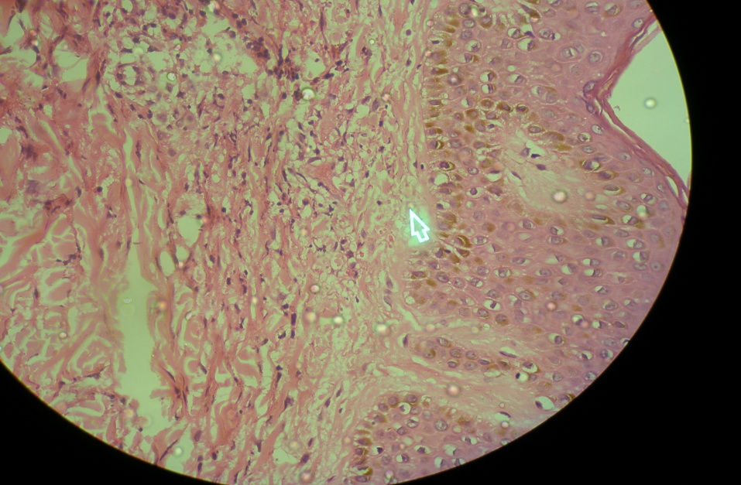
Figure 1 Characteristic flame figures and eosinophils.

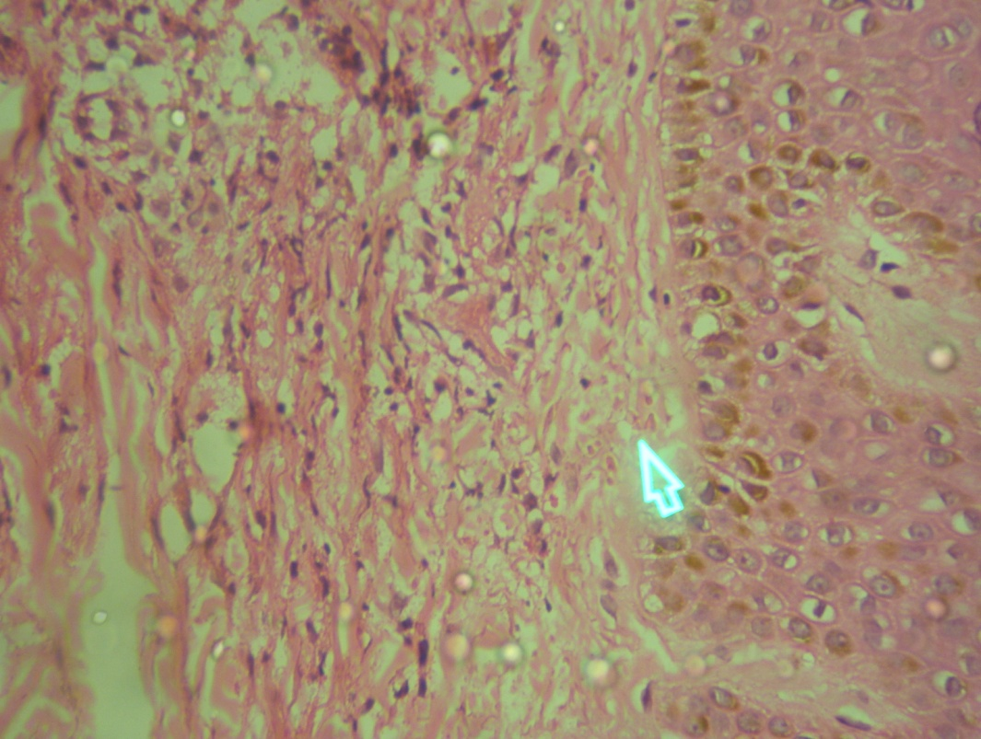
Figure 2 Closeup view of flame figures in the dermis.
lower back and buttocks. Diffuse hyperpigmentation was noticed over the face and neck. Hyperpigmented, scaly plaques were seen on the dorsal aspect of both hands and feet. General and systemic examination failed to reveal any abnormality.
On investigation she had a high leucocyte count (33,000/mm³) with eosinophilia (35%), ESR was 41mm/1st hour. Her fasting blood sugar, postprandial blood sugar and HbA₁C values were 163mg/dl, 263mg/dl and 8.8%, respectively. The urine examination was normal. A skin biopsy was done from a raised lesion on the back. Histopathology showed large number of eosinophils infiltrating into the epidermis with “flame figures” (Figures 1 and 2) and dermal edema. Therefore, a diagnosis of Wells syndrome in a diabetic patient was made. The patient was put on prednisolone 40mg daily along with ranitidine, calcium and oral hypoglycemics. She underwent tooth extraction for recurrent dental abscesses in the dental OPD.
Discussion
Wells syndrome is characterized by a clinical picture resembling cellulitis and a typical histology showing tissue eosinophilia, edema and flame figures.¹ It usually occurs in adults. Initially the lesions appear as itchy erythematous plaques with features resembling both urticaria and cellulitis. After a week or two they flatten and go through a colour change before resolving without any scarring.² Etiologically whether Well’s syndrome is a specific entity or merely a reaction pattern is difficult to discern. A number of conditions have been associated with Wells syndrome like arthropod bites, myeloproliferative disease, colon cancer, Churg-Strauss syndrome, dental abscess, herpes simplex infection, onchocerciasis, drug reactions etc.^{1,2,3} Peripheral blood eosinophilia is observed in approximately 50% of the patients. Histologically it is characterized by diffuse dermal infiltration with eosinophils, histiocytes and foci of amorphous and/or granular material associated with connective tissue fibers (flame figures).
This is a rare disease with reports being few and far between. The hyperpigmentation and paresthesia in our patient have been described in Wells syndrome.^{2,4} Our patient had dental abscess, a known predisposing factor. The association with diabetes mellitus is another unique feature, rarely reported before.⁵
References
- Chaudhary A, Aswani V, Malkani R. Wells’ syndrome. Indian J Dermatol Venereol Leprol. 1997;63:117-9.
- Rousseau L, Beylot-Barry M, Vergier B et al. Guess what? Wells' syndrome. Eur J Dermatol. 1999;9:61-2.
- Renner R, Kauer F, Treudler R et al. Eosinophilic cellulitis (Wells' syndrome) in association with angioimmunoblastic lymphadenopathy. Acta Derm Venereol. 2007;87:525-8.
- Cashin B, Allan N, Kang C. Wells syndrome. West J Emerg Med. 2010;11:95-6.
- Sharma PK, Gautam RK, Sharma AK. Eosinophilic cellulitis - A case study and management with griseofulvin. Indian J Dermatol Venereol Leprol. 1995;61:163-4

