Case Report
Case report of a histoid leprosy patient
Ali Ebrahimi, Mazaher Ramazani, Ahmed Faramarzi, Seiedreza Seidmohammaddoulabi, Hossein Kavoussi

Dermatology Department, Kermanshah University of Medical Science, Kermanshah

Abstract | Histoid leprosy is one of the rare kinds of lepromatous leprosy with specific clinical pathologic manifestations. It is most commonly observed in patients who have been under long-term single drug therapy with dapsone. Clinical manifestations mostly consist of red papules and nodules and pathologic examination there are spindle like histiocytes. Following acid-fast staining, abundant bacilli can be seen. Significance of these patients is due to their rarity, atypicality of dermal lesions, failure in early diagnosis, and high bacillus load which can be a barrier in the eradication of the disease and act as a potential source of infection in areas where the disease has been eradicated. Our case showed up with plentiful dermal papules and nodules from two years ago which caused no discomfort. He had a history of leprosy 25 years ago and had been treated only with dapsone for 3 years. Therefore, the diagnosis of histoid type lepromatous leprosy was made and confirmed based on clinical and histopathological findings.  Key words  Histoid leprosy, Mycobacterium leprae, dapsone.

Introduction
Leprosy is a chronic granulomatous infection with permanent consequences which is caused by Mycobacterium leprae and primarily involves skin and nerves.¹ Clinically leprosy presents as a spectrum of manifestations consisting of two constant poles from polar tuberculoid (TT) to polar lepromatous (LL) disease. Polar tuberculoid (TT) disease is related with high cellular immunity that is signified with less than 5 (mostly one) lesions and a very few number of organisms (paucibacillay). In polar lepromatous (LL) disease, with a limited immunity against the organism, dermal lesions are more in number and there are a lot of organisms (multibacillary). There are types of more common infections, between the two poles, which constitute borderline type.²
Address for correspondence
Dr. Hossein Kavoussi,
Hajdaiee Clinic of Dermatology,
Kermanshah University of Medical Science, Golestan Bloulevard, Kermanshah, Iran
Email: hkawosi@kums.ac.ir
Histoid leprosy is s specific and relatively lasting type of multibacillary leprosy with specific clinical, bacteriologic, and histopathological findings and its pathogenesis is still unknown. Most of the patients have taken long-term single drug therapy with diaminodiphenylsulfone and have shown recurrence after a primary remission.³
The clinical manifestations include numerous, skin to yellowish-brown colored, plane, painless, and firm nodules observed over apparently normal skin. The nodules may affect face, back, limbs, and the skin over bony prominences and in very severe cases, mucous membranes may be affected too.⁴ Sometimes the disease presents with unusual clinical findings.⁵⁻⁹
Our patient had leprosy 25 years ago and had been treated with only dapsone for three years. The disease recurred with gradually appearing papules and nodules 2 years ago. The diagnosis of histoid leprosy was confirmed considering the history and clinical and histopathological findings.
Case report
The patient was a 54-year-old man who showed up in our clinic with multiple dermal lesions causing no discomfort for last two years. The lesions had afflicted the trunk primarily and had then extended to upper and lower extremities. The patient denied past history of any disease or medicine intake at first, but it turned out that the patient had had leprosy 25 years ago and had taken dapsone as single drug therapy for three years with apparent remission. There were no changes in sensory status in the history.
On physical examination, there were numerous erythematous papules, plaques, and nodules which were rather firm with no tenderness on forearms, elbows, thighs, thorax, abdomen, and back of the patient (Figures 1 and 2). There was also subtle thickening of the ulnar nerves. Routine hematologic laboratory tests were normal. Smears and biopsies of dermal lesions were taken simultaneously. Direct smear for
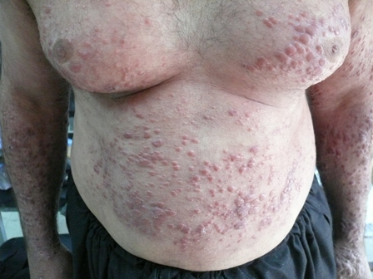
Figure 1 Multiple papules and nodules in chest abdomen and upper extremity
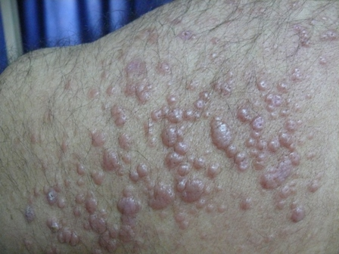
Figure 2 Closeup view of skin lesions.

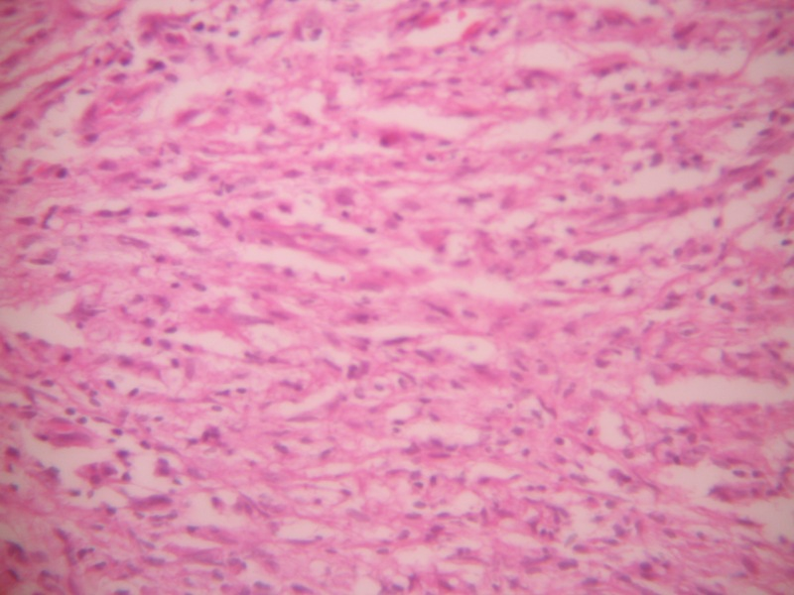
Figure 3 Spindle like histiocyte bundle .

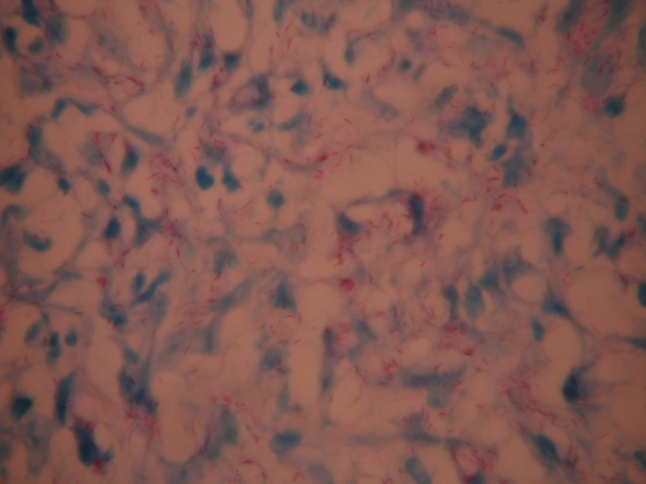
Figure 4 Ziehl-Neelsen staining of multiple AFB bacilli
acid-fast bacilli was positive with a 5+ bacterial index and 50-60% morphologic index.
Histopathological examination showed significant epidermal atrophy and significant grenz zone and bundles of thin spindle like histiocytes with vortex arrangements with pyknotic nuclei and foamy cytoplasm were observed in the dermis (Figure 3). Ziehl-Neelsen staining showed plentiful bacilli (Figure 4). The diagnosis of histoid leprosy was confirmed considering the history and clinical and histopathological findings.
Discussion
Histoid leprosy is a rare type of lepromatous leprosy which has a prevalence of 2.79% to 3.6% among Indian leprosy patients.¹⁰ This kind of leprosy is mostly diagnosed in patients who have taken long-term single drug therapy of dapsone.⁴ Some cases, however, may follow multiple drug therapy.^{11,12} In recent studies, most of these patients have not been treated for leprosy.^{13,14}
Histoid leprosy has specific clinical, histological findings and bacterial morphology. Immunohistological findings show a change in cellular hyperactivity reaction which leads to an inhibition in bacilli destruction in histoid lesions.¹⁵
Dermal lesions include dermal and subdermal, firm, oval or dome-shaped, red or skin-coloured nodules and plaques over an apparently normal skin. These lesions have regular pattern and the overlying skin is shiny and stretched.⁴ However, in some cases histoid leprosy presents as xanthomatous eruption,⁵ lesions similar to molluscum contagiosum,⁶ umbilicated lesions,⁷ tuberous xanthomatous dermal manifestations,⁸ and gigantic dermal lesions.⁹ Men are more commonly involved. Common areas in order of affliction are thighs and buttocks, arms, back, face, forearms, and legs.¹⁴
Three pathological patterns of histoid leprosy include: pure fusocellular, fusocellular with epithelioid components, and fusocellular with vacuolated cells (the most common pattern). There are plentiful bacilli in histoid form with less tendency to globi formation. Fernandez-Mitsuda reaction is not observed.³
Considering the high load of bacillus in histoid leprosy, these patients are potential source of infections especially in the areas where the disease has been eradicated.¹⁴ As such, histoid type of disease can be a big barrier in eradication of leprosy.¹⁶
Our patient had lesions typical for histoid leprosy who denied a history of leprosy at first. After hematoxylin-eosin staining of tissue specimen, fibrohistiocytoma was considered as a possible diagnosis but direct smear, acid-fast staining of tissue specimen, and physical findings confirmed the diagnosis of histoid leprosy.
The significance of such patients includes their rarity, unusual dermal lesions, specific pathologic findings, failure to diagnose the primary disease, high bacillary load which can be a barrier for eradication of leprosy, and being potential reservoir of infection especially in societies where the disease has been eradicated.
References
- Rea HR, Modlin RL. Leprosy. In: Wolff K, Lowell AG, Goldsmith LA et al., editors. Fitzpatrick’s Dermatology in General Medicine, Vol 2. 7th ed. New York: McGraw-Hill; 2008. P.1786-96.
- James WD, Berger TG, Elston DM, editors. Andrew’s Disease of the Skin Clinical Dermatology, 10 Ed. Philadelphia: Saunders; 2006. P. 343-52.
- Sehgal VN, editor. Clinical Leprosy. 4th ed. New Delhi: Jaypee Brothers;2004. P.54-7.
- Sehgal VN, Srivastava G. Histoid leprosy. Int J Dermatol. 1985;24:286-92.
- Monga P, Mehta V, Balachandran C, Mathew M. Wade histoid leprosy as eruptive xanthomas. Dermatol Online J. 2008;14:21.
- Mohan L, Bhatia PS, Nigam P et al. Molluscum contagiosum type lesion in histoid leprosy. J Indian Med Assoc. 1992;90(4):106.
- Sharma AK. Umbilicated lesion in histoid leprosy. Int J Lepr Other Mycobact Dis. 1997;65:101-2.
- Thappa DM, Karthikeyan K, Vijaikumar M, Laxmisha C. Histoid leprosy masquerading tuberous xanthoma. Indian J Lepr. 2001;73:353-8.
- Kamath HD, Sukumar D, Shetty NJ, Nandakishora B. Giant lesion in histoid leprosy-an unusual presentation. Indian J Lepr. 2004;76:355-8.
- Seghal VN, Shrivastav G. Histoid leprosy: a prospective diagnostic study in 38 patients. Dermatologica. 1988;177:212-7.
- Shaw IN, Ebeneger G, Rao GS et al. Relapse as histoid leprosy after multidrug receiving therapy (MDT): A report of three cases. Int J Lepr Other Mycobact Dis 2000;68:272-6.
- Ebeneger GJ, Barkataki A, Job CK. Leprosy relapse presenting in histoid form after MDT. Br J Dermatol. 1999;140:759-60.
- Kaur I, Dogra S, De D, Saikia UN. Histoid leprosy: a retrospective study of 40 cases from India. Br J Dermatol. 2009;160:305-10.
- Annigeri SR, Metgud SC, Patil JR. Lepromatous leprosy of histoid type. Indian J Med Microbiol. 2007;19;70-1.
- Kontokristopoulos GJ, Aroni K, Panteleos DN, Tpsca AD. Immunohistochemistry in histoid leprosy. Int J Dermatol. 1995;34:777-81.
- Palit A, Inamadar AC. Histoid leprosy as reservoir of the disease; a challenge to leprosy elimination. Lepr Rev. 2007;78:47-9.

