Case Report
Extensive papulonodular lesion in a child - granuloma annulare presenting as a diagnostic dilemma
Sanchaita Bala*, Sit Niranjan**, Sengupta Amitava**, Sen Sumit*, Gangopadhyay Anusree*, Saswati Pal†

*Department of Dermatology Venereology & Leprosy, IPGMER & SSKM Hospital, Kolkata, India
**Department of Chest, Nilratan Sircar Medical College& Hospital, Kolkata, India
†Department of Dermatology, NRS Medical College, Kolkata, India

Abstract | Granuloma annulare is an idiopathic, palisaded, granulomatous disorder. There are four main clinical varieties of GA of which the subcutaneous type is less commonly encountered. Here, we report a case of generalized subcutaneous granuloma annulare in a 10-year-old boy. This variety is common in children but its generalized form is a rare presentation.  Key words  Granuloma annulare, necrobiotic granuloma.

Introduction
Granuloma annulare is a self-limited necrobiotic disease. Its clinical variants are the localized type, generalized type, subcutaneous type and perforating type.¹ Though it occurs in all age group localized and subcutaneous variants mostly occur in children and young adults.² Etiology of granuloma annulare is unknown but many precipitating factors are found to produce granuloma with necrobiotic centre of altered collagen in dermis. Histopathology is the most important diagnostic tool showing palisading granuloma as a hallmark feature which differentiates it from other necrobiotic diseases.
Case report
A 10-year-old boy presented with multiple nontender, nonpruritic, erythematous, grouped nodular lesions on the extensor aspect of both upper and lower extremities for last two years (Figure 1). At first lesions were small and papular. The lesions were accompanied with low grade fever for the last 1 month. An examination of other systems did not help in the diagnosis. Routine investigations of blood, stool and urine were normal. A chest X-ray and Mantoux test were also normal. The child was on oral steroids and antibiotics for his fever when seen by us and on stopping these drugs the fever subsided but the cutaneous lesions persisted and were reported to be slowly increasing in size and number by the patient
Address for correspondence
Dr. Sanchaita Bala
Department of Dermatology Venereology & Leprosy,
IPGMER & SSKM Hospital,
Kolkata, India
Email: doc.sanchaita@gmail.com
Histopathological examination of skin showed plenty of histiocytes and lymphocytes distributed in interstitial pattern (Figure 2). There was degenerated collagen in the dermis. Mucin deposition could be seen as faint, blue, stringy material in between the collagen bundles (Figure 3). Specific staining for mucin could not be done as the patient was lost to follow up.

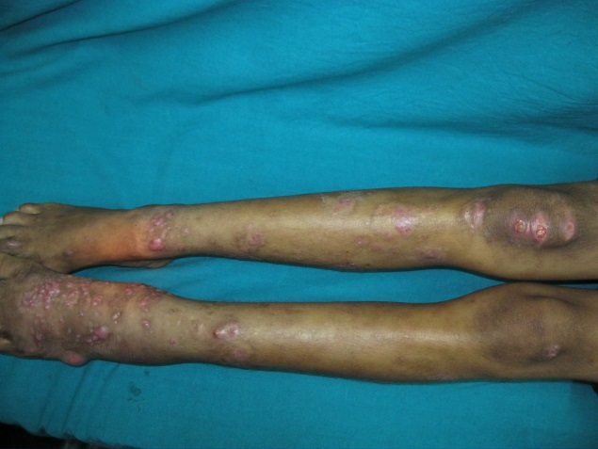Figure 1 Extensive nodular lesion over extensor aspect of both lower extremities.

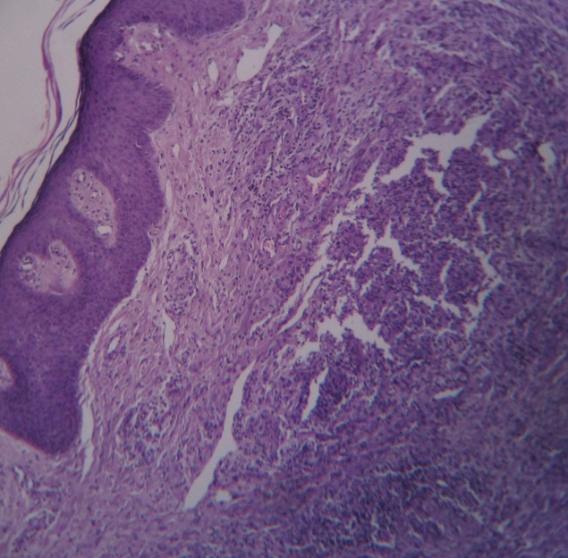Figure2 Histopathological examination of punch biopsy from lesion shows lymphocytes and histiocytes distributed in interstitial pattern. (H&E 100x).

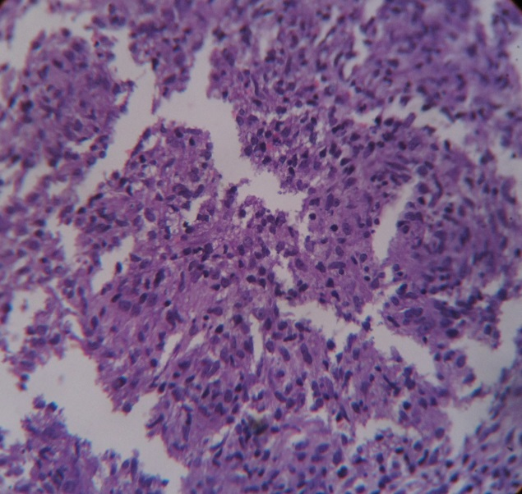Figure 3 Histopathology of punch biopsy shows mucin as faint blue, stringy material intersperse between collagen bundles.(H&E 400x).
Discussion
Granuloma annulare is a idiopathic necrobiotic disorder which has many predisposing factors. It was first described by Colcott Fox in 1895.³ Diabetes mellitus, thyroid disease, tuberculosis, viruses like varicella-zoster virus, human papillomavirus, BCG vaccination, drugs, sun exposure are found to act as triggering factors.^{4,5} Internal malignancy like Hodgkin and non-Hodgkin lymphoma, B cell diseases have been reported to be associated with granuloma annulare.² There is female preponderance. Among all the variants generalized type mostly occurs in adults.² Besides the main four clinical variants some unusual presentations like papular, umbilicated, follicular, pustular, generalized perforating, linear and patch types also have been reported .^{6,7} Subcutaneous granuloma annulare presents as asymptomatic firm to hard nodules located in the deep dermis and subcutaneous tissue distributed mostly over anterior aspect of lower leg. Generalized presentation of this variant has been discussed rarely. This form usually occurs in children. In histopathological examination three patterns are found. These are necrobiotic palisading granulomas, interstitial form and granuloma of sarcoidal or tuberculoid type. Most characteristic histopathological finding is lymphohistiocytic granuloma with connective tissue degeneration and mucin deposition. Subcutaneous granuloma annulare should be differentiated from rheumatoid nodule, sarcoidosis, infections and tumours. This variant usually resolves spontaneously. Cryosurgery and isotretinoin have been used successfully in localized type and cyclosporine has shown good result in generalized type of disease.
In our patient clinical picture corroborated with subcutaneous granuloma annulare but lesions were more generalized. Histopathological examination did not show any palisading granuloma but presence of numerous histiocytes admixed with lymphocytes and epithelioid cells together with mucin deposition pointed toward the interstitial type of granuloma annulare. Subcutaneous granuloma annulare with generalized distribution and interstitial pattern on histology has made our case interesting.
References
- Burns DA. Necrobiotic disorders. In: Burns T, Breathnach S, Cox N, Griffiths C, editors. Rook’s Textbook of Dermatology, 8th ed. Oxford,, UK: Wiley-Blackwell; 2010. p.60.1-17.
- Prendiville JS. Granuloma annulare. In: Wolff K, Goldsmith LA, Katz SI et al, editors. Fitzpatrick’s Dermatology in General Medicine. 7th ed. New York: McGraw-Hill; 2008. p. 369-73.
- Fox TC. Ringed eruption of the fingers. Br J Dermatol. 1895;7:91-2.
- Winkelmann RK. The granuloma annulare phenotype and tuberculosis. J Am Acad Dermatol. 2002;46:948-52.
- Houcke-Bruge C, Delaporte E, Catteau B et al. Granuloma annulaire après vaccination par le BCG. Ann Dermatol Venereol. 2001;128:541-4.
- Vargas-Díez E, Feal-Cortizas C, Fraga J et al. Follicular pustulous granuloma annulare. Br J Dermatol. 1998;138:1075-8.
- Gamo Villegas R, Sopena Barona J, Guerra Tapia A et al. Pustular generalized perforating granuloma annulare. Br J Dermatol. 2003;149:866-8.

