Case Report
Cutaneous variant of angiokeratoma corporis diffusum: a case report
Panchami Debbarman*, Ashim Kumar Mondal*, Niharika Ranjan Lal*, Piyush Kumar**, Ramesh Chandra Gharami*

*Department of Dermatology, Medical College & Hospital, Kolkata
** Department of Dermatology, Katihar Medical College, Katihar

Abstract | Angiokeratoma corporis diffusum (ACD) is a rare clinical type of angiokeratoma and has been reported, mostly, in association with various life threatening conditions, of which Fabry disease is the most known. Rarely, it has been reported as an isolated finding without any systemic features. A 23-year-old male presented with numerous red papules of various sizes with a history of intermittent bleeding. Histopathology findings were consistent with angiokeratoma and our case was diagnosed as ACD. We herein present a case of cutaneous variant of ACD without any associated systemic associations. Also, the conditions associated with ACD have been briefly discussed.  Key words  Angiokeratoma, angiokeratoma corporis diffusum.

Introduction
Angiokeratoma corporis diffusum (ACD) has often been considered pathognomonic of Fabry disease.^{1,2} Contrary to traditional view, ACD recently has been observed in many other enzyme deficiency disorders as described later. Also, ACD has been reported in otherwise healthy individuals without any systemic features.^{3,4} The medical literature on pure cutaneous form is scarce and is in the form of case reports only. We herein report a case of pure cutaneous form of ACD and attempt a brief discussion on various associations of ACD.
Case report
A 23-year-old man, who was born of consanguineous parents, presented with multiple, hyperkeratotic red-purple papules that were symmetrically distributed on the lower back, hips, thighs, buttocks, and scrotum. The lesions first appeared in early childhood and had increased in number and size since then to present status. Occasionally, an individual lesion would bleed on minor trauma, but they were otherwise asymptomatic. There were no features suggestive of ocular, gastrointestinal, cardiovascular, musculoskeletal, central and peripheral nervous system, and renal involvement or hearing and speech impairment. The patient demonstrated normal physical and mental development.
Address for correspondence
Dr. Piyush Kumar,
Department of Dermatology
Katihar Medical College & Hospital,
Katihar – 854105, Bihar, India
Ph# +91 8987280259
E mail: docpiyush@gmail.com
Cutaneous examination showed clusters of discrete, 1-5-mm, deep-red to purple papules, the largest of which were hyperkeratotic. The lesions were distributed symmetrically and involved the lower back, abdomen (Figure 1 and 2), hips, buttocks, thighs, scrotum, and penis, with a few lesions involving the lower lip. Examination of the extremities did not show edema or varicosities. Hepatosplenomegaly was notably absent. Ocular examination did not reveal any abnormality. The routine blood investigations and urine examination were noncontributory.
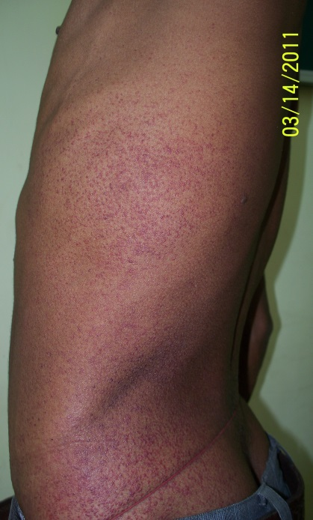Figure 1 Multiple red to purple discrete papules on trunk.

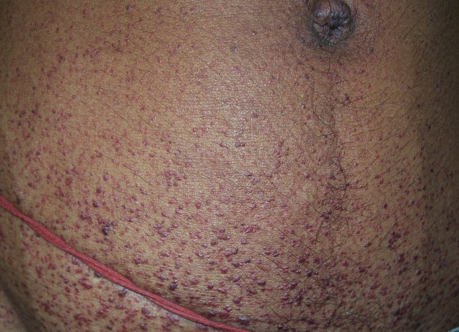Figure 2 Close up view of multiple red to purple papules on abdomen.

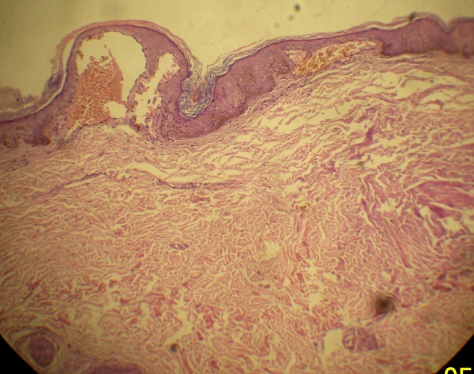Figure 3 Hyperkeratosis, acanthosis and dilated blood vessels in upper dermis. Lower dermis appears normal (H&E X100).
The histopathology from a papule showed hyperkeratotic and acanthotic epidermis. The papillary dermis was notable for dilated blood vessels. Rest of the dermis and subcutis were unremarkable (Figure 3). The histopathological findings were consistent with angiokeratoma and considering clinical presentation, diagnosis of angiokeratoma corporis diffusum was made.
Discussion
Angiokeratoma is a benign vascular lesion characterized by vascular ectasia in the upper dermis and hyperkeratosis.⁵ Clinically, it presents as variably sized (punctuate-to-10-mm in diameter), hyperkeratotic papules that range in colour from deep-red to blue-black. It can be classified into localized and generalized forms. Localized angiokeratoma may be solitary or multiple and has been further classified into Fordyce's angiokeratoma (distributed on the genitals), Mibelli's angiokeratoma (dorsum of toes and fingers) and angiokeratoma circumscriptum naeviforme (unilateral large keratotic plaques). In the generalized form, angiokeratoma corporis diffusum (ACD), lesions are usually symmetrically distributed and are mostly concentrated between the umbilicus and knees.^{6,7}
ACD has been considered a hallmark of Fabry disease, an X-liked recessive condition.^{1,2} However, ACD is no longer regarded as specific to Fabry disease. Widespread angiokeratomas also occur in patients with several additional enzyme deficiencies, which include α-fucosidase (fucosidosis), neuraminidase (sialodosis), aspartylglycosaminase (aspartylglucosaminuria), β-mannosidase (β-mannosidosis), α-N-acetylgalactosaminidase (Kansaki disease), and β-galactosidase (adult-onset GM1 gangliosidosis).⁶ The salient clinical features of these conditions have been summarized in Table 1. As it is evident from Table 1, the presence of one or more of the above conditions can be suspected when progressive psychomotor retardation, visceromegaly, facial dysmorphism, skeletal abnormalities, or ocular findings are present.⁶ Few cases of ACD are known who do not have

Table 1 Conditions associated with angiokeratoma corporis diffusum.
Disease and enzyme deficiency | Key clinical features
Fabry disease^{1,8}  α -galactosidase | - Acroparesthesia  - Hyperhidrosis  - Ocular (Diagnostic value)- corneal opacities: corneal verticillata, retinal ischemia, lenticular opacities, conjunctival vascular lesions  - Gastrointestinal-diarrhoea, malabsorption, nausea, vomiting, pain  - Renal-hypertension, proteinuria, renal failure  - Cardiac-ischemia, infarction, dilatation, arrhythmia  - Cerebrovascular accident, hydrocephalus, optic atrophy, dysfunction of oculomotor, trigeminal, eight nerve and/or hypoglossal nerve
Fucosidosis⁹  α-L-fucosidase | - Delayed mile stones  - Mental retardation, seizures, dementia  - Dysostosis multiplex  - Spasticity  - Visceromegaly
Sialidosis¹⁰  α -N -acetyl neuraminidase (also called sialidase) | - Developmental delay, mental retardation  - Hypotonia, myoclonus  - Kyphoscoliosis, joint stiffness and contractures  - Ocular - visual impairment, cherry-red macula, corneal opacities, lens opacities, and lamellar cataracts
Aspartylglucosaminuria^{11,12}  Aspartylglycosaminase | - Delayed speech  - Progressive intellectual disability, seizures  - Osteoporosis, hypermobility of joints, and loose skin  - Lack of a growth spurt at puberty
β -mannosidosis¹³  β-mannosidase | - Intellectual disability, delayed motor development and seizure  - Introverted, prone to depression, or behavioral problems such as hyperactivity, impulsivity or aggression  - Hearing loss and speech impairment  - Hypotonia and peripheral neuropathy
Adult type GM1 gangliosidosis¹⁴  β-galactosidase | - Normal early neurologic development  - Slowly progressing dementia with parkinsonian features and extrapyramidal disease  - Progressive intellectual impairment  - Generalized dystonia with speech and gait disturbance
Kanzaki disease (Schindler disease type II)^{15,16}  α-N-acetylgalactosaminidase | - Mild cognitive impairment  - Sensorineural hearing loss  - Peripheral neuropathy  - Ocular- dilated blood vessels of conjunctiva and fundus¹⁰

any systemic feature.^{3,4,17} Data are scarce on the exclusively cutaneous form of ACD. Only few cases have been reported.^{3,4,17}
Our case presented with ACD without any systemic findings. All laboratory tests were within normal limits. Histopathology was diagnostic for angiokeratoma; however, it was notable for absence of lipid vacuoles in endothelial cells. Ocular examination did not reveal any abnormality; both anterior and posterior chamber were unremarkable. All these findings support the diagnosis of ACD without any systemic feature. The gold standard of diagnosis is enzyme estimation; however, presumptive diagnosis can be made by clinical features, ophthalmic evaluation, and supportive laboratory findings. Corneal opacity (without affecting vision), “Fabry cataract” (posterior capsular cataracts with whitish spoke like deposits of granular material) and presence of refractile lipid inclusions (called Maltese crosses) in endothelial cells are very suggestive of Fabry disease.^{6,18} However, all this holds true for classical conditions only; many variations are known. For example, Fabry disease has been described in a patient with single angiokeratoma.¹⁹ On the other hand, female carriers are known to develop ACD with milder forms of Fabry disease and are spared of full-blown disease.¹⁸ However, our patient was male and hence, this possibility was not considered further. Similarly, other associated conditions were not considered further in absence of consistent systemic features.
ACD has been observed in both healthy individuals as well as persons with various enzyme deficiency disorders. The awareness of different associated conditions is of paramount importance in managing such patients. Also, unnecessary workup may be avoided in resource poor settings, especially if person is not having consistent systemic features because pure cutaneous form of ACD is being increasingly reported.
References
- Banikazemi M, Desnick RJ, Astrin KH. Genetics of Fabry disease [Internet]. 2009. Available from: http://emedicine.medscape.com/article/951451-overview. [Updated 2009 Jul 8, Cited 2012 Mar 27].
- Sethuraman G, Chouhan K, Kaushal S, Sharma VK. Fabry’s disease. Lancet. 2011;378:1254.
- Laxmisha C, Thappa DM, Karthikeyan K. Cutaneous variant of angiokeratoma corporis diffusum. Dermatol Online J. 2003;9:13.
- Gasparini G, Sarchi G, Cavicchini S, Bertagnolio B. Angiokeratoma corporis diffusum in a patient with normal enzyme activities and Turner's syndrome. Clin Exp Dermatol. 1992;17:56-9.
- Leis-Dosil VM, Alijo-Serrano F, Aviles- Izquierdo A et al. Angiokeratoma of glans penis: clinical, histopathological and dermoscopic correlation. Dermatol Online J. 2007;13:19.
- Karen JK, Hale EK, Ma L. Angiokeratoma corporis diffusum (Fabry disease). Dermatol Online J. 2005;11:8.
- Ghosh SK, Bandyopadhyay D, Ghoshal L, Haldar S. Angiokeratoma circumscriptum naeviforme: A case report of a rare disease. Dermatol Online J. 2011;17:11.
- Peters FPJ, Vermeulen A, Kho TL. Anderson-Fabry’s disease: α-galactosidase deficiency. Lancet. 2001;357:138-40.
- Willems PJ, Gatti R, Darby JK et al. Fucosidosis revisited: A review of 77 patients. Am J Med Genet. 1991;38:111-31.
- Roth KS, Rizzo WS, McGovern MM. Sialidosis (Mucolipidosis I) [Internet]. 2010. Available from: http://emedicine.medscape.com/article/948704-overview. [Updated 2010 May 21, Cited 2012 Mar 27 ].
- Vargas-Díez E, Chabás A, Coll MJ, et al. Angiokeratoma corporis diffusum in a Spanish patient with aspartylglucosaminuria. Br J Dermatol. 2002;147:760-4.
- Aronson NN Jr. Aspartylglycosaminuria: biochemistry and molecular biology. Biochim Biophys Acta. 1999;145:139-54.
- Kleijer WJ, Hu P, Thoomes R et al. β-Mannosidase deficiency: Heterogeneous manifestation in the first female patient and her brother. J Inherit Metab Dis. 1990;13:867-72.
- Tegay DH. GM1 Gangliosidosis [Internet]. 2009. Available from: http://emedicine.medscape.com/article/951637-overview. [Updated 2009 Jun 8, Cited 2012 Mar 27].
- Umehara F, Matsumuro K, Kurono Y et al. Neurologic manifestations of Kanzaki disease. Neurology. 2004;62:1604-6.
- Kruer MC, Steiner RD. Lysosomal Storage Disease [Internet]. 2011. Available from: http://emedicine.medscape.com/article/1182830-overview. [Updated 2011 Dec 5, Cited 2012 Mar 27].
- Marsden J, Allen R. Widespread angiokeratomas without evidence of metabolic disease. Arch Dermatol. 1987;123:1125.
- Scheinfeld NS, Mokashi A, Oppenheim AR. Angiokeratoma corporis diffusum (Fabry syndrome) [Internet]. 2011. Available from: http://emedicine.medscape.com/article/1102964-overview. [Updated 2011 Aug 2 , Cited 2012 Mar 27].
- Corry A, Feighery C, Alderdice D et al. A family with Fabry disease diagnosed by a single angiokeratoma. Dermatol Online J. 2011;17:5.

