Case Report
Eruptive syringoma - A report of two cases
J Seth, A Saha, Rajesh, T Sarkar, N Jain, P Sarkar

Department of Dermatology, Venereology and Leprology, Burdwan Medical College and Hospital, Burdwan, West Bengal, India

Abstract | Syringomas are adenoma of intra-epidermal eccrine duct. Clinically lesions are small, skin-coloured papules; tend to occur in the periorbital area particularly around the lower eyelid. Eruptive syringoma, a distinctive form of syringoma presents as successive crops of numerous, disseminated papules appearing in atypical sites. There are a few reports of its widespread distribution as eruptive syringoma in the literature. Herein, we report two cases of eruptive syringomas in two women aged 35-year and 28-year, respectively. They presented with multiple asymptomatic, skin coloured papules at different sites. In both the cases, histopathology showed multiple ducts and solid nest or cords of epithelial proliferation within the dermis, embedded in fibrous stroma. Some ducts had tadpole like appearance.  Key words  Eccrine duct, syringoma, eruptive.

Introduction
The term syringoma refers to a group of benign adnexal neoplasm with a tendency to ductal (acrosyringeal) differentiation. Though, adult women are most commonly affected, can occur in both the sexes. Although occasionally solitary, the lesions are usually multiple and may be present in great number. Clinically lesions are small, firm, smooth, skin-coloured or slightly yellowish, 1-2 mm papules and tend to occur in the periorbital area, particularly around the lower eyelid. In eruptive syringoma, a rare variant first described by Jacquet and Darier in 1887, the lesions occurred in successive crops on the anterior chest, neck, upper abdomen, axillae and the periumbilical region at puberty or during childhood. They may remain stationary throughout the life or may disappear spontaneously. There is also a familial variant. There are a few reports of its widespread distribution as eruptive syringoma in the literature. We therefore, report these two cases here.
Case report 1
A 35-year-old female, farmer by profession presented with multiple asymptomatic, skin coloured lesions of 6 years duration. Lesions started erupting over the forehead, spreading to both forearms and infra-orbital area. Patient was not on any medication. Family history was unremarkable. Examination revealed skin-coloured papules in the above mentioned areas (Figure 1).
Histopathological examination revealed normal epidermis. Upper and mid dermis showed multiple ducts and small solid epithelial nests, cords or tubules embedded in a sclerotic stroma. Lumina of the ducts were filled with amorphous debris. Ducts were lined by two rows of flat epithelial cells. Some of the ducts had small, comma like tails of epithelial cells giving them the appearance of tadpole.⁴ Cells of epithelial proliferation had pale, eosinophilic cytoplasm and rounded
Address for correspondence
Dr. Joly Seth
Department of Dermatology, Venereology and Leprology,
Burdwan Medical College and Hospital, Burdwan, West Bengal, India
Mobile No. - 9432855142
Email: drjolyseth@gmail.com
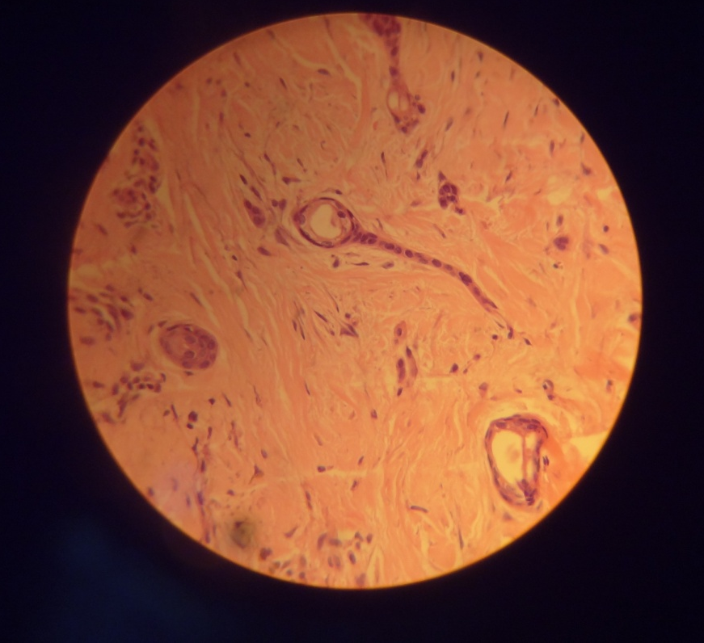
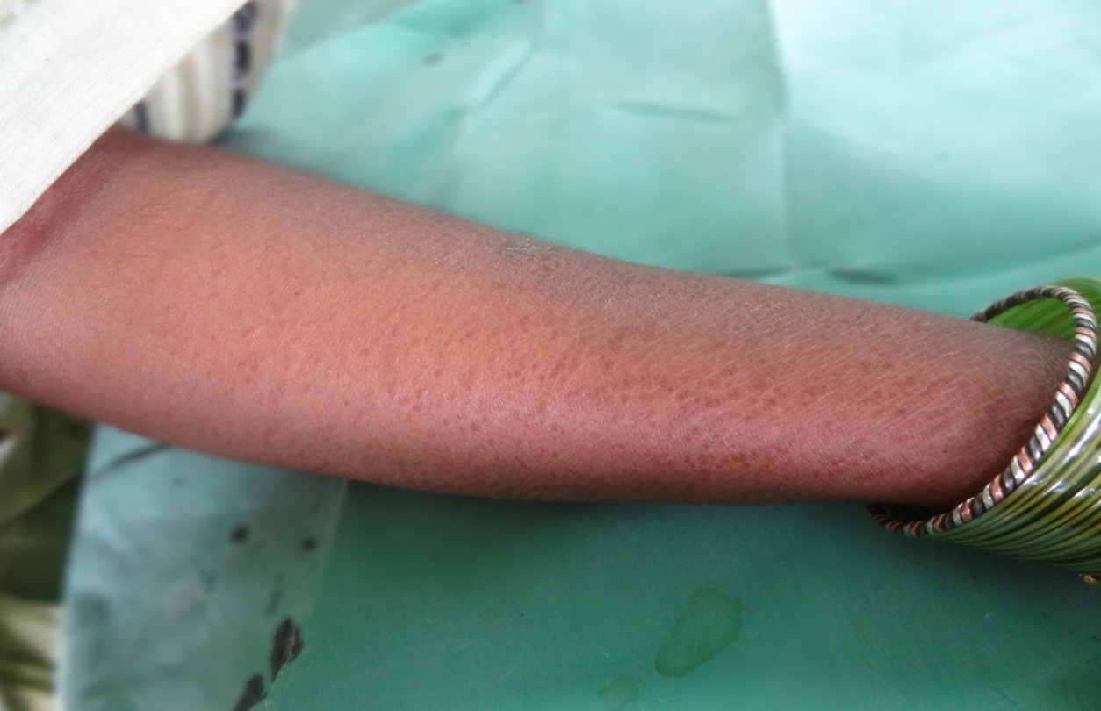
Figure 1 Multiple skin coloured papules of eruptive syringoma over forearm

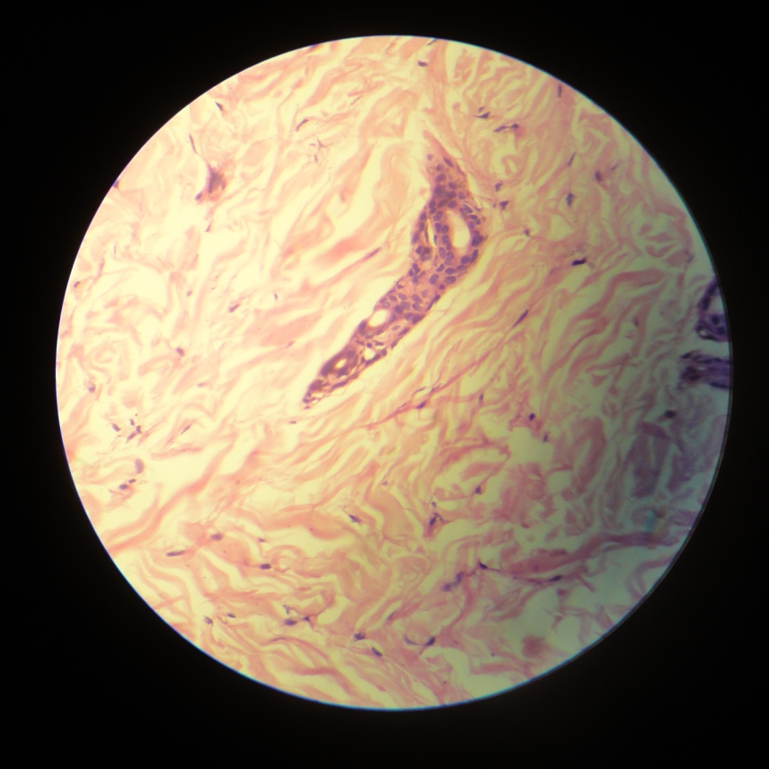
Figure 2 40X showing tubular structure embedded in a collagenous stroma & lined by two rows of epithelial cells

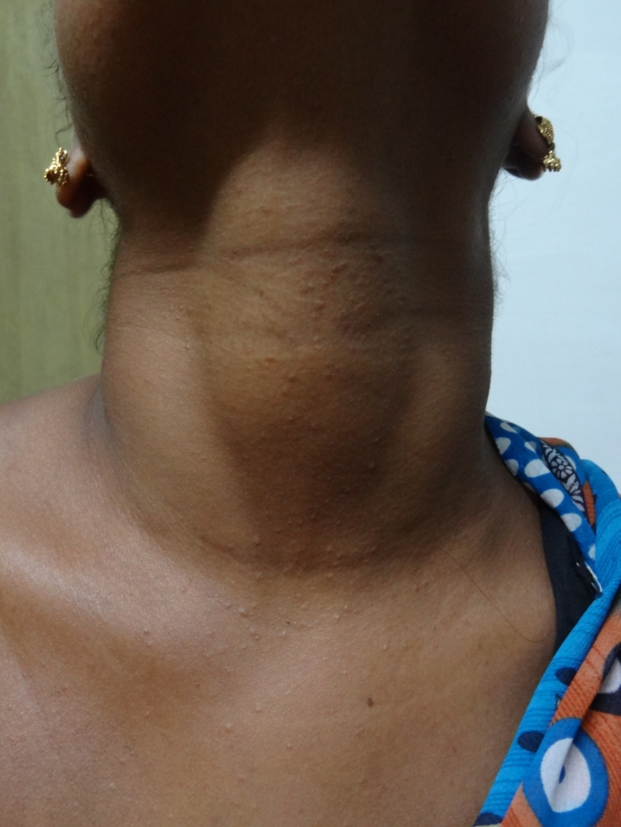
Figure 3 Multiple skin coloured papules of eruptive syringoma over the neck

Figure 4 40X showing typical tadpole body of syringoma.
monomorphic nucleus. The histopathological finding was consistent with the clinical diagnosis of syringoma (Figure 2).
Case report 2
A 28 year old female presented with 12 years history of asymptomatic, skin-coloured, firm papule of 1-2 mm in diameter distributed over forehead, periorbital area, neck and both the forearms. Lesions started over forehead and periorbital areas and then involved the other parts in last 6 months following repeated episode of sun exposure. No family member had ever suffered from similar type of skin eruption (Figure 3).
Histopathology showed multiple ducts and solid nest or cords of epithelial proliferation within the dermis, embedded in fibrous stroma. Some ducts had tadpole like appearance. Features fit with the diagnosis of syringoma (Figure 4).
Discussion
Syringomas are benign adnexal tumour originating from intraepidermal portion of eccrine sweat duct. Initial description of syringoma was given by Kaposi,¹ later on Jacquet and Darier² described the eruptive form. Women are affected more commonly.³ Clinically lesions are small, firm, smooth, skin-coloured or slightly yellowish, 1-2 mm papules tending to occur in the periorbital area, particularly around the lower eyelid. They can also develop in other anatomical sites such as thigh, axilla, abdomen and vulva. Most commonly they occur around puberty or in third to fourth decade.⁴ In cases of eruptive syringomas there are successive crops of numerous disseminated papules, with a predilection to occur over the anterior trunk i.e. on anterior aspect of the neck, chest, trunk, axilla, and inner aspect of upper arm and around axilla.^{3,4} There is association of eruptive syringoma with heat stimuli.⁵ There have been reports of unilateral, nevoid, bathing trunk and generalized distribution of syringoma.⁶
Oestrogen and progesterone receptors have been detected within syringoma with histochemical study. This finding may explain why syringomas are more common in females and peak incidence during puberty.⁷
On histopathology of syringoma, epidermis is unremarkable. Upper and mid dermis show multiple ducts and small solid epithelial nests, cords or tubules embedded in a sclerotic stroma. Lumina of the ducts are filled with amorphous debris. Ducts are lined by two rows of flat epithelial cells. Some of the ducts posses’ small, comma likes tails of epithelial cells giving them the appearance of tadpole.⁸ Cells of epithelial proliferation had pale, eosinophilic cytoplasm and rounded monomorphic nucleus. Histochemical studies have shown that all eccrine type of enzymes and glycogen are present in the tumour cells of syringoma. Eccrine specific monoclonal antibody (EKH6) positively stains syringoma lesions. Hence although formerly thought to be of mixed origin, now syringoma is considered to be benign appendage tumour of intra-epidermal eccrine sweat duct.
Histopathological differential diagnosis should be fibrosing basal cell carcinoma, desmoplastic trichoepithelioma, microcystic adnexal carcinoma. Differentiating point from fibrosing basal cell carcinoma is that latter lacks ductal structure containing amorphous material. Though desmoplastic trichoepithelioma also contains solid strand of basophilic epithelial cell, they lack ductal structure. Differentiating points from microcystic adnexal tumour are; smaller size, greater symmetry, superficial dermal location, lack of horn cyst formation, less single-file strand formation and infrequent calcification. Unlike microcystic adnexal tumour, syringoma does not invade subcutaneous or perineural tissue.⁹
Patients seek medical advice because of cosmetic concern. Multiple treatment options are currently available including surgical excision, dermabrasion, electrodessication with curettage, laser resurfacing, chemical peeling, cryotherapy, and fulguration, oral and topical retinoids. But none of them are satisfactory and recurrence is common because these tumours are situated deep in the dermis and are numerous in numbers.¹⁰⁻¹²
Although, syringoma occur more frequently on the face in a localized manner, it would be better to keep it in mind in differential diagnosis of any eruptive papular lesions throughout the body. The histopathological assays could be very beneficial in this regard.
References
- Kaposi M. Lymphangioma tuberosum multiplex. In: Fagge CH, editor. Hebra on Diseases of the Skin, Vol.3. London: New Sydenham Society; 1872. P. 386.
- Jacquet L, Darier J. Hiydradenomas eruptifs, epitheliomes adenoids des glandes sudoripares ou adenomas sudoripares. Ann Dermatol Syph. 1887;8:317-23.
- Weiss E, Paez E, Greenberg AS et al. Eruptive syringomas associated with milia. Int J Dermatol. 1995;34:193-5.
- Nguyen DB, Patterson JW, Wilson BB. Syringoma of the moustache area. J Am Acad Dermatol. 2003;49:337-9.
- Iglesias M, Serra J, Salleras M et al. Siringomas diseminados de inicio acral,aparecidos en la octava década. Actas Dermosifiliogr. 1999;90:253-7.
- Carrilo J, Estrach T, Mascaro JM. Eruptive syringoma: 27 new cases and review of literature. J Eur Acad Dermatol Venereol. 2001;15:242-6.
- Wallace ML, Smoller BR. Progesterone receptor positivity supports hormonal control of syringomas. J Cutan Pathol. 1995;22:442-5.
- Hashimoto K, DiBella RJ, Borsuk GM, Lever WF. Eruptive hidradenoma and syringoma. Histological, histochemical and electron microscopic studies. Arch Dermatol. 1967;96:500-19.
- Goldstein DJ, Barr RJ, Santa Cruz DJ. Microcystic adnexal carcinoma: a distinct clinicopathologic entity. Cancer. 1982;50:566-72.
- Gómez MI, Pérez B, Azaña JM et al. Eruptive syringoma: treatment with topical tretinoin. Dermatology. 1994;189:105-6.
- Park HJ, Lee DY, Lee JH et al. The treatment of syringomas by CO2 laser using a multiple-drilling method. Dermatol Surg. 2007;33:310-3.
- Aradi IK. Periorbital syringoma: A pilot study of the efficacy of low-voltage electrocoagulation. Dermatol Surg. 2006;32:1244-50.

