Case Report
Cutaneous horn overlying a trichofolliculoma involving the ear
Abdul Rehman Arshad *, Muhammad Younus Awan **

Departments of *Medicine and **Surgery, 1 Mountain Medical Battalion, Bagh, Azad Kashmir

Abstract | Trichofolliculomas are benign hamartomas of the hair follicles. Usually seen around the nose, they present as small skin-coloured papules or nodules. We present a patient who presented with a cutaneous horn on the pinna developing over a trichofolliculoma, something not described in literature in the past. The growth was excised and the diagnosis was established on histopathological examination.  Key words  Cutaneous horn, hyperkeratosis, trichofolliculoma, hamartoma, hair follicle.

Introduction
Cutaneous horns occur mostly on sun exposed areas but are not that commonly seen.1 Still, they are important because they are manifestations of an underlying dermatological condition which could be benign or malignant. Squamous cell carcinoma and basal cell carcinoma are the possibilities, but only in a small proportion of patients. Much more frequently, cutaneous horns are associated with benign skin pathologies like viral warts, actinic keratosis, keratoacanthoma, seborrheic keratosis, pyogenic granuloma, discoid lupus erythematosus and verruca vulgaris.2 We report a case of cutaneous horn overlying a benign tumor, trichofolliculoma.
Case Report
A 65-year-old farmer presented with a painless growth on his left ear, which was noticed twelve months ago and had progressively increased in size slowly since then. There was no history of any trauma or discharge from the lesion. He had not observed similar lesions anywhere else.
Address for correspondence
Dr. Abdul Rehman Arshad,
Classified Medical Specialist
1 Mountain Medical Battalion
Bagh 12500, Azad Kashmir, Pakistan
Ph# 0321 520 2433
Email: maj.abdulrehman@gmail.com
On examination, there was a 1 cm long firm horn- like conical growth on the pinna of his left ear (Figure 1). Skin at the base of the horn appeared to be normal. Cervical lymph nodes were not palpable. After obtaining informed written consent, the horn (along with a patch of surrounding skin) was removed under local anesthesia. The excised sample was sent for histopathological exam to rule out any underlying malignancy. As shown in Figure 2, it revealed thinning and flattening of epidermis with hyperkeratosis. There was focal melanocytic proliferation at dermoepidermal junction with few follicular plugs. Small daughter cysts were seen budding out from main hair follicles. These features were consistent with the diagnosis of trichofolliculoma. No evidence of malignancy was seen in the material examined. The patient was followed up after seven days. His wound healed completely and since local excision alone was adequate for treating trichofolliculoma, he was reassured and sent home.

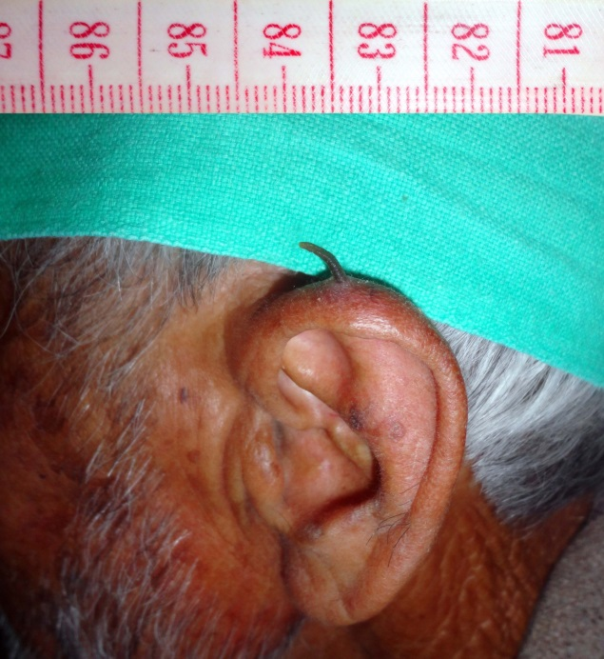
Figure 1 Cutaneous horn.

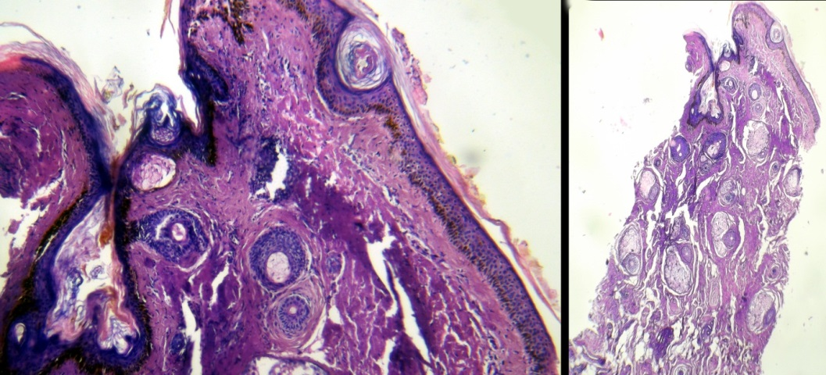
Figure 2 Histopathological appearance of the resected specimen (H&E stain)
Discussion
Cutaneous horns consists of dense keratin that projects up from the surrounding skin in shapes resembling horns of animals. The pathogenesis is not very well known.3 Though this dead keratin is of no significance per se, it is indeed a reflection of an underlying condition and should therefore be evaluated appropriately. Pointers towards an underlying malignancy include surrounding inflammation, an infiltrated base, tenderness at the base and regional lymphadenopathy.⁴ None of these features was present in our patient. It is important to remember that a sufficient part of surrounding skin at the base of the horn should be excised to permit for adequate histopathological assessment and accurate diagnosis.
To the good luck of our patient, this horn was a reflection of an uncommon benign condition named trichofolliculoma. Some authorities believe that it is not a true tumor but actually a benign follicular hamartoma.⁵ It develops spontaneously and the exact etiology is not clear. There is no racial or gender predilection. Common in the middle age, it generally presents as a papule or a nodule on the face, from which at times emerges a tuft of white hair producing a characteristic gross appearance.⁶ Our patient is unique since he presented with a cutaneous horn, which (to the best of our knowledge) has not been described with trichofolliculoma before. This lesion often has a central crater filled with hair and keratin.⁷ It is possible that continuous persistent accumulation of keratin over time resulted in development of a firm keratinized horn in this patient. Histologically, trichofolliculomas consist of a dilated primary follicle lined by infundibular, stratified squamous epithelium and opening to the skin surface.⁸ Secondary and tertiary follicles are also seen developing from the primary follicle, all of which may have a different level of differentiation. Surgical excision is the treatment of choice, with rare chances of recurrence.⁹
References
- Bondeson J. Everard home, John hunter, and cutaneous horns: A historical review. Am J Dermatopathol. 2001;23:362-9.
- Sadeghi E, Johari HG, Deylami HN. Eyelid cutaneous horn. J Cutan Aesthet Surg. 2012;5:153-4.
- Yang JH, Kim DH, Lee JS et al. A case of cutaneous horn originating from keratoacanthoma. Ann Dermatol. 2011;23:89-91.
- Fernandes NF, Sinha S, Lambert WC, Schwartz RA. Cutaneous horn: a potentially malignant entity. Acta Dermatoven APA. 2009;18:189-93.
- McCalmont TH. Adnexal neoplasms. In: Bolognia JL, Jorrijo JL, Rapini RP, editors. Dermatology. 2nd edn. Philadelphia: Mosby Elsevier; 2008. p. 1693-1712.
- Ghosh SK, Bandyopadhyay D, Barma KD. Perifollicular nodule on the face of a young man. Indian J Dermatol Venereol Leprol. 2011;77:531-3.
- Shields JA, Shields CL, Eagle RC Jr. Trichoadenoma of the eyelid. Am J Ophthalmol. 1998;126:846-8.
- Misago N, Kimura T, Toda S et al. A revaluation of trichofolliculoma: the histopathological and immunohistochemical features. Am J Dermatopathol. 2010;32:35-43.
- Carreras B Jr, Lopez-Marin I Jr, Mellado VG, Gutierrez MT. Trichofolliculoma of the eyelid. Br J Ophthalmol. 1981;65:214-5.

