Case Report
Carcinoma en cuirasse
Sajad Ahmad Salati*, Ajaz Ahmad Rather**

*Department of Surgery, College of Medicine, Qassim University, Saudi Arabia
**Department of Surgery, SKIMS Medical College, Bemina, Srinagar, J&K, India

Abstract | Carcinoma en cuirasse is a rare form of metastatic cutaneous breast cancer. We report a typical case of cancer en cuirasse in a 36 years old female who presented with diffuse erythema and scaly nodular lesions over the left breast, axilla, neck and arm. Imaging revealed a lump in upper-outer quadrant of affected breast. Histopathological examination of the cutaneous nodules and fine needle aspiration cytology of the breast lump revealed features of infiltrating ductal cell carcinoma.  Key words  Carcinoma en cuirasse, breast cancer, infiltrating ductal cell carcinoma.

Introduction
Carcinoma en cuirasse is a rare form of cutaneous metastasis.^{1,2} This condition is most commonly associated with breast cancer with local recurrence after mastectomy and presents most commonly a few months or years after the surgical operation.² More rarely, the condition presents as the presenting manifestation of the disease as happened in our reported case. In this condition, the thoracic wall is studded with carcinomatous indurated lesions and the affected skin seems to resemble a breast plate (armor). Carcinoma en cuirasse like other cutaneous metastasis signifies advanced malignant disease with poor prognosis and short survival.
Case report
A 36-year-old female, multigravida, with no significant co-morbidities reported with diffuse discoloration and lumpiness over the left side of chest and axilla. The patient had noticed an initial nodule seven months prior to appointment with us. She had been using over the counter skin preparations (steroid, antihistaminic, antibiotic) till the disease reached the presenting proportions.
Address for correspondence
Dr. Sajad Ahmad Salati
Assistant Professor of Surgery
College of Medicine, Qassim University, Saudi Arabia
Email: docsajad@yahoo.co.in
On examination, the patient was average built with stable vital signs. Local examination revealed diffuse erythema, firm to hard nodularity with scaling over the left breast, left axilla, neck and left arm (Figures 1 and 2). Ultrasonography revealed a 2.3 cm x 1.6 cm x 1.5cm lump in upper-outer quadrant of the affected breast. FNAC of the breast lump and biopsy of the skin lesion revealed features of infiltrating ductal cell cancer. The patient was attached to the services of tertiary care cancer center for further evaluation and management.
Discussion
Cancer en cuirasse is a rare cutaneous manifestation of breast cancer.¹ This term was coined by Alfred Velpeau, a well-known French anatomist and surgeon, after describing this condition for the first time in 1838.³ In females, breast is the commonest primary source of cutaneous metastases and about 23.9% of breast
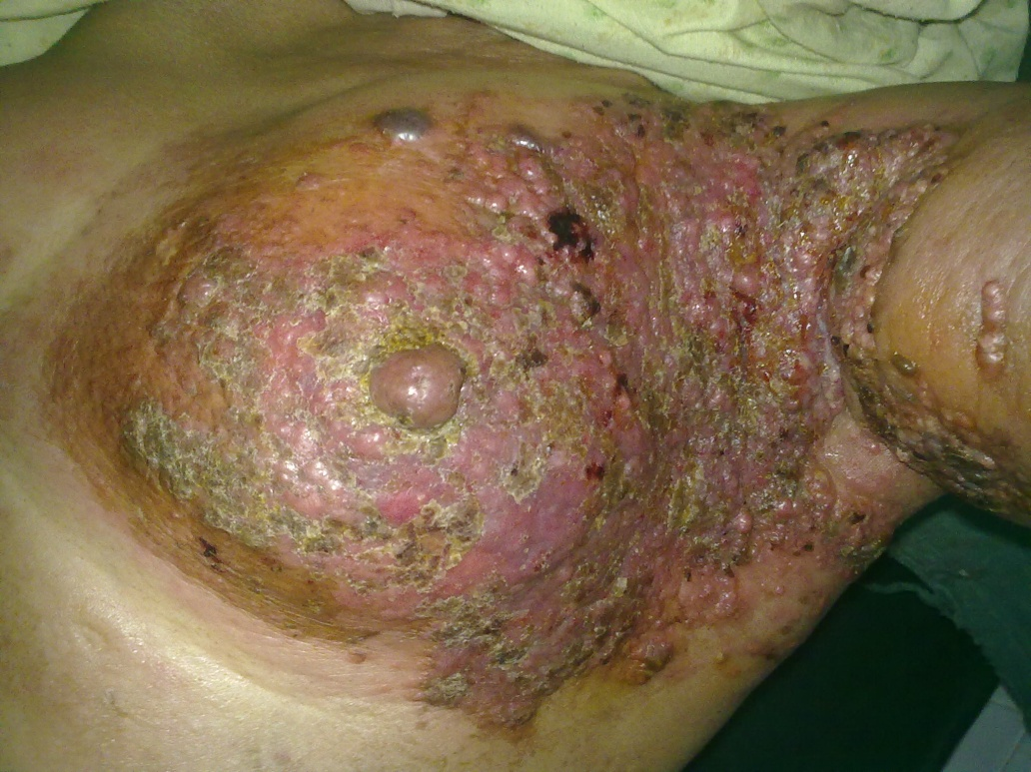
Figure 1 Clinical image of the patient with cancer en cuirasse

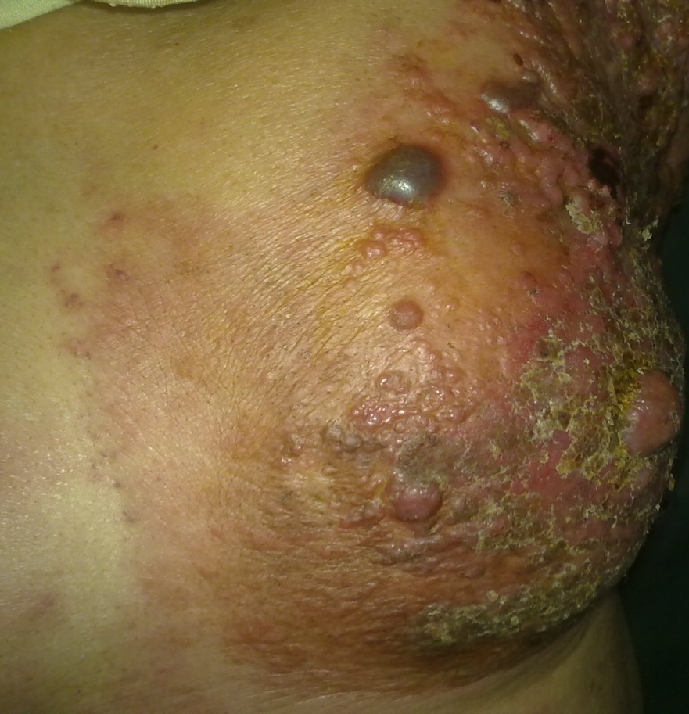
Figure 2 Close up view of the patient as shown in Figure 1.
cancer patients have been reported in literature to manifest cutaneous metastasis.⁴ These cutaneous metastases can occur in form of nodules and/or papules or telangiectatic lesions in more than 90% cases and cancer en cuirasse accounts for only about 2-3 % of such lesions.²
Cancer en cuirasse most commonly appears as a local recurrence after a few months or years of mastectomy for breast cancer. More rarely, the condition presents as the presenting initial manifestation of breast cancer as happened in our reported case.² Cancer en cuirasse may initially appear as few small discrete cutaneous nodule/papules which progressively increase in size and coalesce to form a leathery indurated sheet (Figures 1 and 2) resembling a breast plate of armor.⁵ Uncommonly, the lesion may appear as a subcutaneous nodule or yellowish marbling when it may be regarded as insignificant. Mullinax and Cohen have reported a case where cancer en cuirasse presented as keloids of the chest wall.⁶
Breast fibromatosis (also called extra-abdominal desmoid tumor) is an uncommon differential diagnosis of cancer en cuirasse.⁷ It is indistinguishable on physical examination and imaging but histology shows fibromatosis to have distinctive features of benign infiltrative proliferation of fibrous tissue.
Cancer en cuirasse develops continuitatem by dissemination via lymphogenous and hematogenous pathways.⁸ The prognosis depends upon the type and biological behavior of the underlying primary tumor² and is generally poor as the cutaneous metastases represent the advanced stage of the disease.
Acknowledgement
We thank the patient for allowing the use of images for academic purposes.
References
- Lee SH, Cheng HM, Cheng SF et al. Breast carcinoma en cuirasse – a case report and literature review. Dermatol Sinica 1993;11:129-35
- Mahore SD, Bothale KA, Patrikar AD, Joshi AM. Carcinoma en cuirasse: a rare presentation of breast cancer. Indian J Pathol Microbiol. 2010;53:351-8.
- Savatard L. Cancer en cuirasse. Br J Dermatol. 1943;2:31-9.
- De Giorgi V, Grazzini M, Alfaioli B et al. Cutaneous manifestations of breast carcinoma. Dermatol Ther. 2010; 23:581-9.
- Lacout A, Marcy PY, Lesecc G. Long-standing scirrhous breast carcinoma en cuirasse. Breast Care (Basel). 2010;5:327-9.
- Mullinax K, Cohen JB. Carcinoma en cuirasse presenting as keloids of the chest. Dermatol Surg. 2004;30:226-8.
- Somerville JE, Biggart JD. Fibromatosis of the breast: a benign lesion which simulates a carcinoma. Ulster Med J. 1989;58:97-9.
- Arapovic SJ, Simic L. Cutaneous metastases--carcinoma en cuirasse. Acta Dermatovenerol Croat. 2002;10:167-70.

History of Pediatric Dermatology
Dr. Sidney Hurwitz started his medical career as a paediatrician in New Haven Connecticut in 1950s. He soon became aware that children had many skin problems, an area that had little emphasis in his training. After much contemplation he decided to complete a residency in dermatology. His energies became apparent in the early 1970s when along with Drs. Alvin H Jacobs, Samuel Weinberg and William Western, the society for Paediatric Dermatology was formed. Dr. Alvin H Jacobs served as the first president of the society. They later were instrumental in establishing the international Society of Paediatric Dermatology.

