Case Report
Topical treatment for vitiligo brings remission of vitiligo and halo nevus in a girl: A case report
Delwar Hossain

Department of Dermatology and Venereology, USTC, Foy’s Lake, Khulsi, Chittagong, Bangladesh

Abstract | Our patient had a halo nevus in the scalp and multiple patches of vitiligo elsewhere. Complete remission of her vitiligo and halo nevus was achieved with topical treatment for vitiligo without incurring any harm to the patient.  Key words  Vitiligo, halo nevus, topical treatment.

Introduction
Development of acquired idiopathic white patch on the skin and mucous membrane is called vitiligo, and around a congenital or acquired nevomelanocytic nevus a halo nevus. Both of them could develop simultaneously in a patient¹ and could be self-healing having an unpredictable course.²⁻⁴
Case report
A girl of nine years came to us in April, 2010 with the complaint of multiple de-pigmented patches over axillae, eyelids, face, pinnae, scalp, and in and around a congenital nevomelanocytic nevus over her left temple. The nevus was asymptomatic and symmetric in color and shape with regular margin though the central part of the nevus was progressively getting normal skin color (Figure 1).
A full mucocutaneous examination showed no abnormality except the depigmented patches as mentioned above. However, she had low self-esteem, self-stigmatization and isolation, and apprehension and mental distress parents. We took 5 mm punch biopsy from nevus for histopathology and immunohistochemistry for HMB45 antigen before and after treatment.
Address for correspondence
Prof. Delwar Hossain,
Department of Dermatology and Venereology
USTC, Foy’s Lake, Khulsi,
Chittagong, Bangladesh.
Email: delwar_ustc@yahoo.co.uk
We treated her with a combination of PUVAsol (Meladinine paint, alcoholic solution of methoxsalen, 0.75% w/v and sunlight) and clobetasol propionate BP, 0.05% w/w ointment. Paint was applied on the lesions every alternate day at 9 am and after half an hour, painted lesions were exposed to the sun for 1 minute for the first 3 months, then 2 minutes for the next 3 months and finally 3 minutes for the next 6 months. Patient was asked to wash the paint off with soap and water immediately after exposure to the sun and then apply clobetasol ointment twice daily, once at morning and again at night, for 12 months. She was advised to avoid sun exposure for the remaining part of the day. As it was an outpatient based treatment, we asked her to report quarterly.
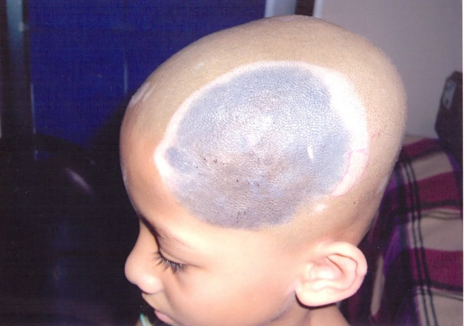
Figure 1 De-pigmented patch in and around a congenital nevomelanocytic nevus (9.5cm x 9cm) over left temple. The central part of the nevus is getting normal skin color. There are multiple de-pigmented patches over other area of the scalp.

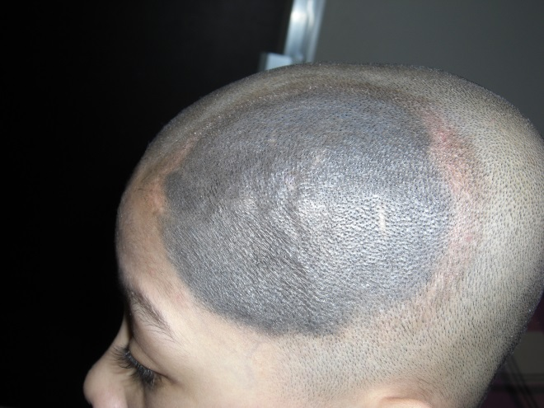
Figure 2 Same patient, after 12 months treatment with our regimen. Complete remission of all vitiligo patches and halo nevus is achieved with congenital nevomelanocytic nevus unchanged. The symmetry in color and shape, and border regularity of nevus is maintained.
With our treatment, at the end of 12th month, all her de-pigmented patches disappeared and the original deep bluish-black color of the nevus returned back (Figure 2).
We did not notice any side effects from this regimen. However occasional interruption of treatment for few days was observed in monsoon season. Though visible improvement was self-rewarding, we had to deliver health education in successive visits to keep her spirit high.
We delivered clinical follow up quarterly for last 24 months after stoppage our treatment. We found her in remission and fine.
Discussion
Our patient had halo nevus in the temple and vitiligo elsewhere. She received topical treatment for vitiligo and got complete remission of both the diseases leaving behind the nevomelanocytic nevus unchanged. This is interesting and unusual in clinical practice.
Halo nevus may be associated with malignant melanoma.⁵ However in our case, a thorough clinical examination together with histopathology and immunohistochemistry of nevus excluded such an association. Ours was associated with a benign disease called vitiligo, as seen in 18-26% cases.⁶
Copeman et al.⁷ found circulating antibody against the cytoplasm of malignant melanoma cell in patients with resolving halo nevus. Unfortunately we do not have facilities to assess antibody for malignant melanoma in our country. However we were able to do histopathology and immunohistochemistry. Innocent clinical appearance, and typical histopathology and negative immunohistochemistry helped us to recognize the case being a benign halo nevus.
In our country, white patch particularly in exposed areas is associated with intense psycho-social suffering. In that case, mere explanation and assurance as a management strategy is not enough. We have to give treatment. Our patient received treatment for vitiligo. Though the treatment of halo nevus is controversial, we brought her halo nevus under same treatment having seen its benign nature. Both the diseases responded well and remained in remission even today (24 months after stoppage of treatment).
Perhaps multiplication and migration of melanocytes from surrounding normal skin to de-pigmented patches by PUVAsol⁸ and strong anti-inflammatory function of topical steroid⁹ was responsible for this outcome. Though, exact mechanism is not known.
Acknowledgement
I highly appreciate the commitment, patience and perseverance of the little girl.
Reference
- Itin HP, Lautenschlager S. Acquired leukoderma in congenital pigmented nevus associated with vitiligo-like depigmentation. Pediatr Dermatol. 2002;19:73-5.
- Dutta AK, Mandal SB. A clinical study of 650 vitiligo cases and their classification. Indian J Dermatol. 1969;14:103-11.
- Frank SB, Cohen JH. The halo nevi. Archive Dermatol. 1964;89:367-73.
- Wayte DM, Helwig EB. Halo nevi. Cancer. 1968;22:69-90.
- Epstein WL, Sagebeil R, Spitler L et al. Halo nevi and melanoma. JAMA. 1973;225:373-7.
- Kopf AW, Morril SD, Silberberg I. Broad spectrum of leukoderma acquisition centrifugum. Archive Dermatol. 1965;92:14-35.
- Copeman PWM, Lewis MG, Elliott PG. Immunological associations of the halo naevus with cutaneous malignant melanoma. Br J Dermatol. 1973;88:127-37.
- Parrish JA, Fitzpatrick TB, Shea C et al. Photochemotherapy of vitiligo. Arch Dermatol. 1976;112:1531-4.
- Kumari J. Vitiligo treated with topical clobetasol propionate. Arch Dermatol. 1984;120:631-5.

