Case Report
Sarcoidosis: misdiagnosed and treated as non-Hodgkin lymphoma
Asher Ahmed Mashhood

Department of Dermatology, Combined Military Hospital Multan
Abstract | Cutaneous sarcoidosis is never the first diagnosis, but must be considered in differential diagnosis of any chronic granulomatous infection. The disease under discussion was misdiagnosed as cutaneous lymphoma and was treated accordingly with no improvement. After the diagnosis of sarcoidosis and treatment the disease resolved very quickly.  Key words  Cutaneous sarcoidosis, non-Hodgkin lymphoma, steroids.

Introduction
Sarcoidosis is a multisystem disease that can involve almost any organ system. The underlying cause of the disease remains unknown. Histologically, cutaneous sarcoidosis is characterized by non-caseating, naked granulomas. Recognition of lesions of cutaneous sarcoidosis is very important because it provide an important clue to the internal organ involvement. Cutaneous sarcoidosis is known as one of the 'great imitators' in dermatology and can be mistaken for a variety of dermatoses. The most effective treatment is systemic and topical corticosteroids.
Case report
A 25-year-old male, belonging to Bannu city, reported in Combined Military Hospital, Kohat on 28th December 2011, with the complaints of several painless, non-itchy, and scaly plaques on face, hands, forearms and legs, since last 10 months (Figure 1). The plaques started as erythematous lesions on the face, and was diagnosed rosacea by a dermatologist in February 2011. Slit skin smear for cutaneous leishmaniasis and tissue culture for AFB were both negative. A biopsy was submitted from a facial lesion in March 2011, with 2 differential diagnoses, rosacea and seborrheic dermatitis. The microscopic description was that “there are a few granulomas around sebaceous glands and hair follicles”, and the report was “consistent with rosacea”. His autoimmune profile was also done in March 2011, comprising of antinuclear antibodies, anti-SM and anti-mitochondrial antibodies. They were all negative. At that time the patient also developed generalized lymphadenopathy. A lymph node biopsy was performed in March 2011. The microscopic description was, “there are large atypical lymphocytes, epithelioid cells, giant cells, but no well demarcated granuloma seen”. Immunohistochemistry was not done, but the possibility of “non-Hodgkin’s lymphoma” was raised. A repeat inguinal lymph node biopsy was done in April 2011. The opinion was a “T-cell rich, B-cell lymphoma”. The infiltrate was positive for both CD3 and CD20.
Address for correspondence
Col Asher Ahmed Mashhood
Consultant Dermatologist
CMH Multan, Multan Cantt
Email: asher.mashhood@yahoo.com

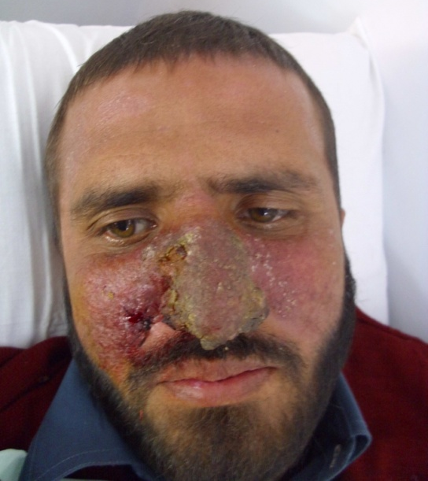 | 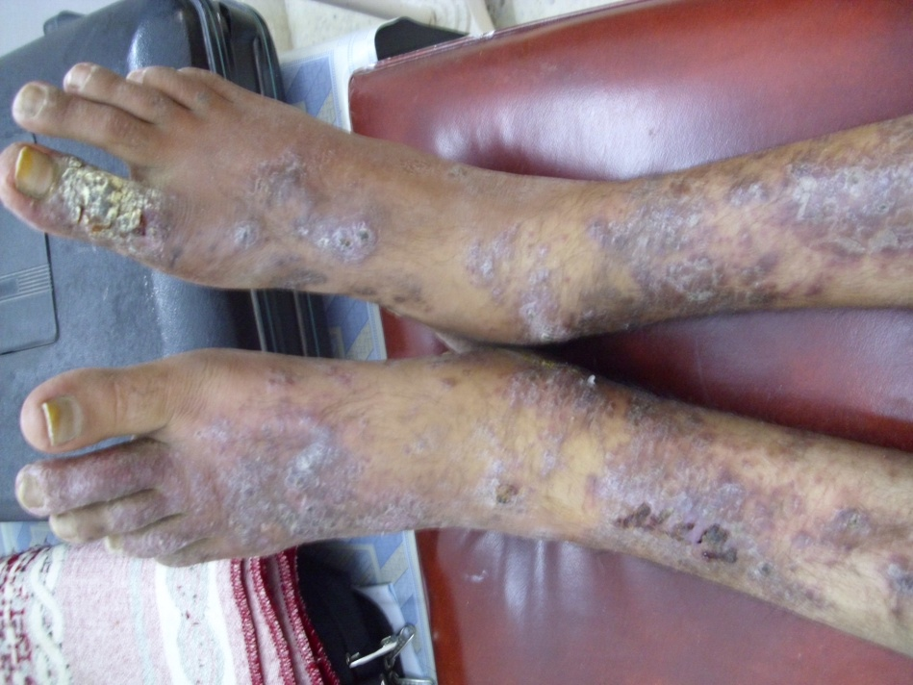
Figures 1 The clinical appearance at presentation.

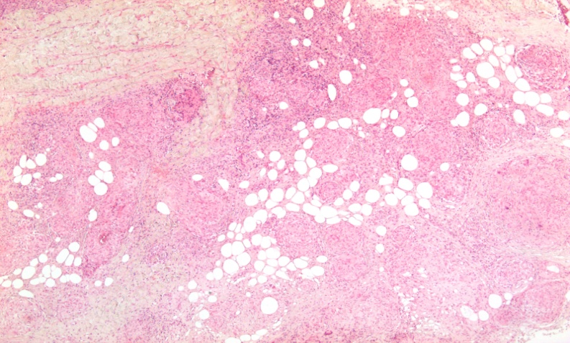
Figure 2 Histopathological appearance showing several discrete, non-caseating, naked granulomas.

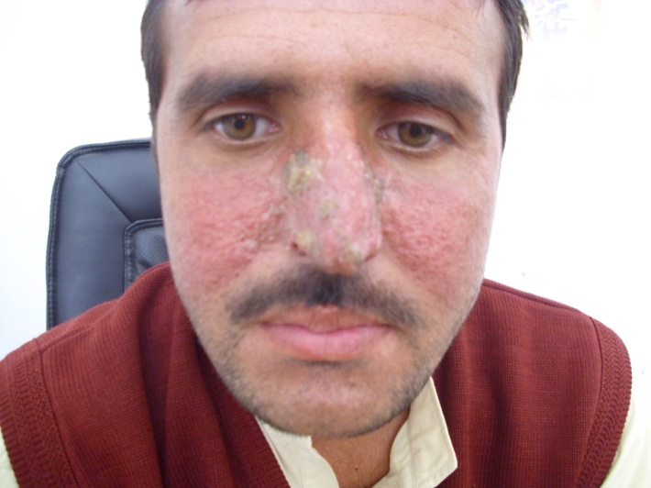 | 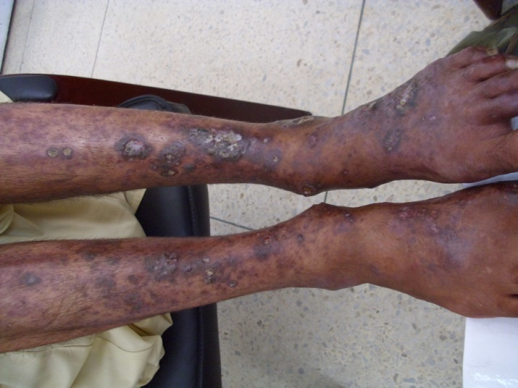
Figure 3 Three months after treatment.

In May 2011, a team of doctors in a well renowned cancer hospital labeled the patient as “non-Hodgkin’s lymphoma” and put him on chemotherapy. From 15th May 2011 to 1st Oct 2011, he received 6 sessions of chemotherapy and spent around 450 thousand rupees. Unfortunately, there was no affect on the skin lesions and lymph nodes even after the completion of chemotherapy. In the meantime VDRL, TPHA, HBsAg, HCV antibodies and Toxoplasma IgG were done and were all negative. A porta hepatis lymph node was biopsied in September 2011, during the chemotherapy, which was reported as “granulomatous inflammation with a possibility of tuberculosis”. After completion of chemotherapy, in November 2011, when there was no response, an axillary lymph node was biopsied and the report was, “excessive atypical lymphoid infiltrate, surrounding extensive granulomatous inflammation”.
Exhausted both physically and financially, he reported to CMH Kohat for another opinion, in December 2011. At this time he had extensive crusted and scaly plaques on the face, upper and lower limbs (Figure 1), with enlarged, cervical, axillary and inguinal lymph nodes. On the basis of his clinical appearance, the differential diagnoses, in order of priority were, disseminated cutaneous leishmaniasis, deep fungal infection, sarcoidosis and cutaneous lymphoma. Skin biopsy was taken from a facial lesion. The biopsy report was, “extensive non-caseating naked epithelioid cell granulomas, with no LT bodies, and PAS stain negative for fungi” (Figure 2). The report was consistent with the diagnosis of “sarcoidosis”. He was then advised chest X-ray, which was normal, ESR was 40mm, Mantoux test was negative, ACE level was 62 IU/L (normal up to 52 IU/L), and serum calcium was on higher side, i.e. 9.7 mg/dl (range 8.6-10.2 mg/dl).
Based on all the above investigations, the patient was diagnosed as “sarcoidosis” and was advised treatment. However, the patient and his family members were not satisfied with the diagnosis, and they took the recent investigations and prescription back to the “cancer hospital” for review. The doctors there performed transbronchial lung biopsy. The lung parenchyma showed acute and chronic inflammation with numerous non-caseating granulomas. Hence they agreed with the diagnosis of Sarcoidosis. Once confirmed by the hospital, the patient reported back to CMH Kohat in March 2012 and started using tab Betnelan (0.5mg) 6 tablets daily in the morning and tab methotrexate 10 mg/week. Within a month the lesions melted down and the patient was remarkably better in 3 months (Figures 3 and 4). The lymphadenopathy also responded, and after 3 months there were no palpable lymph nodes. At that time, tab methotrexate was stopped due to raised transaminase levels, but the steroids were continued and gradually tapered off in 6 months. After 6 months the oral treatment was stopped and only a topical depigmenting agent was prescribed for post-inflammatory hyperpigmentation.
Discussion
Sarcoidosis is a rare multisystem inflammatory disorder which can involve any organ of the body. The histological hallmark is the formation of non-caseating granulomas primarily affecting the lungs but other organs like heart, central nervous system, and skin may be involved. Skin lesions are useful as they can be easily biopsied and many a times help in the diagnosis of internal organ involvement. Hence the cutaneous manifestations may be labeled as “tip of an iceberg”. Cutaneous manifestations occur in 25–30% of the patients with sarcoidosis,¹ but cutaneous sarcoidosis can occur without systemic disease. The cutaneous lesions may be classified as specific or non-specific depending on the presence or absence of granulomatous histology.² Specific lesions include papules, maculopapules, plaques, nodules, lupus pernio, scar sarcoid, ulcerative lesions, hypopigmentation, and many others. Most common non-specific lesion is erythema nodosum. Others include calcifications, prurigo, erythema multiforme, nail clubbing, and sweet syndrome³. Sarcoidosis is most commonly the diagnosis of exclusion, but it requires very high degree of suspicion and precision for the clinical diagnosis as it is easily confused with common disorders like acne, tuberculosis, cutaneous leishmaniasis, deep mycosis, psoriasis, or cutaneous lymphomas.
Prevalence of sarcoidosis in adult population ranges from 10 to 40 per 100,000 in USA and Europe⁴. The incidence of the disease in pediatric patients is not known because of the rarity of the disease and small number of reported cases in childhood. Prevalence of cutaneous sarcoidosis in Pakistan is not exactly known because of non-availability of published data.
The origin of the disease process is not fully understood. Various theories and factors are suggested to be implicated in etiopathogenesis. Antigens of several bacteria may be involved e.g. Mycobacterium tuberculosis, Propionibacterium acnes,⁵ Chlamydia and other atypical species. Mineral dust such as silica and titanium is also implicated. There is association between class I HLA-B8 antigens and acute sarcoidosis. HLA-DRB 1 and DQB 1 have also been associated with sarcoidosis.⁶ Sarcoidosis susceptible genes are present on chromosome 3p and 5q 11.2 and protective genes on region of 5p 15.2.
The development and accumulation of naked granulomas is the main histological abnormality in sarcoidosis. Granulomas in sarcoidosis are compact centrally organized collections of epithelioid cells devoid of or have a sparse rim of lymphocytes. There is depression of cutaneous delayed type hypersensitivity, as demonstrated by a negative Mantoux test, and heightened helper T-cell type response at the sites of the disease. Most granuloma-associated lymphocytes produce high levels of tumor necrosis factor (TNF), Interleukin 12, IL-15, IL-18 and GM-CSF. The CD4+ lymphocytes and immune effector cells such as macrophages, mast cells, and natural killer cells perpetuate inflammatory response by release of cytokines.⁷
No laboratory test is diagnostic of sarcoidosis. Beside skin biopsy, Kveim test is traditionally used for the diagnosis.⁸ The common laboratory findings include elevated ESR, anemia, leucopenia, hypercalcemia, or hypercalciuria. The serum level of ACE is elevated in over 50% of patients with late-onset sarcoidosis.⁹ Chest radiograph may reveal bilateral hilar adenopathy. Bronchoalveolar lavage (BAL) demonstrates the increased number of lymphocytes which are activated helper inducer T cells.
The therapy of choice for cutaneous sarcoidosis with multisystem involvement is systemic corticosteroids. Oral prednisolone is usually initiated at 1-2 mg/kg/day for 4-8 weeks. The drug is gradually tapered depending upon the patient’s clinical improvement.¹⁰ Asymptomatic patients with bilateral hilar adenopathy may not need systemic steroid therapy. Other drugs used in cutaneous sarcoidosis include hydroxychloroquine, methotrexate,¹¹ Allopurinol,¹² thalidomide,¹³ minocycline, and doxycycline.¹⁴ Azathioprine and mycophenolate mofetil (45 mg/kg/day) have been used for their steroid-sparing effects.¹⁵ Biologic agents have recently been employed. The anti-TNF drugs infliximab and etanercept have been used successfully in cutaneous sarcoidosis. Resistance to anti-TNF agents may require a switch to an alternative drug.¹⁶ In lupus pernio, anti-T cell agent alefacept is reported as beneficial.¹⁷ Cutaneous sarcoidosis may also improve with prolonged application of more than 8 weeks of class 1 topical steroid. Intralesional injection of triamcinolone is effective in isolated lesion. Topical tacrolimus has been effective for cutaneous sarcoidosis in several cases. Electrodessication, pulse dye laser, carbon dioxide laser,¹⁸ UVA therapy,¹⁹ photodynamic therapy²⁰ and reconstructive surgical procedures have been used successfully to improve cosmetic disfigurement of cutaneous sarcoidosis, but these interventions do not have effect on disease progression.
The prognosis and natural history of sarcoidosis is unclear, because of the rarity of the disease and small number of cases reported. However, the overall prognosis is good as it is usually self-limiting, non-life-threatening.
As far as the reported case is concerned, there have been negligence and misinterpretation of results by the treating physicians, resulting in prolongation of misery and a significant financial loss. There have been following pitfalls in the case management:
- Granulomas were detected in the 1st skin biopsy, but it was interpreted as granulomatous rosacea.
- First lymph node biopsy reported ill-defined granulomas, but the diagnosis of non-Hodgkin’s lymphoma was made without confirming it with immunohistochemistry.
- The second lymph node biopsy done a month later was of “pseudolymphoma”, which was also ignored.
- The patient was unnecessarily exposed to the hazards and expenses of chemotherapy without proper work-up of the case.
- Even the detection of well-defined granulomas in two lymph node biopsies from porta hepatis and axilla, during chemotherapy did not bother the physicians to think of an alternate diagnosis.
The purpose of presenting this case is to stress upon the fact that proper work up of every case and systematic interpretation of all the investigations is must before proceeding to the treatment. The time taken in the investigations is never lost. In case of doubt never hesitate in getting opinion of your colleagues. Sarcoidosis never kills, but getting treatment for a disease which is never there can be dangerous.
References
- Abu-Hilar M, Krotva J, Chichierchio L et al. Dermatologic aspects and cutaneous manifestations of sarcoidosis G. Ital Dermatol Venereol. 2010;145:733-45.
- Marchell RM, Judson MA. Cutaneous sarcoidosis. Semin Respir Crit Care Med. 2010;31:442-51.
- Fernandez-Faith E, McDonnell J. Cutaneous sarcoidosis: Differential diagnosis. J Clin Dermatol. 2007;25:276-87.
- Hunninghake GW, Costable U, Ando M et al. ATS/ERS/WASOG statement of sarcoidosis. American Thoracic Society/European Respiratory Society/World Association of Sarcoidosis and other Granulomatous Disorders. Sarcoidosis Vasc Diffuse Lung Dis. 1999;16:149-73.
- Ishige I, Eishi Y, Takemura T et al. Propionibacterium acnes is the most common bacterium commensal in peripheral lung tissue and mediastinal lymph nodes from subjects without sarcoidosis. Sarcoidosis Vasc Diffuse Lung Dis. 2005;22:33-42.
- Ishihara M, Ohno S, Ishida T et al. Molecular genetic studies of HLA class II alleles in sarcoidosis. Tissue Antigens. 1994;43:238-41.
- Agostini C, Semenzato G. Biology and immunology of the granuloma. In: James DG, Zumla A, eds. The Granulomatous Disorders. Cambridge: Cambridge University Press; 1999. P.3-16.
- Munro CS, Mitchell DN. The Kveim response: still useful, still a puzzle. Thorax. 1987;42:321-31.
- Callen JP, Hanno R. Serum angiotensin converting enzyme in patients with cutaneous sarcoidosis. Arch Dermatol. 1982;118:232-3.
- Badgwell C, Rosen T. Cutaneous sarcoidosis therapy updated. J Am Acad Dermatol. 2007;56:69-83.
- Veien NK, Brodthagen H. Cutaneous sarcoidosis treated with methotrexate. Br J Dermatol. 1977;97:213-6.
- Bregnhoej A, Jemec GB. Low-dose allopurinol in the treatment of cutaneous sarcoidosis: response in four of seven patients. J Dermatolog Treat. 2005;16:125-7.
- Nguyen YT, Dupuy A, Cordoliani F et al. Treatment of cutaneous sarcoidosis with thalidomide. J Am Acad Dermatol. 2004;50:235-51.
- Bachelez H, Senet P, Cadranel J et al. The use of tetracyclines for the treatment of sarcoidosis. Arch Dermatol. 2001;137:69-73.
- Kouba DJ, Mimouni D, Rencic A, Nousari HC. Mycophenolate mofetil may serve as a steroid-sparing agent for sarcoidosis. Br J Dermatol. 2003;148:147-8.
- Khanna D, Leibling M, Louie J. Etanercept ameliorates sarcoidosis arthritis and skin disease. J Rheumatol. 2003;30:1864-5.
- Garcia-Zuazaga J, Korman NJ. Cutaneous sarcoidosis successfully treated with alefacept. J Cutan Med Surg. 2006;10:300-3.
- O’Donoghue NB, Barlow RJ. Laser remodelling of nodular nasal lupus pernio. Clin Exp Dermatol. 2006;31:27-9.
- Graefe T, Konrad H, Barta U et al. Successful ultraviolet A1 treatment of cutaneous sarcoidosis. Br J Dermatol. 2001;145:354-5.
- Gilaberte Y, Serra-Guillen C, de las Heras ME et al. Photodynamic therapy in dermatology. Actas Dermosifi Liogr. 2006;97:83-102.

