Case Report
Bleomycin induced flagellate pigmentation and sclerodermoid change co-existent in a patient of Hodgkin’s lymphoma
Sudip Das, Joyeeta Chowdhury, Suchibrata Das

Department of Dermatology, N.R.S. Medical College and Hospital, Kolkata

Abstract | Bleomycin is a chemotherapeutic drug known to cause a variety of cutaneous side-effects. Pigmentary changes are the commonest. We report a case of bleomycin induced flagellate pigmentation and sclerodermoid change co-existent in a patient of Hodgkin’s lymphoma.  Key words  Bleomycin, flagellate pigmentation, sclerodermoid change.

Introduction
Bleomycin is a glycopeptide antibiotic produced by bacterium Streptomyces verticillus. It causes breakage in DNA. It is used in the treatment of Hodgkin’s lymphoma, squamous cell carcinoma, testicular cancer and plantar warts.
Hydrolase rapidly inactivates bleomycin. This hydrolase is present in every organ except skin and lungs which accounts for the frequency of cutaneous side effects.
The administration of bleomycin has been associated with alopecia, Raynaud's phenomenon, sclerodermoid changes, various pigmentary changes, painful inflammatory nodules on fingers, warty hyperkeratotic plaques on the knees and elbows, digital gangrene, erythema multiforme, mucocutaneous ulcerations, stomatitis and radiation recall.^{1,2,3} Hyperpigmentation associated with bleomycin may be diffuse, patchy or linear. The linear type is characterised by band like or "flagellate" cutaneous hyperpigmentation in areas of trauma, occurring predominantly on the trunk and proximal extremities and has been reported to occur in up to 66% of patients.⁴ This flagellate pigmentation is also known as scratch dermatitis.^{5,6} The pigmentation usually resolves within a few months after treatment.
Case report
A 40-year-old gentleman presented with multiple linear and diffuse hyperpigmented lesions over upper trunk for last 7 months. It was associated with itching, followed by tender hard swelling over right foot. Patient was suffering from Hodgkin’s lymphoma. He received six cycles of chemotherapy containing bleomycin, vinblastine, doxorubicin and dacarbazine which ended 2 months ago. The chemotherapy regime was as follows: inj. adriamycin 25 mg/m² – day 1 and 15, inj. bleomycin 10 mg/m² – day 1 and 15, inj. vinblastine 6 mg/m² – day 1 and 15 and inj. dacarbazine 375 mg/ m² – day 1 and 15.
Address for correspondence
Dr. Sudip Das
Associate Professor
Dermatology &Venereology Department,
138, AJC Bose Road, Kolkata NRSMCH
Email: drsudip1966@yahoo.co.in
Cell# +919433423929
He started developing pruritus a few days after the first cycle. But the linear hyperpigmentation lines over the trunk were

Figure 1 Flagellate pigmentation on trunk

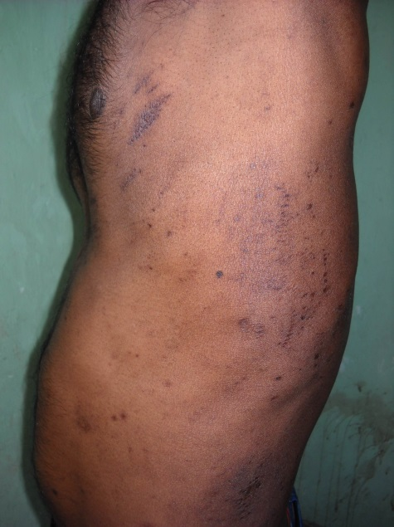
Figure 2 Flagellate pigmentation with excoriation marks.

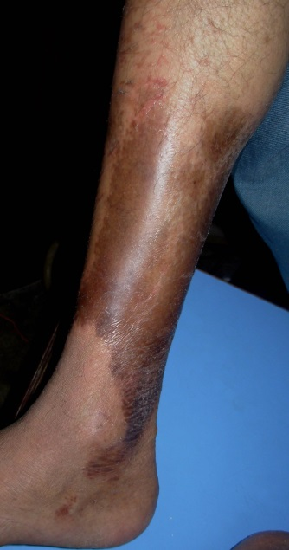
Figure 3 Sclerodermoid change.
noted after the second cycle. After the third cycle the patient noticed a painful swelling over his right lower leg that gradually increased in size. It was followed by hyperpigmentation and hardening of the skin. Examination revealed multiple linear flagellate pigmentation over the trunk (Figure 1) with few excoriation marks (Figure 2). There was an area of sclerodermoid change over the right lower leg and it was tender on palpation (Figure 3). Both the flagellate pigmentation and sclerodermoid change resolved within 5 months of stopping chemotherapy and application of topical corticosteroids.
Discussion
Flagellate linear hyperpigmentation is the characteristic lesion associated with bleomycin and is seen in about 20-30% of cases, primarily on the upper trunk and limbs.⁷ It is dose dependent, occurring after a cumulative dose of 90 and 285 mg, but some cases have been reported with doses as low as 15 mg given parenterally. It follows the administration of bleomycin by a duration ranging from 1 day to 9 weeks⁷ and may persist for up to 6 months.⁵ The exact pathogenesis of these lesions is not known. Some authors consider that the linear lesions result from increased leakage of the drug from dilated vessels after rubbing or scratching the skin. The reason for the increased pigmentation is thought to be due to increased melanocyte stimulation by melanocyte stimulating hormone and stimulation of melanocytes by adrenocorticotrophic hormone.⁸ In our patient the flagellate pigmentation started appearing after the second cycle. It was preceded by pruritus. He noticed tightness over his right lower leg after the third cycle.
This was a rare case of bleomycin induced flagellate pigmentation co-existent with sclerodermoid change.

References
- Hood AF. Cutaneous side effects of cancer chemotherapy. Med Clin N Am. 1986;70:187-209.
- Weiss RB, Bruno S. Hypersensitivity reactions to cancer chemotherapeutic agents. Ann Int Med. 1981;94:66-74.
- Soble AR. Chronic bleomycin-associated Raynaud's phenomenon. Cancer Treatment Reports. 1978;60:570.
- Gupta L, Tanwar R K, Khare A, Jain S. Bleomycin induced flagellate pigmentation. Indian J Dermatol Venereol Leprol. 2002;68:158-9.
- Duhra P, Ilchyshyn A, Das RN. Bleomycin-induced flagellate erythema. Clin Exp Dermatol. 1991;16:216-7.
- Kerr LD, Spiera H. Scleroderma in association with the use of bleomycin. J Rheumatol. 1992;19:294-6.
- Mowad CM, Nguyen TV, Elenitsas R, Leyden JJ. Bleomycin induced flagellate dermatitis: a clinical and histopathological review. Br J Dermatol. 1994;131:700-2.
- Cortina P, Garrido JA, Tomas JF et al. 'Flagellate' erythema from bleomycin with histopathological findings suggestive of inflammatory oncotaxis. Dermatologica. 1990;180:106-9.

