Original Article
Efficacy and safety of tap water iontophoresis for palmoplantar hyperhidrosis
Talat Masood Akbar, Mahmood A. Saqib, Sundas Fahim, Mohammad Nasir, Haroon Nabi

Department of Dermatology, Lahore Medical & Dental College/Ghurki Trust Hospital, Lahore

Abstract | Objective To evaluate the efficacy and safety of tap water iontophoresis (TWI) for the treatment of palmoplantar hyperhidrosis in our local setting.  Patients and methods Thirteen patients of idiopathic palmoplantar hyperhidrosis were enrolled in the study from the Department of Dermatology, Lahore Medical and Dental College/Ghurki Hospital and Skin Clinic, Gulberg, Lahore from May 2009 to August 2012. Two patients dropped out, and the study was completed by eleven patients. The patients were treated with TWI three times a week for six weeks and followed up at twelve weeks. Each session lasted for 20 minutes, with the polarity being reversed after 10 minutes. The results were assessed by the hyperhidrosis disease severity index, improvement of sweating on a scale of I to IV and the starch-iodine test. Any adverse events were noted.  Results All the patients responded well to the treatment with minimal discomfort.  Conclusion Tap water iontophoresis is a safe, effective, inexpensive and affordable treatment modality for palmoplantar hyperhidrosis. It improves quality of life significantly during treatment.  Key words  Tap water iontophoresis, hyperhidrosis.

Introduction
Hyperhidrosis is an excessive production of sweat more than the physiological amount necessary to maintain thermal homeostasis. Primary focal hyperhidrosis is a disorder of unknown etiology, causing excessive, bilateral, symmetrical sweating of palms, soles, axillae and craniofacial regions.^{1,2} The condition results not only in physical impairment, but also interferes with professional and social life. It has a significant impact on the patient’s quality of life with a potential for social stigmatization.^{2,3}
Studies estimated the incidence of idiopathic hyperhidrosis to be 0.6-1.0%.^{4,5}
Thermoregulatory control is regulated through cerebral cortical structures, anterior hypothalamus, and the sympathetic nervous system. Sato et al.⁴ have speculated that the hypothalamic sweat centre that controls sweating in the palms and soles is distinct from the rest of the hypothalamic sweat centers. The pathophysiology of primary hyperhidrosis is poorly understood, but believed to be associated with overstimulation via an autonomic pathway. Someone with palmar sweating may suffer episodic sweating with either social stress or high ambient temperature.¹
Address for correspondence
Dr. Talat Masood Akbar
Department of Dermatology
Lahore Medical & Dental College,
Ghurki Trust Teaching Hospital, Lahore.
Ph: +92 3004125163
Email: dr.talatakbar@gmail.com

Excessive sweating is extremely debilitating. It leads to clammy hands and feet, even dripping of sweat from the hands. It makes any physical contact like shaking hands, holding hands or hugging, embarrassing for the patient. Sweat stains clothing, saturates socks, so appearance is humiliating.
Palmoplantar hyperhidrosis is occupationally disabling. For students, their pens slip from their hands, sweat stains the papers and causes blurring of ink, making examinations a nightmare. Sports are difficult with rackets, bats and balls slipping from fingers. Professionally, use of electrical equipment is dangerous and metal objects can rust. The condition predisposes to or worsens diseases like fungal infections, contact dermatitis, pompholyx and pitted keratolysis.
A variety of treatments have been used to control or reduce the profuse sweating involving the palms, soles and axilla. Various treatment options available are topical applications like aluminium chloride, glutaraldehyde and glycopyrronium bromide, iontophoresis with tap water or anticholinergics, botulinum toxin injections, systemic anticholinergic drugs or sympathectomy.^{1,5-10} Topical aluminium chloride is usually the first line therapy for palmoplantar hyperhidrosis,¹¹ but clinically it is not usually effective for more severe disease.
Bouman et al.¹² first used iontophoresis to treat hyperhidrosis, and interest was revived by the use of a simple device by Levit.¹³ During the past 50 years, tap water iontophoresis (TWI) has been established as the most effective, safe, and inexpensive therapeutic modality for palmoplantar hyperhidrosis.^{6,7,11-15}
The mechanism of action of TWI is unknown. Various theories postulate eccrine ductal blockage without damage to sweat ducts,¹⁶ hyperkeratinization and obstruction of eccrine sweat duct,¹⁷ blockage of neuroglandular transmission and inhibition of secretory mechanism at cellular level.¹⁸
The aim of this study was to evaluate the efficacy and safety of tap water iontophoresis in our local setting.
Patients and methods
This was an open-label study with patients recruited from the Skin Clinic, Gulberg and Lahore Medical and Dental College/Ghurki Hospital, Lahore from May 2009 to August 2012.
Patients diagnosed with idiopathic palmoplantar hyperhidrosis between the ages of 14 to 45 years of age were enrolled, according to the following diagnostic criteria recommended by Hornberger et al.¹ I. Patient should have focal, visible, excessive sweating, of six months duration; without apparent cause; and II. Two or more of the following: 1. Bilateral and symmetric sweating, 2. Impairment of daily activities, 3. At least one episode per week, 4. Onset of less than 25 years, 5. Positive family history, 6. Cessation of focal sweating during sleep.
Patients who were pregnant or lactating, had any cuts, abrasions, eczema or infections on hands, had a history of ischemic heart disease, with metal implants like pacemakers, or those who had previous treatments like botulinum toxin or sympathectomy were excluded.
All patients had the procedure explained to them and had to sign a written consent form. A detailed history and clinical examination were performed. Investigations included CBC, T3, T4, TSH and fasting blood sugar. A starch iodine test was done to define areas of hyperhidrosis. Findings and adverse events were noted on a predesigned pro forma.

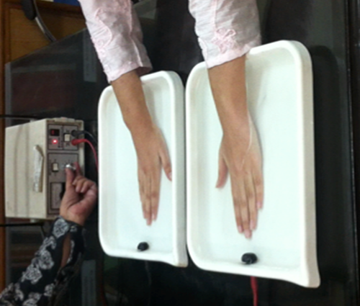
Figure 1 The iontophoresis procedure

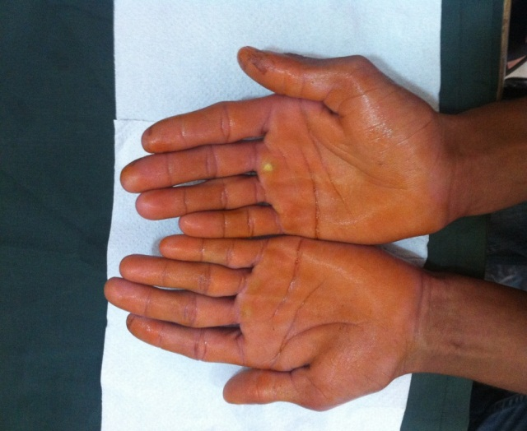
Figure 2a Hands painted with iodine.

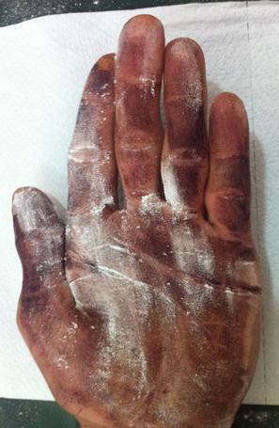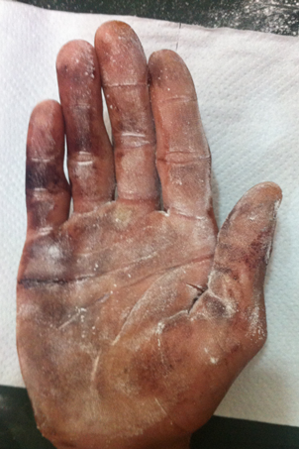
Figure 2b Areas of hyperhidrosis turn blue-black after dusting with starch powder.
Patients had thrice weekly treatments of iontophoresis with tap water for 6 weeks. The procedure was performed with a single machine (Fischer MD-1a, USA). The apparatus consisted of a machine that delivered direct current between 0-50mA (controlled by a dial), and two water bath trays connected to it by leads. The patient immersed both hands in pronated position in separate water baths, current intensity was slowly increased till a maximum comfortable level was achieved, maintained for 10 minutes and then reduced to zero (Figure1). Polarity was reversed (by a switch on the machine), current was again slowly increased to tolerable level, allowed to pass for another 10 minutes and then reduced. Patients could then take their hands out of the water.
Assessment of severity was done at baseline, week 3 and 6, with a follow up at week 12. Severity was graded from 1-4 according to the Hyperhidrosis Disease Severity Scale indicating the extent of interference with patient’s daily activities¹⁸ as: 1. Never noticeable, never interferes; 2. Tolerable, sometime interferes; 3. Barely tolerable, frequently interferes; and 4. Intolerable and always interferes.
Subjective improvement in sweating was graded as: grade I: 1-25%; grade II: 26-50%; grade III: 51-75%; and grade IV: 76-100%.
The starch iodine test was done pre-treatment to define areas and severity of hyperhidrosis and at weeks 6 and 12. The hands were painted with 1% iodine, allowed to dry, then dusted with starch powder. Areas of sweating turned dark blue-black in colour (Figure 2a, b).
Results
Thirteen patients were enrolled in the study. Two dropped out and the study was completed by eleven patients. There were 5 (45.4%) males and 6 (54.5%) females. Ages ranged between 15 and 32 years, with a mean of 21 years.

Table 1 Hyperhidrosis Disease Severity Index.
Disease severity | N (%)
 | Pretreatment | 6 Weeks | 12 Weeks
1 | 0 | 0 | 0
2 | 2 (18.2) | 8 (72.7) | 3 (27.3)
3 | 5 (45.5) | 2 (18.2) | 6 (54.5)
4 | 4 (36.3) | 1 (9.1) | 2 (18.2)

Figure 3 Improvement in Sweating as assessed by the patient.

Table 2 Side effects noted during treatment (n=11).
Side effects | N (%)
Tingling | 11 (100)
Irritation along water line | 5 (45.5)
Erythema | 2 (18.2)
Electric shock on removing hands from water | 1 (9.1)
Vesicles | 0
Burning | 0
The Hyperhidrosis Disease Severity Index indicated that pretreatment 5 patients (45.5%) had 3-point severity (barely tolerable, frequently interferes with patients daily activities), and 4 (36.3%) patients had 4-point severity (intolerable, always interferes with daily activities). At week six, 8 patients (72.7%) had a 2-point intensity scale (tolerable, sometimes interferes with daily activities) and 2 patients (18.2%) had a 3-point scale, with only 1 patient (9.1%) having a 4-point scale. However, at 12 week follow-up, 6 patients (54.5%) had a 3-point scale with 3 (27.3%) patients in 2-point and 2 patients (18.2%) in 4-point scale (Table 1).
Figure 4(a) Starch iodine test: pretreatment.

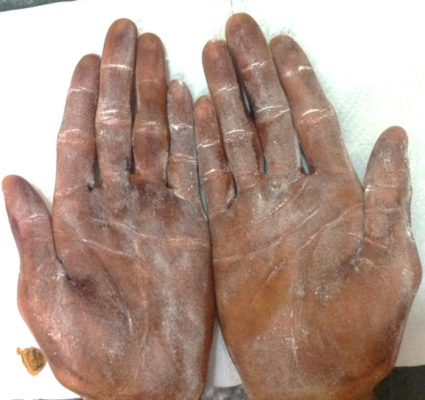Figure 4(b) Posttreatment.
Subjective assessment of improvement in sweating was made as patients were asked to score improvement on a scale of 1-4 (Figure 3). At week 3, grade I improvement was seen in one patient (9.1%), grade II in two patients (18.2%), grade III in 7 (63.6%) and grade IV in one patient (9.1%). At 6 weeks, one patient (9.1%) had grade II improvement, nine (81.8%) had grade III, and one (9.1%) had grade IV improvement. However at week 12 follow up, six patients (54.5%) had grade I improvement, two patients (18.2%) each had grade II and III improvement and one patient (9.1%) had grade IV (Figure 3).
Starch iodine test showed improvement of hyperhidrosis during treatment (Figure 4).
Side effects were noted as tingling, which affected all patients (Table 2). Five patients felt irritation of hands along the water line. One had a mild feeling of electrical shock on removing hands from water, while two patients had erythema on their hands. No patients had vesicles or burning of hands.
Discussion
Previous studies have shown that iontophoresis using tap water alone is effective in treating hyperhidrosis.^{6,7,15,16} Our study, although limited by the small number of patients, also indicates that tap water iontophoresis is an effective treatment modality for palmoplantar hyperhidrosis. The treatment resulted in improvement of sweating in all our patients, although of varying degrees, as assessed by both the hyperhidrosis disease severity index and the subjective improvement of sweating.
It is a safe procedure, as none of the patients suffered any serious side-effects.
However, six weeks after cessation of treatment, both the hyperhidrosis disease severity score and the subjective improvement of sweating showed worsening, though not to pre-treatment levels. It may suggest that maintenance therapy sessions are needed, although less frequently.
Conclusion
TWI is an effective and well-tolerated treatment for palmoplantar hyperhidrosis.
It is simple, inexpensive and affordable for patients in our country, so should be used more frequently to alleviate the distressing symptoms.
An inherent problem is the inconvenience of required hospital visits 2-3 times a week for 20 minute sessions. Also, the patient needs follow-up maintenance treatments, although less frequently after these sessions. Our recommendation is the use of smaller home devices for maintenance treatment, if patient can afford it. With technology becoming less expensive, we may soon have affordable home-use units within reach of our patients.
References
- Hornberger J, Grimes K, Neuman M et al. Recognition, diagnosis and treatment of primary focal hyperhidrosis. J Am Acad Dermatol. 2004;51:274-86.
- Swartling C, Naver H, Lindberg M. Botulinum A toxin improves life quality in severe primary focal hyperhidrosis. Eur J Neurol. 2001;8:247-52.
- Naumann MK, Hamm H, Spalding JR et al. Comparing the quality of life effect of primary focal hyperhidrosis as assessed by the Dermatology Life Quality Index (DLQI). Paper presented at the July 2003 meeting of the American Academy of Dermatology; July 25–29, 2003; Chicago, Ill.
- Sato K, Kang WH, Saga K, Sato KT. Biology of sweat glands and their disorders. II. Disorders of sweat gland function. J Am Acad Dermatol. 1989;20:713-26.
- Manusov EG, Nadeau MT. Hyperhidrosis: a management dilemma. J Fam Pract. 1989;28:412-5.
- Stolman LP. Treatment of excess sweating of the palms by iontophoresis. Arch Dermatol. 1987;123:893-6.
- Dahl JC, Gland Madsen L. Treatment of hyperhidrosis manuum by tap water iontophoresis. Acta Derm Venereol Stockh. 1989;69:346-8.
- Shelley WB, Talanin NY, Shelley ED. Botulinum toxin therapy for palmar hyperhidrosis. J Am Acad Dermatol. 1998;38:227-9.
- Moran KT, Brady MP. Surgical management of primary hyperhidrosis. Br J Surg. 1991;8:279-83.
- Bonjer HJ, Hamming JF, DuBois NAJJ et al. Advantages of limited thoracoscopic sympathectomy. Surg Endosc. 1996;10:721-3.
- To ̈gel B, Greve B, Raulin C. Current therapeutic strategies for hyperhidrosis: a review. Eur J Dermatol. 2002;12:219-23.
- Bouman HD, Lentzer EM. The treatment of hyperhidrosis of the hands and feet with constant current. Am J Phys Med. 1952;31:158-69.
- Levit F. Simple device for the treatment of hyperhidrosis by iontophoresis. Arch Dermatol. 1968;98:505-7.
- Shen JL, Lin GS, Li WM. A new strategy of iontophoresis for hyperhidrosis. J Am Acad Dermatol. 1990;22 (2 Part 1):239-41.
- Chan LY, Tang WYM, Lo KK et al. Treatment of palmar hyperhidrosis using tap water iontophoresis: local experience. HKMJ. 1999;5;191-4.
- Templeton EA, Sato E, Sato K. Mechanism of action of tap water iontophoresis for hyperhidrosis and simple innovation for improving its efficacy. J Invest Dermatol. 1985;84:360.
- Shelley WB, Horvath PN, Weidman F et al. Experimental miliaria in man: production of sweat retention, anhidrosis, and vesicles by means of iontophoresis. J Invest Dermatol. 1948;11:275-89.
- Holzle E, Ruzicka T. Treatment of hyperhidrosis by a battery-operated iontophoretic device. Dermatologica. 1986;172:41-7.
- Stratton DR, Kowalski JW, Galser DA, Stang PE. US prevalence of hyperhidrosis and impact on individuals with axillary hyperhidrosis: results from a national survey. J Am Acad of Dermatol. 2004;51:241-8.

