Original Article
A clinical and histopathological study of cicatricial alopecia
Neerja Puri

Consultant Dermatologist, Punjab Health Systems Corporation, Ludhiana, Punjab, India

Abstract | Objective To document the causes and clinical and histopathological features of cicatricial alopecia.  Patients and methods A study of 40 patients was conducted to study the clinical variants and histopathology of cicatricial alopecia.  Results In our study, major causes of cicatricial alopecia were lichen planopilaris (27.5%), discoid lupus erythematosus (25%), pseudopelade of Brocq (20%), systemic lupus erythematosus (5%) followed by scleroderma, dermatomyositis, keratosis follicularis spinulosa decalvans, aplasia cutis, kerion, follicular mucinosis, pemphigus, dissecting cellulitis of scalp/ pyogenic folliculitis and acne keloidalis nuchae in 2.5% cases each. Morphological features included epidermal atrophy in 90%, erythema in 55%, follicular plugging in 40%, telangiectasia in 27.5%, diffuse scaling in 25% and mottled hyperpigmentation in 20% patients. The commonest histopathological features were perifollicular fibrosis in 65%, basal cell vacuolization in 52.5%, perifollicular lymphocytic infiltrate in 50%, epidermal atrophy in 35% and hyperkeratosis in 20% patients.  Conclusion  Lichen planopilaris, discoid lupus erythematosus, pseudopelade of Brock were the common causes of cicatricial alopecia in the studied population.  Key words  Cicatricial alopecia, histopathological, lichen planopilaris, folliculitis, lupus erythematosus.

Introduction
Cicatricial (scarring) alopecia refers to a group of rare disorders which destroy the hair follicle and replace it with scar tissue, thereby causing permanent hair loss.¹ Causes of cicatricial alopecia are considered either primary or secondary. In primary cicatricial alopecia, the hair follicle is the target of inflammatory destruction, with little effect of the disease process on other components of the dermis.² Examples of primary alopecia include discoid lupus erythematosus, lichen planopilaris, central centrifugal cicatricial alopecia, pseudopelade of Brocq, folliculitis decalvans, and acne keloidalis.^{3,4} In secondary cicatricial alopecia, the hair follicle is an "innocent bystander" and is destroyed indirectly. Examples of secondary alopecia include burns and blistering disorders such as pemphigus vulgaris. In primary cicatricial alopecia, there is an inflammatory assault directed primarily at the follicular unit. Although the antigenic trigger for this inflammation is unclear, there is eventually loss of the sebaceous glands and follicular stem cells leading to permanent hair loss. The term "cicatricial alopecia" or scarring alopecia implies the potential of permanent destruction of hair follicle most likely as a result of irreversible damage to epithelial hair follicle stem cells in the region of bulge.
Address for correspondence
Dr. Neerja Puri, Consultant Dermatologist, Punjab Health Systems Corporation,
Ludhiana, Punjab, India
Email: neerjaashu@rediffmail.com
In some cases, hair loss is gradual, without symptoms, and is unnoticed for long periods. In other cases, hair loss is associated with severe itching, burning and pain and is rapidly progressive. The inflammation that destroys the follicle is below the skin surface and there is usually no "scar" seen on the scalp. Affected areas of the scalp may show little signs of inflammation, or have redness, scaling, increased or decreased pigmentation, pustules, or draining sinuses.⁵
The present study aimed to study the causes and clinical and histopathological features of cicatricial alopecia.
Patients and methods
We selected 40 patients of cicatricial alopecia for the study. Written informed consent of all the patients was taken, as well as, prior approval of hospital ethical committee. All the patients were subjected to detailed clinical examination. Routine investigations of all the patients were performed including complete blood count, fasting blood sugar, liver function tests, renal function tests and X-ray chest. Specialized investigations done included antinuclear antibodies, VDRL and scalp biopsy. For histopathology, 4 mm punch biopsy of all the patients was performed and both vertical and horizontal sections were prepared and stained with hematoxylin and eosin.
Results
Out of 40 patients, there were 24 (60%) females and 16 (40%) males and female: male ratio was 1.5:1. The maximum number of patients (37.5%) with cicatrical alopecia was between 41-50 years (Table 1). Twelve (30%) patients had single patch and 28 (70%) patients had multiple patches of alopecia.

Table 1 Age distribution of patients (n=100).
Age group (years) | N (%)
≤10 | 1 (2.5)
11-20 | 1 (2.5)
21-30 | 8 (20)
31-40 | 14 (35)
41-50 | 15 (37.5)
51-60 | 1 (2.5)

Table 2 Etiology of cicatrical alopecia (n=40).
Etiological cause | N (%)
Lichen planopilaris | 11 (27.5)
Discoid lupus erythematosus | 10 (25)
Pseudopelade of Brocq | 8 (20)
Systemic lupus erythematosus | 2 (5)
Scleroderma | 1 (2.5)
Dermatomyositis | 1 (2.5)
Keratosis follicularis spinulosa decalvans | 1 (2.5)
Aplasia cutis | 1 (2.5)
Kerion | 1 (2.5)
Follicular mucinosis | 1 (2.5)
Pemphigus | 1 (2.5)
Dissecting cellulitis of scalp/ pyogenic folliculitis | 1 (2.5)
Acne keloidalis nuchae | 1 (2.5)

Table 3 Clinical features of cicatricial alopecia seen in the study population (n=40).
Clinical features | N (%)
Atrophy | 36 (90)
Erythema | 22 (55)
Follicular plugging | 16 (40)
Diffuse scaling | 10 (25)
Telangiectasia | 9 (27.5)
Mottled hyperpigmentation | 8 (20)

Table 4 Histopathological features of cicatricial alopecia (n=40).
Histopathological features | N (%)
Perifollicular fibrosis | 26 (65)
Follicular plugging | 22 (55)
Basal cell vacuolization | 21 (52.5)
Perifollicular lymphocytic infiltrate | 20 (50)
Epidermal atrophy | 14 (35)
Hyperkeratosis | 8 (20)
The maximum number of cases of cicatrical alopecia (27.5%) was of lichen planopilaris (LPP) [Figure 1] followed by 25% of discoid lupus erythematosus (DLE) [Figure 2], and 20% patients had pseudopelade of Brocq (PB) [Table 2]. Amongst the less frequent causes, systemic lupus erythematosus (SLE) was seen in 5% cases followed by scleroderma, dermatomyositis, keratosis follicularis
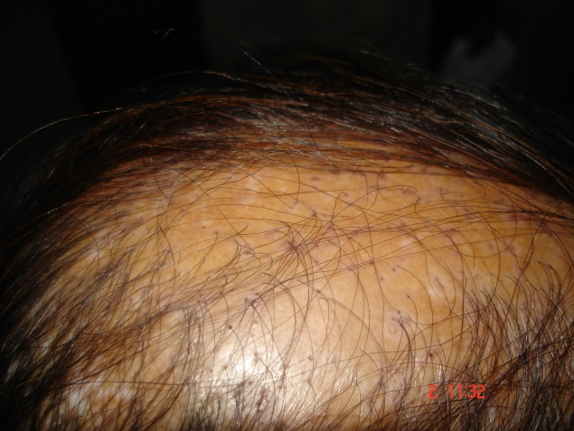
Figure 1 Atrophic violaceous plaque of lichen planopilaris.

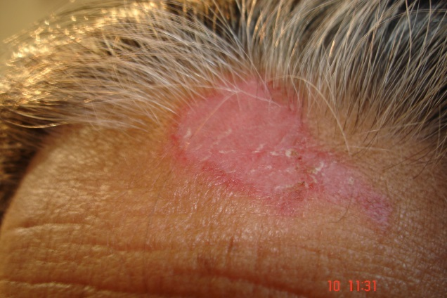
Figure 2 Erythematous scaly plaque of DLE on forehead.

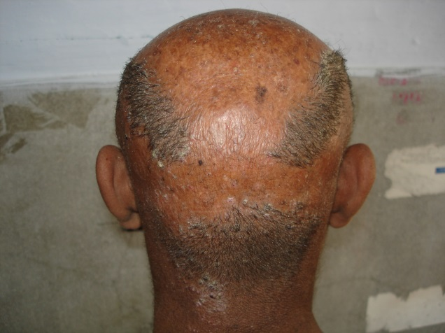
Figure 3 Atrophic scaly plaque of keratosis follicularis atrophicans decalvans.
spinulosa decalvans (Figure 3), aplasia cutis, kerion, follicular mucinosis, pemphigus, dissecting cellulitis of scalp/ pyogenic folliculitis (Figure 4) and acne keloidalis nuchae in 2.5% cases each.
Different clinical features noted included (Table 3), epidermal atrophy (90%), erythema (55%), follicular plugging (40%),
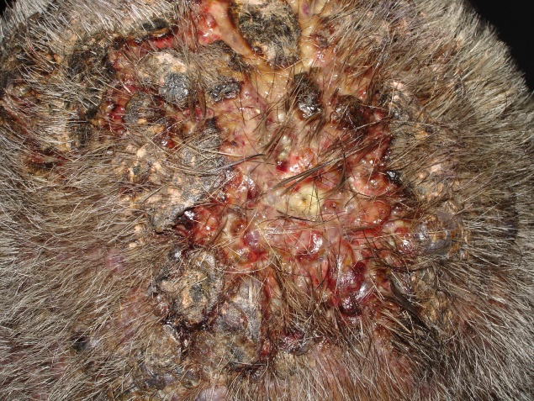
Figure 4 Pustular folliculitis in a 50-year-old man.

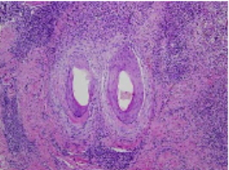
Figure 5 Photomicrograph showing lymphocytic bandlike infiltrate involving the infundibulum (H&E stain 100X).
telangiectasia (27.5%), diffuse scaling (25%) and mottled hyperpigmentation (20%).
Table 4 shows that the commonest histopathological feature of alopecia was perifollicular fibrosis seen in 65% patients, followed by basal cell vacuolization in 52.5%, perifollicular lymphocytic infiltrate in 50%, epidermal atrophy in 35% and hyperkeratosis in 20% patients.
Discussion
In our study, maximum number of patients with cicatrical alopecia was between 41-50 years (37.5%), followed by 35% patients between 31-40 years, 20% patients between 21-30 years. Females outnumbered males with a ratio of 1.5:1. 70% patients had multiple patches of alopecia. In our study, the maximum number of cases of cicatrical alopecia were due to LPP (27.5%) followed by DLE (25%) and pseudopelade of Brocq (25%). Less frequent causes were SLE in 5% cases followed by scleroderma, dermatomyositis, keratosis follicularis spinulosa decalvans, aplasia cutis, kerion, follicular mucinosis, pemphigus, dissecting cellulitis of scalp/ pyogenic folliculitis and acne keloidalis nuchae in 2.5% cases each. Regarding the morphology of lesions, epidermal atrophy was seen in 90% patients, erythema in 55% cases, follicular plugging in 40% patients, telangiectasias in 27.5% patients, diffuse scaling in 25% patients and mottled hyperpigmentation in 20% patients. In our study, the commonest histopathological feature of alopecia was perifollicular fibrosis seen in 65% patients, basal cell vacuolization in 52.5% patients, perifollicular lymphocytic infiltrate in 50% patients, epidermal atrophy in 35% patients and hyperkeratosis in 20% patients.
The combination of diffuse scaling, erythema, telangiectasia, and mottled hyperpigmentation within areas of scarring alopecia was a distinctive feature of DLE.^{6,7} In most patients with LP, the histologic changes involved only the follicles and the perifollicular dermis. Less frequently, the inflammatory process extended to the epidermis and the papillary dermis. In all cases, histopathologic features allowed LP (Figure 5) to be distinguished from DLE regardless of the stage of the disease. The finding of a bandlike fibrotic thickening of the papillary dermis accompanied by fibrotic tracts at sites of destroyed follicles appeared to be a hallmark of "burnt out" lesions of LP. Most early lesions of lichen planopilaris showed a focally dense band like perifollicular lymphocytic infiltrate at the level of infundibulum and the isthmus where the hair ‘bulge’ is located.
Three types of alopecia have been described in patients with SLE: 1) discoid lesions with associated scarring alopecia; 2) a diffuse non-scarring alopecia with transient hair loss related to the activity of the disease (a telogen effluvium like picture); and 3) lupus hair which is an unusual type of non-scarring alopecia characterized by thin, weakened hair at the periphery of the scalp. The hair fragment and result in a characteristic unruly appearance. In addition alopecia areata has been discovered in patients with SLE rarely scarring DLE and non-scarring AA like lesions may coexist in the same patient.
In a study of 89 patients with scarring alopecia and DLE showed a lymphocytic infiltrate mainly directed to the mid portion of the follicle and a normal anagen: telogen ratio.⁸ The authors postulated that the loss of follicle may be due to the destruction of the stem cells which reside in the bulge area where the arrector pili muscle inserts.
Pseudopelade of Brocq (PB) is a permanent progressive scarring alopecia characterized by numerous alopecic patches localized only in the scalp, that tend to coalesce into larger, irregular plaques with polycyclic borders. PB can be considered either the final atrophic stage of several scarring disorders such as lichen planus pilaris (LPP) and discoid lupus erythematosus (DLE) (secondary PB) or an autonomous disease (primary PB). PB is a type of scarring alopecia of the scalp associated with a peculiar clinical presentation and evolution, which cannot be considered an autonomous nosologic entity because in 66.6% of patients it is the end stage of other inflammatory chronic diseases such as LPP and DLE.⁹ The early evolving lesions of the hair follicles are described in pseudopelade, a type of cicatricial alopecia where clues for the diagnosis of lupus erythematosus or lichen planopilaris are lacking. A sudden and synchronized cell death of all the cells of the epithelial sheaths of the hair follicles occurs and is associated with a dense infiltration by lymphocytes. The epidermis remains uninvolved.
The histopathology of pseudopelade of Brocq is of ‘burn out’ scarring alopecia. The classical description of PPB is one of predominantly follicular scarring characterized by columns of fibrosis replacing hair follicles and sometimes extending into subcutaneous fat. This is accompanied by a loss or decrease of sebaceous glands and absence of widespread (interfollicular) scarring. Epidermis is normal or rarely atrophic, sweat glands are normal and marked inflammation is absent. The inflammatory phase is short with lymphocytic inflammation in superficial dermis which is perivascular or perifollicular, centred about the infundibulum or midpoint of the follicle. The inflammation remains patchy, mild perivascular and eventually disappears. Follicles are destroyed with marked hair shafts remaining fibrous tracts mark the site of obliterated follicles.
The histopathology of folliculitis decalvans is characterized by patchy pustular alopecia with areas of scarring with pustules at periphery. Early pustular lesions show an abscess centered about the affected follicle at the level of the lower to the upper infundibulum, which may show comedonal dilatation. Later lesions typically show perifollicular inflammation composed predominantly of lymphocytes with fewer plasma cells, neutrophils, eosinophils and giant cells. There may be hyperkeratosis and follicular plugging. Late stage lesions show follicular destruction secondary to diffuse dermal scarring. In such lesions, the inflammation is less pronounced and is composed of lymphocytes, macrophages and some giant cells in response to follicular remnants.
References
- Ross EK, Tan E, Shapiro J. Update on primary cicatricial alopecias. J Am Acad Dermatol. 2005;53:1-37.
- Olsen E, Bergfeld W, Cotsarelis G, Price VH. Workshop on Cicatricial Alopecia. Summary of North American Hair Research Society (NAHRS. J Am Acad Dermatol. 2003;48:103-10.
- Whiting D, Olsen E. Central centrifugal cicatricial alopecia. Dermatol Ther. 2008;21:268-78.
- Templeton SF, Solomon AR. Scarring alopecia: a classification based on microscopic criteria. J Cutan Pathol. 1994;21:97-109.
- Headington JT, Astle N. Familial focal alopecia. A new disorder of hair growth clinically resembling pseudopelade. Arch Dermatol. 1987;123:234-7.
- Werth VP, White WL, Sanchez MR, Franks AG. Incidence of alopecia areata in lupus erythematosus. Arch Dermatol. 1992;128:368-71.
- Wilson CL, Burge SM, Dean D, Dawber RP. Scarring alopecia in discoid lupus erythematosus. Br J Dermatol. 1992;126:307-14.
- Annessi G, Lombardo G, Gobello T, Puddu P. A clinicopathologic study of scarring alopecia due to lichen planus: comparison with scarring alopecia in discoid lupus erythematosus and pseudopelade. Am J Dermatopathol. 1999;21:324-31.
- Nayar M, Schomberg K, Dawber RP, Millard PR. A clinicopathological study of scarring alopecia. Br J Dermatol. 1993;128:533-6.

