Original Article
Follicular unit extraction: a new armamentarium for hair restorative surgeon
Humayun Mohmand, Muhammad Ahmad

Cosmetic Plastic and Hair Restorative Surgeon, Hair Transplant Institute, Islamabad

Abstract | Objectives To share the experience of follicular unit extraction (FUE).  Patients and methods The study was conducted from January 2009 to June 2012 at the Hair Transplant Institute, Islamabad. All the patients who underwent FUE were included. SAFE system™ was used for extraction using 0.9mm or 1.0mm punch. The speed was adjusted according to the skin resistance in individual cases. After extraction, these FUs were placed in the recipient site according to the pre-operative plan. Any complication occurring during the study was also noted.  Results A total of 56 patients were included in the study. The mean age of the patients was 35.11 years. Majority of the patients (67.9%) belonged to the middle age group. The average number of graft harvested was 1766.25 FUs (range, 16-3582). Most of the patients (21.4%) had type VI followed by type IV (16.1%) and type V (14.3%). Most of the patients (51.8%) were smokers and 5.4% were known diabetic. There was no major complication noted. The overall satisfaction rate was 91.1%. The pain was an issue in two patients. Shaving of the hair resulted in patient’s concerns in 3 cases.  Conclusion FUE is minimally invasive surgical procedure that can benefit a large number of patients. The modern technology has resulted in lower transection rates and high yield in grafts number.  Key words  Hair transplant, follicular unit extraction.

Introduction
Over 60% of men and 50% of women suffer from androgenetic alopecia.^{1,2} Since this type of hair loss is semi-natural process, and medication can only inhibit this temporarily, hair transplantation is the only method to restore hair permanently.³ There are different techniques of hair transplantation, all with their advantages and dis-advantages. The most common method is ‘Follicular Isolation Technique (FIT) or so-called ‘strip method’.⁴ In recent years, new methods have been developed, of which the Follicular Unit Extraction (FUE) is the most promising, naming it ‘FOX’ (FOllicular unit eXtraction).⁵ This involves the removal of follicular units individually from the donor area. This technique has provided a less invasive patient-friendly method for graft production, and it results in the absence of a linear scar.⁶ Another advantage of FUE is the possible use of other potential donor areas like chest, back, extremities, or pubic area, a technique called Body Hair Transplantation (BHT).⁷ It has undergone various improvements starting from the manual use of punches to more sophisticated, automated machines.⁸⁻¹¹
Address for correspondence
Dr. Muhammad Ahmad,
Plastic and Hair Restorative Surgeon,
Hair Transplant Institute,
H.1-B, Street No. 16, Main Kaghan Road,
Sector F-8/3, Islamabad, Pakistan
Email: plasticsurgeonpk@yahoo.com
In FUE, the extraction of the intact follicular unit is dependent on the principle that the area of attachment of arrector muscle to the follicular unit is the tightest zone. Once this is separated from the surrounding dermis, the inferior segment can be extracted easily. Moreover, the follicular unit is the narrowest at the surface, the use of micro punches (less than 1mm) result in the minimally visible scar which is too small to be recognized.
FUE has a long learning curve. The depth of insertion of the sharp punch should be limited in order to prevent the transection of the FUs. This has resulted in the development of serrated punches or dull surface-punches, significantly reducing the transection rates.^{12,13} Magnification and proper lighting are the prerequisites for the FUE. The hair should be shaved to 1-2 mm length in order to save the time. This technique is truly minimally invasive which results in decreased post-operative pain, rapid recovery time, above all, avoidance of the straight line scar in the donor area.
In order to share the experience of FUE, we conducted the following study.
Patients and methods
The study was conducted from January 2009 to June 2012 at the Hair Transplant Institute, Islamabad. All the patients who underwent FUE were included. Patients undergoing hair transplant surgery by strip method were excluded. The demographic characteristics were noted, e.g., age of the patient, age of onset of baldness, baldness pattern according to Norwood scale. Patients’ expectations, future hairstyle were kept in mind while designing the hairline and the number of grafts. The donor hairs were trimmed to 1-2mm length.
Technique
All the procedures were performed under local anesthesia using tumescent solution containing 1% xylocaine with 1:100,00 epinephrine. The SAFE™ system was used for the extraction of follicular units (Figure 1). The 1mm diameter punch was used in all cases for extraction. The speed of the machine was adjusted according to the degree of resistance in the individual patients. The extracted FUs were then trimmed under the microscope.
Tumescent anesthesia was also used at the recipient area after the supra-orbital/supra-trochlear nerve block. The recipient site was prepared using the micro-minde knife (1.5, 1.3 or 1.0 mm). The FUs were placed in these prepared sites by the technicians. All the patients were reviewed postoperatively and the course of the progress was noted (Figure 2). Any complication occurring during the study was also noted.
Results
A total of 56 patients were included in the study. The mean age of the patients was 35.1 years (range, 22-61 years). Majority of the patients (67.9%) belonged to the middle age group (Table 1). The average number of graft harvested was 1766.25 FUs (range, 16-3582). Most of the patients (21.4%) had type VI followed by type IV (16.1%) and type V (14.3%). Most of the patients (51.8%) were smokers and 5.4% were known diabetic.
There was no major complication noted during the surgery, however, the patients experienced crust formation (Figure 3). Only three cases
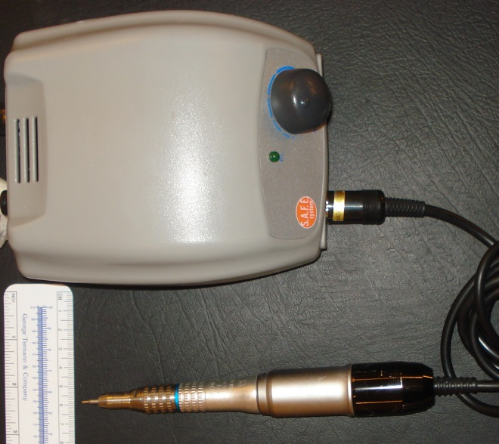
Figure 1 SAFE™ system.

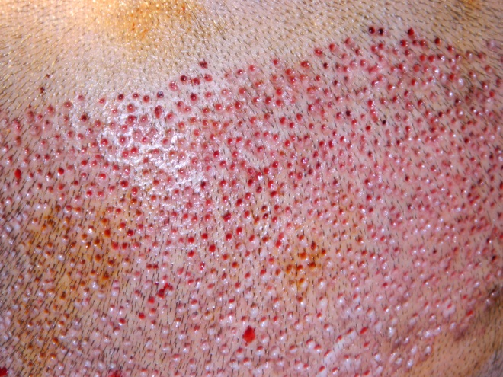
Figure 2 Immediate postoperative photographs showing FUE with 1mm drill.

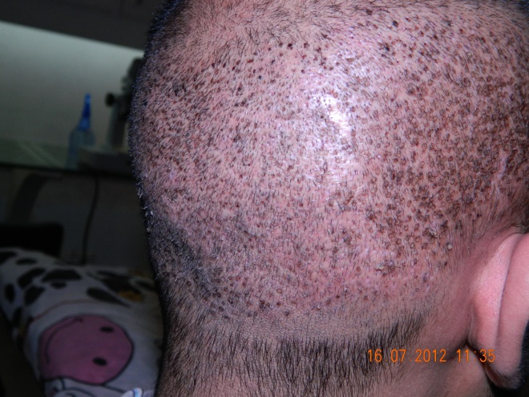
Figure 3 Crust formation in the donor area.
developed folliculitis which was managed conservatively (local cleaning with alcohol swabs and oral antibiotics). None of the patients
Table 1 Age of the patients
Age (years) | No. of patients (%)
21-30 | 16 (28.6)
31-40 | 30 (53.6)
41-50 | 8 (14.3)
>51 | 2 (03.6)

Table 2 Number of grafts.
No. of grafts | No. of patients (%)
<500 | 7 (12.5)
501-1000 | 8 (14.3)
1001-1500 | 7 (12.5)
1501-2000 | 7 (12.5)
2001-2500 | 14 (25.0)
2501-3000 | 8 (14.3)
>3001 | 5 (8.9)
needed dapsone therapy. The overall satisfaction rate was 91.1%. The pain was an issue in two patients. Shaving of the hair resulted in patient’s concerns in 3 cases.
Discussion
Although the strip method is the most efficient means of obtaining follicular units (FUs), it produces a linear scar in the donor area. Various technical details have been mentioned in the literature to minimize the donor scar.¹⁴⁻¹⁵ However if the strip is too wide, the patient’s scalp is too tight or if the closure of the wound edges is too tight, a widened scar can result.
FUE eliminates the linear scar. It is generally considered for those who want to wear very short hair on the back and sides (soldiers etc.) or in patients who want to shave their heads. FUE is a technique that requires more skill in the part of the physician and more cost on the part of the patient than the strip method. It is a newer technique than strip harvesting. It has evolved to more technically sophisticated, and to the latest development of a robotic FUE device. The key point in the FUE technique is the intact, damage-free removal of FUs. It is practically a blind procedure. A transection rate of 3% or lower can be considered good to excellent, a transection rate of more than 5% can be considered poor. Newer FUE instruments and techniques claim to lessen the problem of transection and improve the effectiveness of FUE.
There are a few misconceptions about FUE. The total area of scarring in FUE is larger than follicular unit transplant (FUT), linear scar. It was calculated to be 1560mm in FUE versus 200mm in strip method by Rassmann.⁵ It is just that the individual scars of FUE are tiny, but distributed over a larger area. FUE is also felt to decrease the healing time. However the small open wounds of FUE tend to ooze more and develop the crust for a number of days. Similarly the hair in the donor area has to be shortened for extraction of the FUs. The FUE is more difficult to learn and master with a higher transection rate.¹⁶
FUE has posed many advantages over strip method. The linear wound of FUT takes weeks to months to regain its full strength, whereas in FUE, the strength of the donor area is never compromised. Similarly the non-scalp hair can also be harvested.¹⁷
Conclusion
FUE is minimally invasive surgical procedure that can benefit a large number of patients. The modern technology has resulted in lower transection rates and high yield in grafts number.
References
- Gan DC, Sinclair RD. Prevalence of male and female pattern hair loss in Maryborough. J Invest Dermatol Symp Proc. 2005;10:184-89.
- Otberg N, Finner AM, Shapiro J. Androgenic alopecia. Endocrinol Metab Clin North Am. 2004;36:379-98.
- Gho CG, Neumann HAM. Donor hair follicle preservation by partial follicular unit extraction. A method to optimize hair transplantation. J Dermatolog Treat. 2010;Early online,1-13.
- Bisaccia E, Scarborough D. Hair transplant by incisional strip harvesting. J Dermatol Surg Oncol. 1994;20:443-8.
- Rassman WR, Bernstein RM, McClellan R et al. Follicular unit extraction: minimally invasive surgery for hair transplantation. Dermatol Surg. 2002;28:720-8.
- Serder G, Nessin B, Gurcan A. Follicular unit extraction in hair transplantation: personal experience. Ann Plast Surg. 2008;60:127-33.
- Woods R, Campbell AW. Chest hair micrografting display extended growth in scalp tissue: a case report. Br J Plast Surg. 2004;57:789-91.
- Ekrem C, Mate AH, Erol K, Berna A. Evaluation of three instruments used in FUE. Hair Transplt Forum Intl. 2009;19:14-5.
- Bernstein RM, Rassman WR. New instrumentation for three-step follicular unit extraction. Hair Transpl Forum Intl. 2006;16:229-37.
- Harris JA. The SAFE system: New instrumentation and methodology to improve follicular unit extraction (FUE). Hair Tranpl Forum Intl. 2004;14:163-4.
- Lin X, Nakazawa T, Yasuda R et al. Robotic hair harvesting system; a new proposal. Med Image Comput Assist Interv. 2011;14:113-20.
- Follicular Unit Extraction (FUE): Manual and Powered-Devise_Assisted. www.ISHRS.org accessed September 15th, 2012.
- Ahmad M. A technique of achieving minimal donor scar. Hair Transpl Forum Intl. 2011;21:123.
- Frechet P. Minimal scars for scalp surgery. Dermatol Surg. 2007;33:45-55.
- Yamamato K. Trichophytic closure of both wound edges after strip excision for hair transplantation. Hair Transpl Forum Intl. 2009;19:189-91.
- Onda M, Igawa HH, Inoue K, Tanio R. Novel technique of follicular unit extraction hair transplantation with a powered punching device. Dermatol Surg. 2008;34:1683-8.
- Umar S. Hair transplantation in patients with inadequate head donor hair supply using nonhead hair: report of 3 cases. Ann Plast Surg. 2011;67:332-5.

