Original Article
A study on the efficacy of TCA CROSS for the management of acne scars
Neerja Puri

Consultant Dermatologist, Punjab Health Systems Corporation, Ludhiana, Punjab, India

Abstract | Objectives The purpose of this study was to evaluate the clinical effects of the CROSS method on atrophic acne scars in Indian patients.  Patients and methods We selected twenty cases with ice pick scars from the department of dermatology for the study. Focal application of 70% TCA was done by pressing hard on the entire depressed area of atrophic acne scars using a sharpened wooden applicator.  Results After treatment, marked improvement was seen in 60% patients, moderate improvement in 30% patients and mild improvement was seen in 10% patients. Regarding the side effects of treatment, erythema was seen in 15% patients, and stinging was noted in 10% patients and post-procedure hyperpigmentation was seen in none of the patients.  Conclusions CROSS is a safe and very effective single modality for the treatment of atrophic acne scars with no significant complications.  Key words  Acne scars, TCA, atrophic scars, icepick scars, treatment, CROSS.

Introduction
Various treatment modalities are used for reconstructing and improving the appearance of acne scars, including punch excision, punch elevation, subcutaneous incision (subcision), chemical skin resurfacing, and laser skin resurfacing.¹ Recently acne scars have been classified into three types: icepick, rolling, and boxcar. Most surgeons want to use higher trichloroacetic acid (TCA) concentrations because they produce increased dermal thickening and collagen volume.² However, such use results in resurfacing difficulties and can produce severe scarring because of damage to the adjacent normal skin, although severe scarring usually does not occur in resurfacing with lower TCA concentrations because of reepithelialization from hair follicles and adjacent normal tissue that were spared from chemical damage. So peeling with higher TCA concentrations is very risky and definitely not recommended.³
Address for correspondence
Dr. Neerja Puri
C/O Dr. Asha Puri
House No 626, Phase II, Urban Estate,
Dugri Road,
Ludhiana, Punjab - India
Ph: 0091-98146-16427
Email: Neerjaashu @ Rediffmail.Com

Chemical reconstruction of skin scars (CROSS) as called by the authors,³ consists of the focal application of higher TCA concentrations, even up to 100%, by pressing hard on the entire depressed area of atrophic acne scars using a sharpened wooden applicator. This technique, achieved with higher TCA concentrations of 70% or 100% TCA alone, has the great advantage of reconstructing the acne scars by focusing on the dermal thickening and collagen production that increases with high TCA concentrations. Of interest is that rather than being equivalent to the classic full-face chemical resurfacing, this technique can be used on focal chemical scar reconstruction. Moreover, this technique can avoid scarring and reduce the risk of developing hypopigmentation by sparing the adjacent normal skin and adnexal structures.^{4,5} Repeated CROSS application can normalize deep rolling and boxcar scars, and a similar result can be achieved for deep icepick scars with higher TCA concentrations of up to 100%. Because clinical improvement is proportional to the number of courses of CROSS treatment, this method is effective for the treatment of all deep acne scar types. Furthermore, it can also be utilized for autologous soft tissue augmentation prior to performing the classic full-face resurfacing modalities for deeply pitted areas.^{6,7} Also, we have used this technique successfully for treating dilated pores. Recently we used the CROSS method for reconstructing depressed surgical scars.
The purpose of this study was to evaluate the clinical effects of the CROSS method on atrophic acne scars in Indian patients.
Patients and methods
We selected twenty cases with ice pick scars from the department of dermatology for the study. Informed written consent was taken from all the patients before the study and prior approval of hospital ethical committee was taken for the study. Focal application of 70% TCA was done by pressing hard on the entire depressed area of atrophic acne scars using a sharpened wooden applicator.
The improvement of the patients was categorized as follows: excellent, improvement greater than 70%; good, improvement of 50-70%; fair, improvement of 30-50%; poor, improvement less than 30%. The complications such as persistent erythema, permanent hyperpigmentation, hypopigmentation, herpes simplex flare-up, scarring, or keloids were also noted.
Patients were evaluated carefully before treatment about current and past medications and active acne lesion. Relevant history was obtained, including any history of prior hypertrophic scarring, keloids, allergies, or herpes simplex infection. Pretreatment photographs of the patients were taken. Before CROSS, pretreatments such as tretinoin cream were not applied because of the risk of unpredictable and excessive TCA penetration. Local anesthetics or sedation were not needed for CROSS. Patients were comfortable during the procedure. After facial washing with soap, the skin was cleansed with alcohol. Then 70% TCA was focally applied by pressing hard on the entire depressed area of atrophic acne scars using a sharpened wooden applicator. The skin was monitored carefully until it reached a "frosted" appearance after a single application. The frosted appearance is the result of coagulation of epidermal and dermal proteins and is used mainly to monitor the peel depth. Focal application of TCA produced even frosted spots on each acne scar within 10 seconds. After CROSS, an ointment based antibiotic instead of an occlusive dressing was applied for moisturizing effect, but this application was discontinued after crust formation in order to avoid the risk of detaching the crust. Oral prophylaxis consisting of antibiotics and antiviral medications were not needed after CROSS.
One week after CROSS, a moisturizer sunscreen cream was used in some patients for a minimum of 4 weeks. The application of makeup was allowed after CROSS. CROSS was repeatedly performed every 1 month to allow dermal thickening and collagen production.
The data were collected and the results analyzed.
Results
Most of the patients (45%) were between 21-30 years of age, 35% patients were between 31-40 years, 20% patients were between 11-20 years of age and 5% patients were more than 40 years of age. Males outnumbered females and male: female was 1.5:1.
Regarding improvement, excellent response to treatment was seen in 20% patients after 3 courses, 25% patients after 4 courses, 40% patients after 5 courses and 70% patients (Figures 1, 1a and 1b) after 6 courses. Good response to treatment was seen in 15% patients after 3 courses, 20% patients after 4 courses, 25% patients after 5 courses and 25% patients (Figures 2, 2a and 2b) after 6 courses. Fair response to treatment was seen in 10% patients after 3 courses, 10% patients after 4 courses, 15% patients after 5 courses and 20% patients after 6 courses (Table 1).

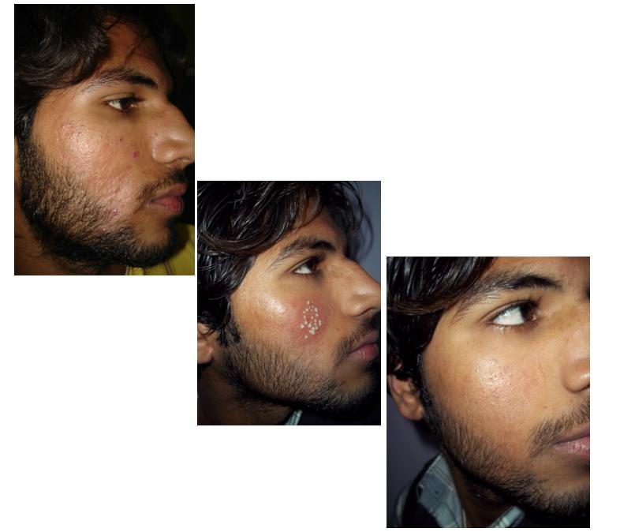
Figure 1, 1a, 1b Pre- and posttreatment photographs of a 25-year-old male after six sessions of TCA CROSS.

Figure 2, 2a, 2b Pre- and posttreatment photographs of a 20-year-old girl after six sessions of TCA CROSS.

Table 1 Efficacy of 90% TCA CROSS method.
Grades of efficacy | Number of treatments
Grades of efficacy | 3 | 4 | 5 | 6
Excellent | 4 (20%) | 5 (25%) | 6 (46%) | 14 (70%)
Good | 3 (15%) | 4 (20%) | 5 (25%) | 15 (25%)
Fair | 2 (10%) | 2 (10%) | 3 (15) | 2 (20%)
Poor | 1 (5%) | 1 (5%) | - | -

Table 2 Side effects with TCA CROSS.
Side effects | N (%)
Erythema | 3 (15)
Stinging /burning | 2 (10)
Hyperpigmentation | -
Regarding the side effects of treatment, erythema was seen in 15% patients, and stinging was seen in 10% patients and post procedure hyperpigmentation was seen in none of the patients (Table 2). There were no cases of significant complication at the treatment sites such as persistent erythema, permanent hyperpigmentation, hypopigmentation, herpes simplex flare-up, scarring, or keloids.
Discussion
In our study, excellent response to treatment was seen in 20% patients after 3 courses, 25% patients after 4 courses, 40% patients after 5 courses and 70% patients after 6 courses (Table 1). Good response to treatment was seen in 15% patients after 3 courses, 20% patients after 4 courses, 25% patients after 5 courses and 25% patients after 6 courses. Fair response to treatment was seen in 10% patients after 3 courses, 10% patients after 4 courses, 15% patients after 5 courses and 20% patients after 6 courses.
Regarding the side effects of treatment, erythema was seen in 15% patients, and stinging was seen in 10% patients and post procedure hyperpigmentation was seen in none of the patients (Table 2). There were no cases of significant complication at the treatment sites such as persistent erythema, permanent hyperpigmentation, hypopigmentation, herpes simplex flare-up, scarring, or keloids.
The results indicated that higher treatment frequency of CROSS application on acne scars improved the therapeutic effect, and there were no significant complications. Of interest is that all patients in the 100% TCA group who received five or six courses of treatment showed excellent results.
Recently acne scars have been classified into three types: icepick, rolling, and boxcar. Various treatment modalities are used for reconstructing and improving the appearance of acne scars, including punch excision, punch elevation, subcutaneous incision (subcision), chemical skin resurfacing, and laser skin resurfacing.^{8,9,10} By combining these multiple modalities, it is possible to produce dramatic improvement in acne scars. So far, no appropriate and effective single treatment modality has been developed for reconstructing and ameliorating the appearance of acne scars. CROSS is a useful addition to this armamentarium.
Repeated CROSS application can help normalize deep rolling and boxcar scars, and deep ice pick scars, but it is likely that other procedures will be used to obtain the most change.^{3,10} The degree of clinical improvement in the original study was proportional to the number of courses of CROSS treatment, with good improvement after three to six courses being recorded in more than 90% of cases. CROSS is repeated every month until maximal change is achieved, usually within 4-6 sessions. A consultation will be necessary to evaluate each patient's needs and develop a comprehensive and individualized approach to scar rejuvenation. Of interest is that rather than being equivalent to the classic full-face chemical resurfacing, this technique can be used on focal chemical scar reconstruction. Moreover, this technique can avoid scarring and reduce the risk of developing hypopigmentation by sparing the adjacent normal skin and adnexal structures.¹¹ This technique can also treat chickenpox scars and dilated pores, as well as reconstructing depressed surgical scars.
CROSS is a safe procedure. Local anesthetics or sedation are not needed for CROSS. The area is cleansed and prepped with alcohol. The TCA is focally applied until a "frosted" appearance is achieved.⁹ Mild stinging is usually encountered, easily controlled with an electric fan. An antibiotic ointment is applied to the treated areas after the procedure, and used as needed until crust formation occurs. The skin will be cleansed daily with a non-drying cleanser and moisturized with a moisturizer-sunscreen. No antibiotic or antiviral therapy is needed with after CROSS. The application of makeup is allowed after CROSS.
Although possible, side effects or complications such as persistent redness, permanent darker or lighter skin color, bacterial infections or herpes simplex flare-up, or scarring are unlikely to occur. Patients sometimes encounter mild redness or temporary darker color, both disappearing in 4-6 weeks.
Application of TCA to the skin causes precipitation of proteins and coagulative necrosis of cells in the epidermis and necrosis of collagen in the papillary to upper reticular dermis.^{12,13} Over several days the necrotic layers slough off and the skin reepithelializes from the adnexal structures that were spared from chemical damage. Dermal collagen remodeling after chemical peel may continue for several months. Many investigators have observed that the clinical effects of TCA were due to both a reorganization in dermal structural elements and an increase in dermal volume as a result of an increase in collagen content, glycosaminoglycan, and elastin. The CROSS method, achieved with 65% or 100% TCA alone, has the advantage of reconstructing acne scars by focusing on the dermal thickening and collagen production that increase with high TCA concentrations. Healing is more rapid and has a lower complication rate than conventional full-face medium to deep chemical resurfacing, because the adjacent normal tissue and adnexal structures are spared. This technique does not involve the classic full-face chemical resurfacing, but rather it can be used on focal chemical scar reconstruction.
Conclusion
CROSS is a safe and very effective single modality for the treatment of atrophic acne scars with no significant complications. The simplicity of this procedure makes this an easier procedure for the clinician and more patient friendly than more conventional dermabrasion or CO2 laser resurfacing. It also requires less equipment than nonablative laser treatments of scars.
References
- Jacob CL, Dover JS, Kaminer MS. Acne scarring: A classification system and review of treatment options. J Am Acad Dermatol. 2001;45:109-17.
- Khunger N, editor. Trichloroacetic acid. Step by Step Chemical Peels, 1st ed. New Delhi, India: Jaypee Medical Publishers; 2009. p. 90-110.
- Lee JB, Chung WG, Kwahck H, Lee KH. Focal treatment of acne scars with trichloroacetic acid: Chemical reconstruction of skin scars method. Dermatol Surg. 2002;28:1017-21.
- Rivera AE. Acne scarring: A review and current treatment modalities. J Am Acad Dermatol. 2008;59:659-76.
- Fabbrocini G, Cacciapuoti S, Fardella N et al. CROSS technique: Chemical reconstruction of skin scars method. Dermatol Ther. 2008;21:S29-32.
- Brodland DG, Cullimore KC, Roenigk RK, Gibson LE. Depths of chemicoexcision induced by various concentrations and application techniques of trichloroacetic acid in a porcine model. J Dermatol Surg Oncol. 1989;15:967-71.
- Dewandre L. The chemistry of peels and a hypothesis of action mechanisms. In: Rubin MG, editor. Chemical Peels: Procedures in Cosmetic Dermatology. New Delhi: Elsevier; 2006. p.1-12.
- Savant SS. LN2 cryoroller for nodulocystic acne and superficial acne scars. In: Savant SS, editor. Textbook of Dermatosurgery and Cosmetology. 2nd edn. Mumbai, India: ASCAD; 2005. p. 421-5.
- Alam M, Dover JS. Treatment of acne scarring. Skin Ther Lett. 2006;11:7-9.
- Goodman G. Post acne scarring: A review. J Cosmet laser Ther. 2003;5:77-95.
- Cho SB, Park CO, Chung WG et al. Histometric and histochemical analysis of the effect of trichloroacetic acid concentration in the chemical reconstruction of skin scars method. Dermatol Surg. 2006;32:1231-6.
- Yug A, Lane JE, Howard MS, Kent DE. Histologic study of depressed acne scars treated with serial high-concentration (95%) trichloroacetic acid. Dermatol Surg. 2006;32:985.
- Khunger N. Scar revision. In: Sehgal VN, editor. Dermatologic Surgery Made Easy. 1st edn. New Delhi, India: Jaypee Brothers; 2006. p.172-8.

