Original Article
CROSS treatment of acne scars with trichloroacetic acid
Safoora Aamir*, M. Ali Rafique Mirza**, Zafar Iqbal***

*Department of Dermatology, Federal Postgraduate Medical Institute & Sheikh Zayed Hospital, Lahore.
**Department of Plastic & Reconstructive Surgery, Federal Postgraduate Medical Institute & Sheikh Zayed Hospital, Lahore.
***Department of Medicine, Federal Postgraduate Medical Institute & Sheikh Zayed Hospital, Lahore.

Abstract | Objective To establish efficacy and safety of medium depth spot peeling with 35% TCA in atrophic and rolled acne scars, in Asian skin (Fitzpatrick skin type III to IV).  Patients and methods The study was carried out in the Department of Dermatology Sheikh Zayed Hospital form September 2009 to April 2010. Patients with rolled or atrophic acne scars who presented to skin or plastic surgery outdoor were enrolled in the study. After taking informed consent and counseling, the enrolled patients were put on prepeel regimen of topical application of 4% hydorquinone and tretinoin for 2 weeks. 1 to 3 spot peeling sessions, with 35% TCA, were carried out depending on severity of scars. Prepeel and postpeel photographs were taken.  Results Nine patients with acne scars were enrolled in the study. The average age was 24 years. Total of 22 peeling sessions were done. Five patients had good, 4 had excellent and 1 patient had fair improvement. None of the patients had postinflammatory hyper- or hypopigmentation, scarring or keloid formation.  Conclusion 35% TCA spot peeling in rolled and atrophic acne scars is safe, effective and affordable treatment in patients with Fitzpatrick skin type III to IV.  Key words  TCA, CROSS treatment, acne scars.

Introduction
Acne is one of the most common dermatological conditions affecting 80 to 90% individuals in the 12-24 age group.¹ Treatment is tailored according to the severity of acne. If left untreated, few cases with severe acne can lead to permanent scarring which is one of the most difficult and challenging conditions for the dermatologists to treat. There are three types of acne scars,² ice pick, rolling and box or punch shaped. More than one type of scarring may occur in the same patient. Ice pick scars are usually the deepest and can extend into the dermis and subcutaneous tissue. Scarring affects the quality of life of affected individuals.
Address for correspondence
Dr. Safoora Aamir, Assistant Professor,
Department of Dermatology,
Federal Postgraduate Medical Institute &
Sheikh Zayed Hospital, Lahore
Ph# 0300 4248549
Email: safooraamir@yahoo.com
Trichloroacetic acid (TCA), a well established peeling agent, is mostly used for superficial and medium peels; depth of peel depends on its concentration and number of layers.^{3,4} It is a self-neutralizing agent so there is no risk of absorption into the circulation even with deep peeling. CROSS technique (chemical reconstruction of skin scars) first described by Lee et al.⁵ using high concentration of TCA on ice pick scars, showed that healing occurred more rapidly and with fewer complications as adjacent normal tissues and adnexal structures are spared.
Patients and methods
This study was carried out in the Department of Dermatology at Sheikh Zayed Hospital from September 2009 to April 2010. Patients of both sexes and of any age group, who came for the treatment of acne scars and had atrophic or rolled scars, were included in the study. Patients who had been treated with oral isotretinoin during the past one year, those who were on photosensitizing drugs like oral contraceptive pills or minocycline and those who had history of recurrent herpes simplex or could not practice strict sun avoidance were excluded from the study. After obtaining informed written consent patients were enrolled in the study.
The enrolled patients were asked to avoid sun exposure and were advised application of sun block in the day and combination of 4% hydroquinone and 0.1% tretinoin at night, as prepeel regimen, for at least 2 weeks. 35% TCA was dispensed in bulk and the same dispensed chemical was used in all patients to avoid variation in concentration. The patients were asked to come to the outdoor on the day of peeling with a washed face. Skin was thoroughly degreased with alcohol swabs and spot application of 35% TCA was done on the very center of the acne scars with a very thin cotton tip applicator. The applicator was held tightly in contact with the skin for 30 seconds to ensure penetration of the chemical. A uniform white frosting at the site was the end point indicating medium depth penetration. If the desired frosting was not achieved after 2 minutes of application, the process was repeated. Discomfort was alleviated with hand held fan and skin was neutralized after peeling with water mixed with bicarbonate soda. Antibacterial ointment was applied and patient was instructed to resume prepeel regime after 5-7 days or when crusts shed. The number of sessions varied from 1 to 3 depending on the degree and severity of the scars and the patient’s willingness and satisfaction. Photographs were taken before and after the procedure and at 1 month follow-up.
Results were assessed by clinical and photographic assessment, the appearance especially depth and size of scars was noted and results were rated as excellent if improvement was >75%, good if >50%, fair if >25% and no or poor improvement if <25%, respectively. Patients’ satisfaction was similarly noted at completion of treatment and on one month follow-up visit.
Results
Nine patients were enrolled in the study, 7 were females and 2 were males. Fitzpatrick skin type ranged from III to IV. Average age was 24 years (range 18 to 38 years). As motivated and well-counseled patients were included in the study there were no drop outs. A total of 22 peeling sessions were done. Five (55.5%) out of 9 patients experienced good clinical response (Table 1), while 4 patients had excellent, >70% improvement. Only one patient rated the results to be >25% (fair) despite the clinical improvement being more than 50% according to the laid down criteria.
No side effects, such as herpes labialis, postinflammatory hypo- or hyperpigmentation or keloid formation were reported in any patient.

Table 1 Summary of patients, and the results of treatment.
Serial No | Age/sex (years) | Type of scar | No of peels | % improvement  Clinician | % improvement  Patient
1 | 19/F | Rolled | 1 | >50 | ≥50
2 | 26/F | Rolled | 2 | >50 | ≥50
3 | 30/M | Rolled | 3 | >75 | ≥75
4 | 18/F | Atrophic | 3 | >75 | ≥75
5 | 18/F | Rolled | 3 | >75 | ≥50
6 | 24/F | Atrophic | 2 | >50 | ≥50
7 | 38/F | Atrophic | 2 | >75 | ≥50
8 | 21/M | Rolled | 3 | >50 | ≥25
9 | 20/F | Rolled | 3 | >50 | ≥50

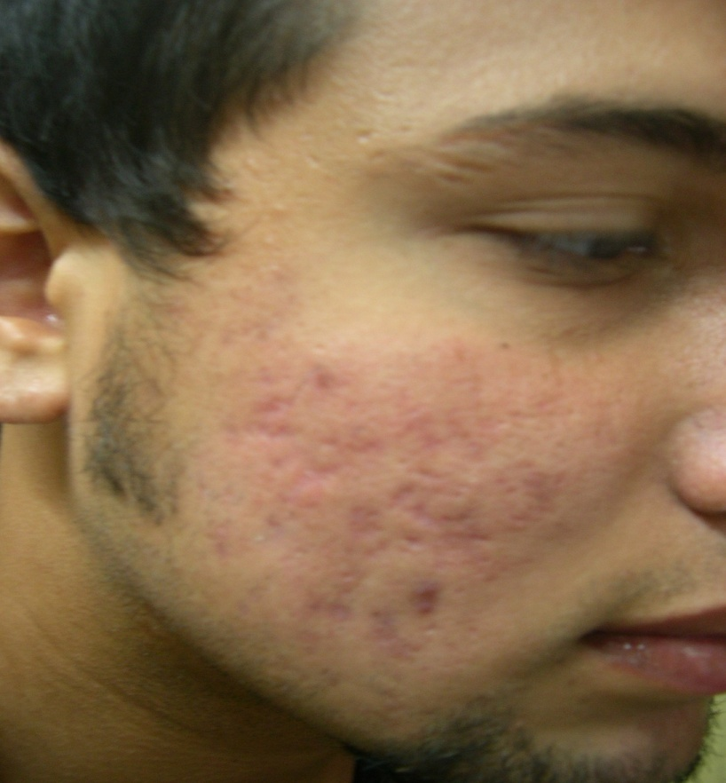
Figure 1 Acne scars before treatment.
Three patients complained of loss of work/study due to crusting and being nonpresentable for 3 to 7 days.
Figures 1 and 2 show before and after pictures of patients with acne scars.
Discussion
Acne scarring greatly affects the quality of life of the individuals and many a times leads to financial burden on the family in the form of expensive treatments e.g. Fraxel® laser which may cost between Rs. 20,000 to 30,000 per session. Various other treatments like subcision of scars, dermabrasion and topical tretinoin

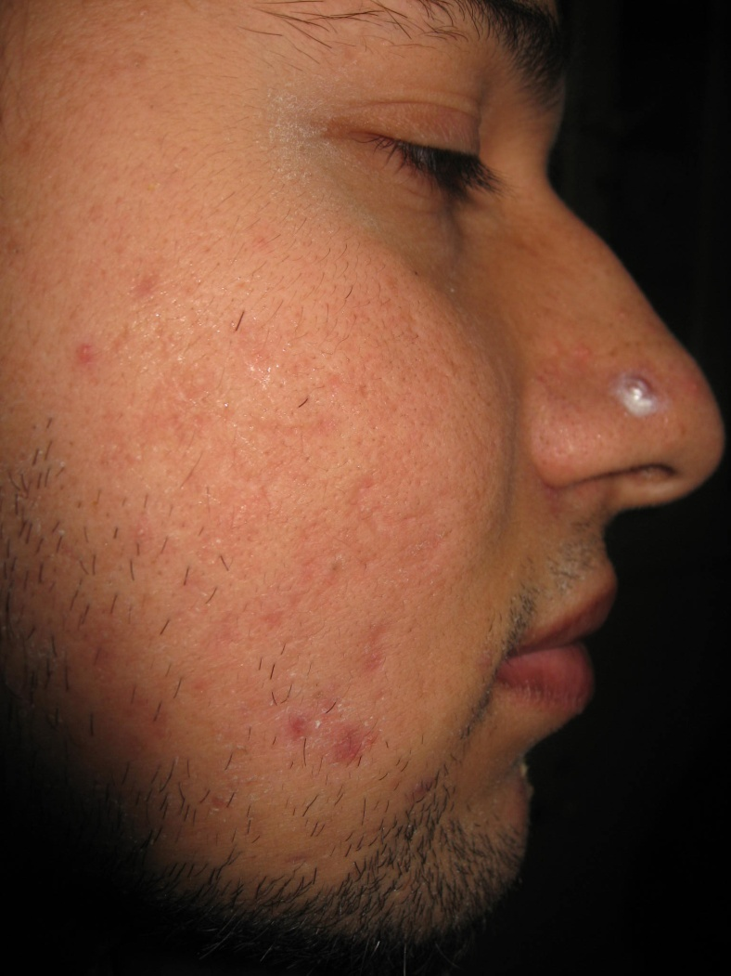
Figure 2 Improved acne scars after 2 sessions.
application have their own limitations like lack of proper technique, availability of machine and slow or negligent response, respectively. Although microneedling or derma roller is gaining popularity and does show worthwhile results, it also requires familiarity with technique and is somewhat expensive.
TCA is an excellent peeling agent; it can be used for very superficial to deep peeling¹ by altering its concentration and method of application and the desired level of peel can be visibly gauged by the resultant frosting. In safe hands, with proper patient selection and appropriate pre- and postpeel care there are virtually no complications. The only drawback is the initial downtime and persistent erythema which may last 1 to 2 months. The basis of improvement is graded inflammation followed by neocollagenization which causes leveling of the scars. We used a much lower concentration of TCA as compared to similar studies which used concentrations ranging from 65-100% TCA.^{6,7} Even with this concentration the results were comparable with 77.5% patients showing excellent improvement.
The discomfort/pain during the procedure was momentary and tolerable and easily managed by hand held fan. However, ice compresses, cooling device and even topical application of EMLA can be used in apprehensive patients. A study⁸ has shown that topical application of EMLA does not affect level of penetration of TCA.
Prepeel regimen of sunscreen, tretinoin and hydroquinone is very important.³ It facilitates uniform penetration of the chemical, reduces wound healing time⁹ and prevents postinflammatory pigmentation.
A word of caution is to handle the chemical mindfully, avoid splashing or dripping, keep the patient comfortably lying down during the procedure and take special care to avoid contact with eyes by covering with gauze pads. History of oral medication is also very important, especially oral isotretinoin which is missed many a times.
A study with a larger group and in other types of acne scars and probably higher concentration of TCA can further strengthen this easy and effective treatment modality.
Conclusion
CROSS treatment of acne scars with 35% TCA is safe, effective and inexpensive treatment of atrophic and rolled acne scars in our population.
References
- Thiboutout DM, Strauss JS. Diseases of the sebaceous glands. In: Fitzpatrick’s Dermatology in General Medicine. 6th edn. New York: McGraw-Hill; 2003. P.672-87.
- Jacob CL, Dover JS, Kaminer MS. Acne scarring: A classification system and review of treatment options. J Am Acad Dermatol. 2001;45:109-17.
- Goodman G. Post acne scarring: a review. J Cosmet Laser Ther. 2003;5:77-95.
- Kunger N. Standard guidelines of care for chemical peels. Indian J Dermatol Venereol Leprol. 2008;74:5-12.
- Lee JB, Chung WG, Kwahck H, Lee KH. Focal treatment of acne scars with trichloroacetic acid; Chemical reconstruction of skin scars method. Dermatol Surg. 2002;28:1017-21.
- Fabbrocini G, Cacciapuoti S, Fardella N, Monfrecola G. Cross technique: chemical reconstruction of skin scars method. Dermatol Ther. 2008;21 Suppl 3:S29-32.
- Yug A, Lane JE, Kent DE. Histological study of depressed acne scars treated with serial high concentration (95%) trichloroacetic acid. Dermatol Surg. 2006;32;985-90.
- Koppel RA, Coleman KM, Coleman WP. The efficacy of EMLA versus ELA-Max for pain relief in medium-depth chemical peeling: a clinical and histopathologic evaluation. Dermatol Surg. 2000;26:61-4.
- Hevia O, Nemeth AJ, Taylor JR. Tretinoin accelerates healing after TCA chemical peels. Arch Dermatol. 1991;127:678-82.

