Original Article
Lichen planus along with Blaschko lines "Blaschkoian lichen planus"
Hossein Kavoussi, Mazaher Ramazani, Elias Salimi

Dermatology Department, Kermanshah University of Medical Sciences, Kermanshah, Iran

Abstract | Objective To compare the characteristics of Blaschkoian lichen planus with typical lichen planus.  Patients and methods In this case series, we diagnosed 7 patients of Blaschkoian lichen planus (3 males and 4 females) based on specific clinical presentation, histopathological findings and exclusion of other dermatologic disease mimicking Blaschkoian lichen planus.  Results Of 7 patients, 4 (57.1%) had middle to senile age, without involvement of the buccal mucosa, nails and scalp. Involvement of both trunk and lower extremity were seen in one patient. Unilateral lichenoid skin lesion with specific configuration were located on trunk in 6 (85.7%) cases, forehead in 1 (14.3%) and on lower extremity in 1 (14.3%) case. One (14.3%) patient had history of troublesome pruritus.  Conclusion Although diagnosis of typical lichen planus is uncomplicated but in Blaschkoian lichen planus absence of prominent pruritus, different configurations of skin lesion on each site of the body without involvement of buccal mucosa may pose problems in diagnosis. We recommend further studies with large number of Blaschkoian lichen planus to find out more about clinical manifestations.  Key words  Blaschko line, lichen planus, Blaschkoian lichen planus, zosteriform lichen planus.

Introduction
Blaschko's lines (BL) are the surface patterns manifest by various nevoid and acquired skin diseases on the human skin and mucosa. BL are distinct from other patterns such as Voight's lines, Langer's lines of cleavage, and the lines of innervations of the appendages, vascular system and hypodermal adipose tissue, all, alone or in combination may be implicated in the morphological presentation.^{1,2}
The underlying mechanisms suggested for BL include a congenital error of morphogenesis because of a single mutant gene or skin stretching during embryogenesis. BL show a type of human 'mosaicism' where two or more different cell populations, originating from a single zygote, are present in an individual. BL have specific configurations on each site of the body.^{1,3}
Address for correspondence
Dr. Hossein Kavoussi,
Hajdaie Dermatology Clinic,
Golestan Blvd, Kermanshah, Iran
Tel: 00988318357070
Fax:00988314274623
E-mail: hkawosi@kums.ac.ir,
hkavoussi@gmail.com

Lichen planus (LP) is an inflammatory mucocutaneous disease in which cell-mediated immunity plays a major role in triggering the disease. Most of the T cell infiltration in perilesional and lesional skin of LP is activated CD8⁺ cytotoxic lymphocytes that recognize an LP-specific antigen although the nature of this antigen is unknown. Typical cutaneous LP presents as extremely pruritic, polygonal, flat-topped, violaceous papules and plaques. Oral mucosa is commonly involved in LP, mostly as asymptomatic, whitish and reticular patches. Many clinical variations of LP have been described according to the configuration of lesion and morphologic appearance, one of which is linear LP (LLP). A subtype of LLP has linear lesions following blaschkoid distribution, namely blaschkoian LP (BILP).^{4,5}
Due to interesting clinical feature, differential diagnosis with other variants especially zosteriform LP and scarcity of this entity in the literature and thus possibility of missing this disease, we report 7 patients of BILP.
Patients and methods
This case series study was done in Hajdaie Clinic from 2006 to 2012. Firstly, we suspected of BILP in patients who presented with unilateral and specific configuration (except head and neck) of lichenoid, hyperpigmented or atrophic skin lesions. Later, with consent of patients, biopsy and histopathological study of lesions were done. Ultimately, according to clinical and pathological findings, other dermatologic entities mimicking BILP were ruled out. After consultation with other dermatologists, patients that had most characteristics of BILP were enrolled in our study.
History of any symptom (pruritus, burning or pain), herpes zoster and medication were recorded. We examined whole skin surface besides the mucous membranes, scalp and nails. Complete blood count, liver function tests, erythrocyte sedimentation rate and serology for hepatitis B and C were done in all patients.
Results
We diagnosed 7 (4 females, 3 males) BILP patients, mostly middle aged to senile according to clinical, pathological findings and rule out of other dermatologic entity that mimicking BILP. There were no history of medication and clinical herpes zoster, prominent pruritus, burning, and pain in any of the patients. The time range between onset of disease and presentation to physician was 3 to 18 months (Table 1).
One patient showed concurrent BILP on both trunk region with whorls configuration and lower extremity with vertical configuration. In 6 (75%) cases, unilateral erythematous or violaceous papules and patches or postinflammatory hyperpigmentation with whorls shapes were seen mostly in the trunk area but in 1 (12.5%) case unilateral atrophic and brown-violaceous hyperpigmented lesion without any characteristic configurations were seen on forehead similar to actinic LP. Also in 1 (12.5%) case unilateral lichenoid papules and plaques with vertical configuration were seen in lower extremity (Figure 1a-d).
Involvement of nails, mucosa and scalp was not seen in any patients. The laboratory findings, including complete blood count, liver function tests and erythrocyte sedimentation rate were within normal range, also serology for hepatitis B and C were negative. Histopathological findings in our cases were consistent with typical LP. Histologic sections showed hyperkeratosis, focal epidermal atrophy, basal layer squamatization and lichenoid infiltration of lymphohistiocytes with a few neutrophils in dermoepidermal junction, also pigment incontinence was prominent (Figure 2a and b).

.
Table 1 Clinical characteristics of patients
Patients | Case 1 | Case 2 | Case 3 | Case 4 | Case 5 | Case 6 | Case 7
Gender | male | male | female | female | female | female | male
Age (years) | 62 | 74 | 43 | 25 | 42 | 21 | 25
Symptoms | mild pruritus | no | no | mild pruritus | no | mild pruritus | troublesome pruritus
Location | lower trunk | Forehead | lower trunk | Upper & lower trunk | Upper & lower trunk | Upper & lower trunk | Trunk & lower extremity
Time onset (months) | 12 | 8 | 6 | 3 | 18 | 15 | 5
Involvement of mucosa, scalp and nail | no | No | no | no | no | no | no
History of herpes zoster | no | no | no | no | no | no | no
History of medication | no | No | no | no | no | no | no
Cutaneous findings | purplish macules and patches | brown- violaceous atrophic patches | violaceous macules and patches | violaceous patches and plaques | violaceous patches and plaques | purplish papules and patches | lichenoid papules and plaques
Configuration of lesion | whorls | nonspecific | whorls | whorls | whorls | whorls | whorls in trunk & perpendicular down in lower extremity

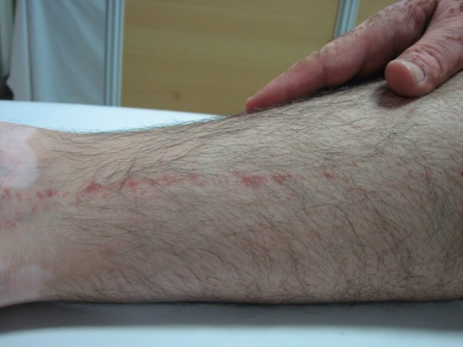
Figure 1a Lichenoid papules and plaques with vertical configuration on lower limb

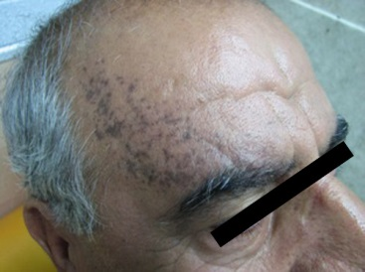
Figure 1b Violaceous-brown skin lesions on forehead without any specific configuration.

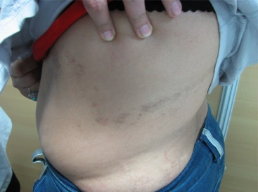
Figure 1c Postinflammatory hyperpigmentation and violaceous discoloration on upper and lower trunk with whorls configuration.
Discussion
BL may represent embryological development pathways which are V-shaped over upper spine,
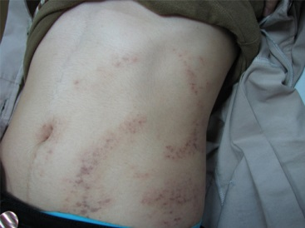
Figure 1d Lichenoid skin lesion on upper and lower trunk with whorls configuration.

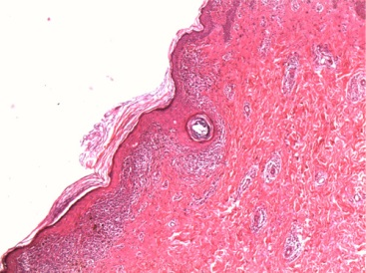
Figure 2a Hyperkeratosis, band like infiltration in dermoepidermal junction (H&E stain x40).

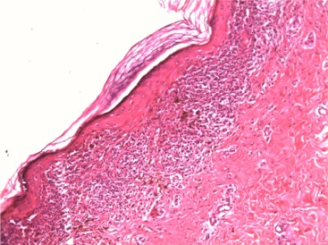
Figure 2b Lichenoid infiltration of lymphohistiocytes and significant pigment incontinence (H&E stain x100).
S-shaped on the abdomen, inverted U-shaped from the breast area to the upper arm, vertical on posterior and anterior surfaces of lower extremity but BL are poorly-defined on the head and neck.^{1,3,6}
There are some inflammatory cutaneous diseases that follow patterns of BL such as LP, lichen nitidus, scleroderma, vitiligo, fixed drug eruption and chronic lupus erythematosus.¹ Linear LP as a variant of LP may present as Koebner phenomenon, isolated linear lesions, lichenoid epidermal nevus, segmental LP, zosteriform LP, and BILP.⁷
BILP must be differentiated from the other variants of LLP, epidermal nevi, lichen striatus, linear psoriasis, inflammatory linear verrucous epidermal nevus (ILVEN), drug reaction and linear Darier disease based on histopathological findings and clinical manifestations, including lichenoid skin lesions, specific linearity distribution and had not intake any medications.^{8,9}
There are several case reports of BILP with different ages that had moderate to severe pruritus with lesions mostly located on trunk, and occasional buccal mucosa involvement but intact nails and scalp. Their histopathological findings identical to those observed in typical LP included basal cell degeneration, band-like inflammatory cell infiltration, and melanin incontinence.^{6,9-11}
Happle¹² believes that many of cases reported as zosteriform LP do not have dermatomal distribution and they are indeed BILP. In our patients, despite typical findings of LP in cutaneous lesions and histopathological assessment, we did not observe involvement of mucous membranes, scalp, and nails as well as troublesome pruritus except in one patient that may result in delay of patient for medical visit or diagnostic problem.
Our findings indicate that trunk was involved in 6 (85.7%) out of 7 cases that is consistent with previous reports but interestingly in one patient, forehead was involved by unilateral, linear, atrophic and violaceous-brown macules, that was similar to actinic LP. This latter case could be a subvariant of BILP, therefore, it was named as "actinic blasckoian lichen planus". Although our patients showed slight predominance in females (3 males and 4 females) but apart from 2 (28.6%) young patient, 5 cases (71.4%) had middle to senile age (Table 1).
In conclusion BILP has variable and interesting clinical presentations that result in non-diagnosis or problem in diagnosis. Due to absence of troublesome itching in many patients, referral to physician may be delayed. We suggest further studies in multicentric clinics with larger number of patients to identify more about this disease.
Reference
- Grosshans E, Marot L. Blaschkitis in adults. Ann Dermatol Venereol. 1990;117:9-15.
- Jackson R. The lines of Blaschko: a review and reconsideration: Observations of the cause of certain unusual linear condition of the skin. Br J Dermatol. 1976;95:349-60.
- Tagra S, Talwar AK, Singh Wilia RL. Lines of Blaschko. Indian J of Dermatol Venereol Leprol. 2005;71:57-9.
- Happle R. Mosaicism in human skin. Understanding the patterns and mechanisms. Arch Dermatol. 1993;129:1460-70.
- Pittelkow MR, Daoud MS. Lichen planus: In: Wolff K, Lowell AG, Goldsmith LA et al., editors. Fitzpatrick’s Dermatology in General Medicine, vol 2. 7th edn. New York: McGraw Hill; 2008. p244-55.
- Lehman JS, Tollefson MM, Gibson LE. Lichen planus. Int J Dermatol. 2009;48:682-94.
- Long CC, Finaly AY. Multiple linear lichen planus in the line of Blaschko. Br J Dermatol. 1996;135:275-6.
- Breathnach SM, Black MM. Lichen planus and lichenoid disorders. In: Burns T, Breathnach S, Cox N, Griffiths C, editors. Rook’s Textbook of Dermatology. Vol. 3, 8th edn. Oxford: Wiley-Blackwell; 2010. P.42.1.
- Munoz MA, Perez-Bernal AM, Camacho FM. Lichenoid drug reaction eruption following the Blaschko lines. Dermatology. 1996;193:66-7.
- Kabbash C, Laude TA, Wienberg JM, Silverberg NB. Lichen planus in the lines of Blaschko. Pediatr Dermatol. 2002;19:541-5.
- Rahman SB, Bari AU, Mumtaz N. Unilateral Blaschkoid lichen planus involving the entire of the body, a unique presentation. Dermatol Online J. 2007;13(3):36.
- Sharma R, Maheshwari V, Chandra M. Unilateral multiple linear lichen planus along the line of Blaschko: A report of two cases. Indian J Dermatol Venereol Leprol. 1999;65:225-6.
- Happle R. “Zosteriform” lichen planus: is it zosteriform? Dermatology. 1996;192:385-6.

