Original Article
Clinical and epidemiological study of Paederus dermatitis in Manipal, India
Anuj Taneja*, Sudhir Nayak UK**, Shrutakirthi D Shenoi†

*Consultant Dermatologist, Alsoor Clinic, Mahaboula, Kuwait and earlier Junior Resident, Department of Dermatology, Kasturba Medical College, Manipal, Manipal University, India
**Department of Dermatology, Kasturba Medical College, Manipal, Manipal University, India
†Department of Dermatology, Kasturba Medical College, Manipal, Manipal University, India

Abstract | Objective To study the clinical features and factors associated with Paederus dermatitis/blister beetle dermatitis (BBD) and to carry out an epidemiological survey in Manipal with regard to Paederus dermatitis.  Patients and methods The study was conducted in two parts, viz., clinical and epidemiological. In the clinical study the patients were evaluated by means of a standard pro forma. In the epidemiological study, 55 randomly chosen houses each in 4 localities were assessed by a detailed standard questionnaire.  Results The majority of subjects in the clinical study comprised of students with exposed areas being common sites of occurrence and a higher incidence in summer seasons. There was a previous occurrence in nearly one third of patients. The epidemiological study revealed preventive measures like closing windows and use of repellents being utilized. Presence of dense vegetation around household accounted to be a factor in occurrence of BBD. There was a higher occurrence in summer and rainy seasons. The exposed parts of the body were common sites of occurrence of BBD.  Conclusion The lesions of Paederus dermatitis arise following crushing of the bug following bite and are associated with burning or itching sensations mainly on the exposed areas. Kissing ulcers, whiplash dermatitis and Nairobi eye are some of the clinical manifestations of Paederus dermatitis. This study provides epidemiological as well as clinical data of Paederus dermatitis and recommends preventive measures in reducing future incidences of Paederus dermatitis.  Key words  Blister beetle dermatitis, epidemiological and clinical study, Paederus.

Introduction
Paederus dermatitis (blister beetle dermatitis (BBD) is a geographic seasonal vesiculobullous disorder caused by three major groups of beetles i.e. Family Oedemeridae, Meloidae and Staphylinidae.^{1,2} Beetles of the genus Paederus belong to the family Staphylinidae (Rove beetles) which is the largest of all three families. Paederus dermatitis is not an insect bite reaction but a true dermatitis as it is produced by crushing and wiping the insect on the skin. Paederus dermatitis or Manipal bug or MIT bug, as it is locally known, is a very common dermatological problem in the university town of Manipal, which is on a plateau overlooking the sea on one side and the mountainous Western Ghats on the other side. Though isolated cases are reported throughout the year, they are common during the monsoons especially at the onset of rains. Though quite prevalent, neither the species of the insect causing the dermatitis in Manipal has been identified till now nor has an epidemiologic study conducted until now.
Address for correspondence
Dr. Sudhir Nayak UK. MD, DDVL,
Assistant Professor, Department of Dermatology,
Kasturba Medical College, Manipal University,
Manipal-576104, India
Ph# 9900412394
Email: sudhirnayakuk@yahoo.com
The aims of the study were to study the clinical profile and factors associated with Paederus dermatitis in patients attending the out-patient department of the dermatology department of Kasturba Hospital, Manipal and to carry an epidemiologic survey at Manipal to find out number of households affected by Paederus dermatitis in the last two years; factors associated with the occurrence of dermatitis; and awareness of the condition and preventive measures used by the population.
Patients and methods
The study was done in two parts:
- Clinical study of patients attending the outpatient department of the dermatology department of Kasturba Hospital, Manipal
- Epidemiological study of blister beetle dermatitis in Manipal town
Clinical study
100 affected patients with BBD attending the outpatient department of the dermatology department of Kasturba Hospital, Manipal were studied. Diagnosis of BBD was done on clinical grounds. The clinical details of all the patients were recorded using a standard pro forma. Few of the insect specimens collected by the patients were sent for taxonomical identification to the Kerala Agricultural University, Thrissur, Kerala, India.
Epidemiological study
A total of 220 households in 4 different localities of Manipal were surveyed. From each of the 4 localities, 55 households were chosen by random sampling for survey. The households chosen were assessed by a detailed standard questionnaire. The residents were shown clinical photographs for identification of the condition.
Results
Clinical study
100 patients (66 male and 34 female) were examined of whom majority were in the age group 15-25 (80 patients). 83% were residing in the hostels of the university. 61% were from the engineering college campus and the rest 39% were from the medical college campus. The commonest sites affected were the face and neck (36%), forearms (22%) and trunk (18%). Majority of the cases were reported in March (31%) and April (45%). 33% of the affected individuals had at least one previous episode, while 26% had at least other family member/room-mate affected. Mean duration of the symptoms were 3.5 days.
The signs and symptoms of the disease encountered in the patients were (Table 1). Factors influencing the occurrence of the disease were (Table 2).
Tzanck smear showed the presence of white blood cells with lymphocytes (40%), neutrophils (35%) and eosinophils (25%).
Histopathological examination of intact vesicle showed an intraepidermal vesicle with few
Table 1 The signs and symptoms of the disease encountered in the patients.
Feature | Number (%)
Severe pain and burning | 74 (74)
Erythema, swelling and itching | 78 (78)
Blistering | 35 (35)
Eye involvement | 7 (7)
Constitutional symptoms | 5 (5)
Regional lymphadenopathy | 5 (5)
Kissing ulcers | 4 (4)

Table 2 Factors influencing the occurrence of the disease.
Factor | Yes (%)
Dense vegetation | 59 %
Sleeping with lights on | 17 %
Use of window nets | 28 %
Repellent use | 40 %
Pesticide use | 13 %
Use of protective clothing | 28 %
Windows open/closed at night | 62 % (open)
Sleeping on bed/ floor | 89 % (floor)

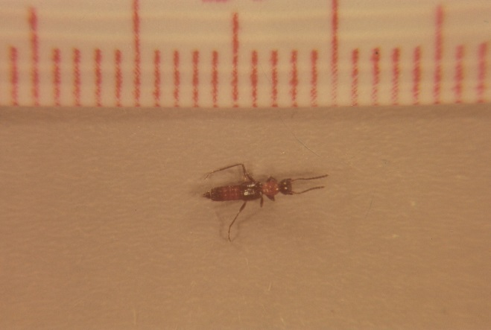
Figure 1 Paederus extraneus.
neutrophils. There was dermal edema with dense perivascular lymphocytic infiltrate. The insects caught by the patients were identified as Paederus extraneus (Figure 1).
Epidemiological study
Majority of the households surveyed were nuclear families (85.5%). 74.5% of the people surveyed were professionals, 24.5% were semiskilled and skilled workers. Majority of the residents (74%) resided on the ground floor, 38% had a garden in front of the house and 53% had dense vegetation near their house. Of the 810 people surveyed in the household, 25 people had suffered from the condition in the past 2 years making the incidence 15/1000 population. 36% of the affected slept with lights on at night. 66% had dense vegetation within 200m of their residence. 64% wore bare minimum clothing at night. The common months of occurrence were March followed by August and September. Majority of the affected individuals had only one episode in the past 2 years. The sites affected were mainly the face and neck (40%), forearms (28%). 54% of the surveyed houses were aware of the condition, with the local terminologies as “Manipal bug bite” (57%) and “MIT bug bite” (40%) were being used.
The common preventive measures used were keeping the windows closed at night (62.7%), use of repellants (50.5%), use of nets (33.2%) and use of sprays (17.7%)
Discussion
Paederus dermatitis is a seasonal vesiculobullous disorder. This has a worldwide distribution but is mostly reported from hot tropical climate areas. Paederus bug belongs to Order Coleopetra, Family Staphylinidae. It lives in damp moist areas³ and is elongated 5-10 mm long with bright blue/black and orange sections.
The earliest published record of Paederus dermatitis is that of Vorderman in 1901 from Java. It was first described in East Africa by Ross in 1916. Since then these cases have been reported from all parts of the world.
The crushing and wiping of the Paederus beetle on the skin causes an acute dermatitis within 24 hours, corresponding in shape and dimension to the area affected by the release of the vesicating agent paederin found in the haemolymph of the beetle. The cutaneous eruptions are of greater
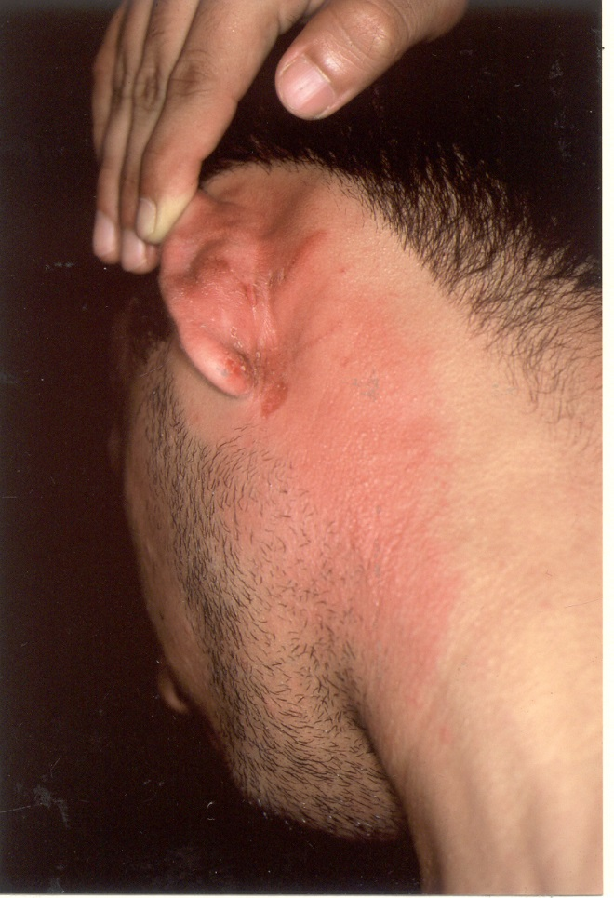
Figure 2 Kissing lesions,

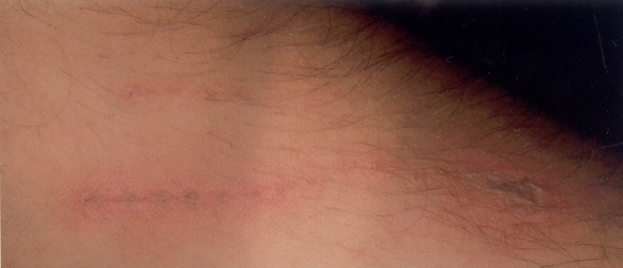
Figure 4 Whiplash dermatitis.

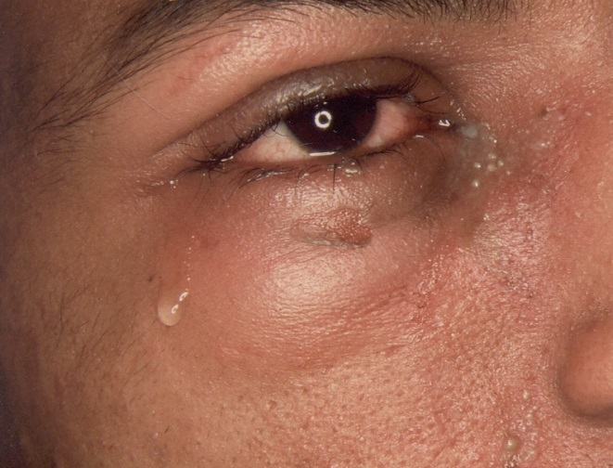
Figure 5 Eye involvement.

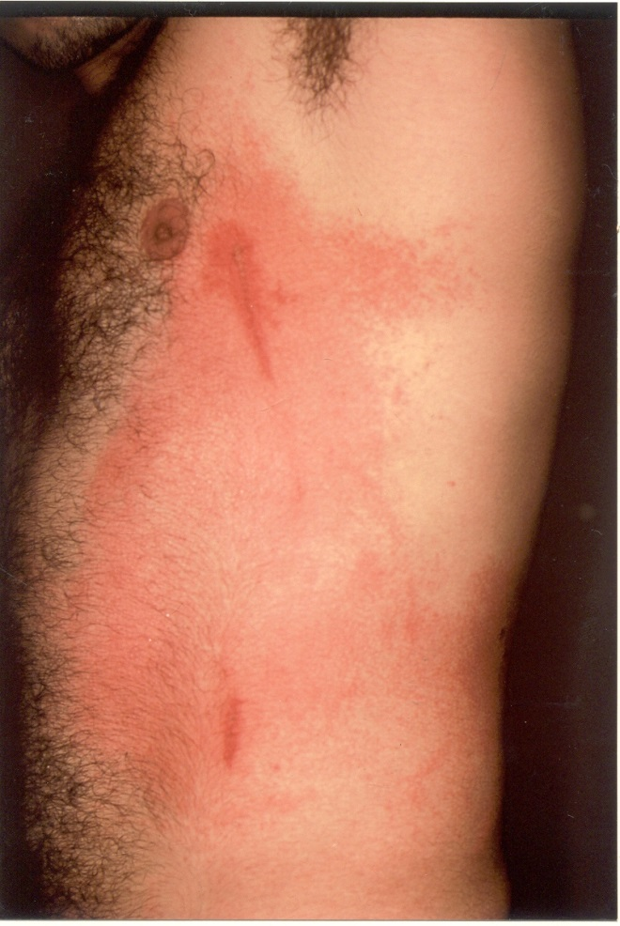
Figure 3 Whiplash dermatitis.
severity than that produced by cantharidin.¹ The commonest symptoms produced are severe burning or itching whereas the signs commonly seen are vesicles or pustules on an erythematous and edematous base.
Mirror image or kissing lesions (Figure 2) and drip marks can occasionally be seen. Commonly the exposed parts of the body are involved. A drip mark is occasionally seen when the toxin has run down the skin producing whiplash dermatitis (Figures 3 and 4).
Ocular involvement in African cases has been referred to as Nairobi eye and is mainly due to the transfer of the toxin to the conjunctiva and periorbital areas by the hand (Figure 5).^{4,5} Extensive skin involvement has been produced systemic complaints in cases in New Guinea and Malaysia.⁶ Histopathologic examination showed intraepidermal vesicle with weft of degenerated epithelial cells. The basal layer may be intact or indistinct and the dermo-epidermal junction may be destroyed. The dermis contains perivascular and periadnexal lymphocytic infiltrate. There may be associated edema
Epidemics of Paederus dermatitis in Queensland Australia,⁷ Srilanka,⁸ and Nigeria⁹ were all reported following heavy rainfall as is in the present study. Outbreaks of Paederus dermatitis have also been reported from Venezuela, Malaysia, Italy and the Mediterranean region of Turkey.^{6,9-13} The insect species reported earlier were Paederus sabeus⁹ and P. fuscipes⁸ whereas in the present study it was P. extraneus.
The present study was also in agreement with other studies with regard to seasonal outbreaks, involvement predominately of exposed areas in proximity of dense vegetation and attraction of insects to fluorescent light.
Wearing of minimum clothes (t-shirts and shorts) in 72% and keeping the lights on in the corridor and rooms could be the reason for increased occurrence in hostel inmates.
Majority of the people affected in the epidemiologic study (45%) lived on the ground floor. This is in contrast to the clinical study where the majority of affected people lived in the second floor or above. This discrepancy could be due to the fact that majority of surveyed houses were of one storey only.
66% of the affected houses were located within 200m of dense vegetation. 33% of the affected people slept with lights on at night, while 64% slept with bare minimum clothes on at night. Thus vegetation close to the dwellings provided the breeding ground for the beetles.
As in the clinical study, the exposed parts of the body like face, neck and arms were involved in majority of the affected in the epidemiological study. Most of the affected also did not take treatment as the condition is self-limiting.
Despite being a common problem, 46% of the surveyed population was unaware of the condition. Various insect control measures were used by the population like keeping windows closed after dark (62.7%) in households, use of repellants (50.5%), use of nets (33.2%) and use of sprays (17.7%) but seasonal outbreaks continue to occur.
Recommendations
Recommended control measures during the time the beetle is active are:
- Fitting houses with good insect screens, light-proof curtains and yellow light (which do not attract insects)
- Constructing a light trap, consisting of an external floodlight to attract beetles away from the buildings, to be placed over a large container half filled with soapy water in which the insects are drowned.
- Clearing decaying animal and vegetable matter from around the house to a distance of 50m.
- Dense vegetation near dwellings should be cleaned.
- If contact with the beetle is suspected, immediately the area must be washed with soap and water.
- Creating awareness of the condition among the local population and instructing them regarding the control measures.

References
- Christmas TI, Nicholls D, Greigh D. Oedemerid blister beetle dermatosis: a review. J Am Acad Dermatol. 1990;22:815-9.
- Alexander JO’D, editor. Arthropods and Human Skin. Berlin: Springer-Verlag; 1984. P.81-2.
- Cameron M, editor. The Fauna of British India, including Ceylon and Burma. Coleopetera. Staphlinidae. Vol 2. London. Taylor and Francis; 1931. P.257.
- Fox R. Paederus (Nairobi fly) vesicular dermatitis in Tanzania. Trop Doctor. 1993;23:17-9.
- Poole TR. Blister beetle periorbital dermatitis and keratoconjunctivitis in Tanzania. Eye. 1998;12:883-5.
- Mokthar N, Singh R, Ghazali W. Paederus dermatitis among medical students in USM, Kelantan. Med J Malaysia. 1993;48:403-6.
- Banney LA, Wood DJ, Francis GD. Whiplash rove beetle dermatitis in central Queensland. Aust J Dermatol. 2000;41:162-7.
- Kamaladasa SD, Perera WD, Weeratunge L. An outbreak of Paederus dermatitis in a suburban hospital in Sri Lanka. Int J Dermatol. 1997;36:34-6.
- George AO, Hart PD. Outbreak of Paederus dermatitis in southern Nigeria. Int J Dermatol. 1990;29:500-501.
- Todd RE, Guthridge SL, Montgomery BL. Evacuation of an aboriginal community in response to an outbreak of blistering beetle dermatitis induced by a beetle (Paederus austarlis). Med J Aust. 1996;164:238-40.
- Sendur N, Savk E, Karaman G. Paederus dermatitis. A report of 46 cases in Aydin, Turkey. Dermatology. 1999;199:353-5.
- Veraldi S, Suss L. Dermatitis caused by Paederus fuscipes. Curt. Int J Dermatol. 1994;33:277-8.
- Uslar C, Kavukcu H, Alptein D et al. An epidemicity of Paederus species in the Cukurova region. Cutis. 2002;69:277-9.

