Original Article
Comparison of hair reduction in idiopathic hirsutism by intense pulsed light at two different wavelengths in Asian skin types
Bushra Bashir, Zahida Rani, Faria Altaf, Khawar Khurshid, Sabrina Suhail Pal

Department of Dermatology, Unit II, King Edward Medical University, Mayo Hospital, Lahore

Abstract | Objective To determine a wavelength range of IPL most suitable for hair removal in Asian skin types.  Patients and methods Thirty women (group A) were treated using hair removal 755-1200 nm filter and thirty (group B) using 690–1200 nm filter in the facial (moustaches, beard and neck) area. Six treatment sessions were carried out at intervals of 4 weeks; follow-ups were conducted and final evaluation was done one month after the last treatment session. Mean energy settings were 32.40±3.10 J/cm² for group A and 29±3.61 J/cm² for group B. Hair counts and photographic evaluation of skin sites were made at baseline and at the last follow-up.  Results Average clearance of 68.80±15.37% and 65.97±13.27% were achieved by A and B filters, respectively. No statistically significant difference occurred in the mean percentage hair reduction between the two groups.  Conclusion 755-1200 nm wavelength filter of IPL has no preference over 690-1200 nm wavelength filter in Asian skin. Both the wavelengths are effective.  Key words  Idiopathic, hirsutism, intense pulsed light.

Introduction
Hirsutism is defined as excess hair growth in androgen dependent areas of the body in women. Studies have reported frequencies of up to 18 percent.¹ It affects a woman's perception of her femininity and results in immense distress. Women spend significant time and funds seeking permanent hair removal.²
Underlying causes of hirsutism may be polycystic ovary syndrome, ovarian and adrenal tumors, congenital adrenal hyperplasia, pharmacological agents or hyperprolactinemia. It may be idiopathic where no cause is identified. Cosmetic methods of hair removal include bleaching, plucking, waxing, depilatory creams, electrolysis, laser and intense pulsed light (IPL) sources.³
IPL devices use flashlamp and bandpass filters to emit polychromatic incoherent high-intensity pulsed light of determined wavelength spectrum, fluence and pulse duration that facilitates the treatment of a wide spectrum of skin conditions. The basic principle of IPL is more or less selective thermal damage of the target. The emission spectrum of IPLs ranges from 500-1300nm. With the aid of convertible cutoff filters, IPLs can be easily adapted to the desired wavelength range.⁴
Address for correspondence
Dr. Bushra Bashir, Senior Registrar,
Department of Dermatology, Unit II,
King Edward Medical University,
Mayo Hospital, Lahore
E mail: bushra.b27@gmail.com
Melanin is the target chromophore in light-assisted hair removal. A short wavelength technology is appropriate for light brown/blond hair of thin diameters (Fitzpatrick skin types I-III), whereas larger wavelengths is chosen for the darker skin phenotypic individuals with coarse dark brown/black hair (Fitzpatrick skin types IV-VI). Multiple repeat treatments are more effective than single treatment.⁵
Aim of this study was to determine a wavelength range of IPL most suitable for hair removal in Asian skin types.
Patients and methods
Sixty females, 18 to 40 years of age having moderate to severe idiopathic hirsutism using Ferriman and Gallwey scoring (FGS) system were entered in the study. After taking informed consent patients were divided into two equal groups randomly by lottery method. All selected variables and demographic data was recorded. Group A was treated with 755-1200 nm wavelength and group B was treated with 690-1200 nm wavelength. Areas of unwanted hair were marked and hair counting was done at a 1 cm² area of maximum hair density at the start and one month after each treatment session. Fluence and pulse duration of IPL was selected according to the patient’s Fitzpatrick skin type.
Immediately before IPL treatment patients were asked to wash the area with soap and water. Cooling transparent gel was applied to the surface area under treatment. Area was marked with blue ball pen to avoid any overlapping of laser pulses or any skipped areas. Patients were given ice packs to cool the area. They were advised to use sun block and to avoid heat and sunlight till the end of treatment. In case of persistent erythema mild topical steroid was advised.
Treatment was done in multiple sessions with intervals of 4 weeks for a total of six sessions by a single researcher. Patients were evaluated one month after each session. The two groups were compared for percentage hair reduction at the end of treatment i.e., one month after the sixth session. Digital photographs were taken before the start of treatment, at final evaluation and compared for hair reduction.
Results
All patients successfully completed six-treatment sessions protocol and follow ups.
The mean age of patients in group A was 26.20±4.84 years whereas in group B it was 27.10±6.87 years. The mean FGS of groups A was 21.17±3.34 whereas of group B 19.96±1.86. There was no statistically significant difference in the initial FGS between the groups (P=0.091). The mean baseline hair count within the assessed area (1cm²) in the group A was 28.70±8.65 and 23.86±5.76 in group B. Mean fluences applied during treatment were 32.40±3.10 J/cm² for group A and 29.00±3.61 for group B.

Table 1 Percentage hair reduction in group A (755-1200nm) and group B (690-1200nm).
 | Group A  (N=30) | Group B  (N=30)
Minimum | 37.5% | 30%
Maximum | 93.1% | 87.5%
Mean | 68.80±15.37 | 65.97±13.27

P=0.448

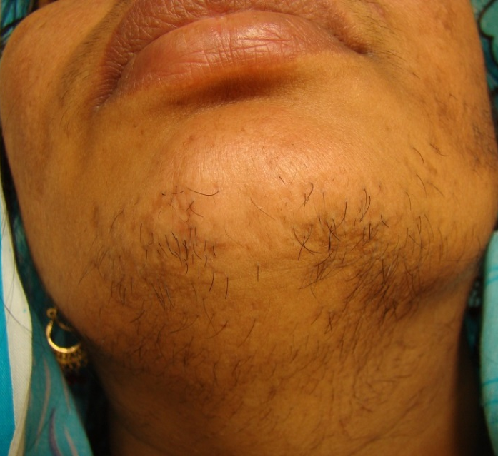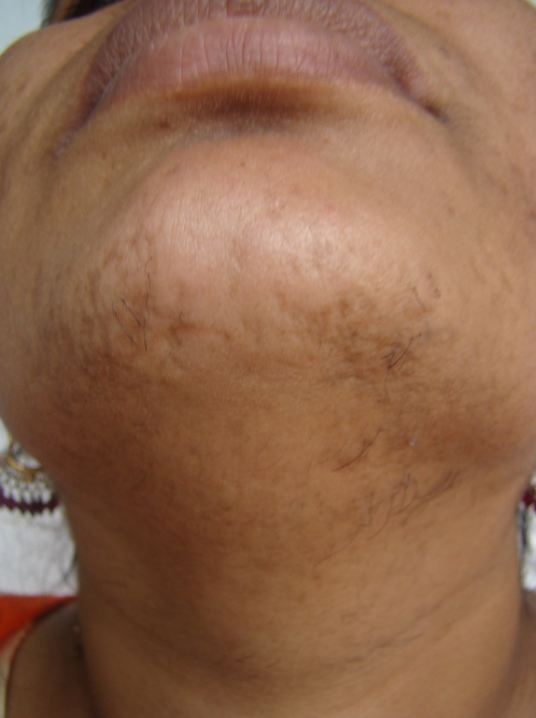
IPL group A pretreatment (Figure 1a) and after six treatment sessions (Figure 1b).

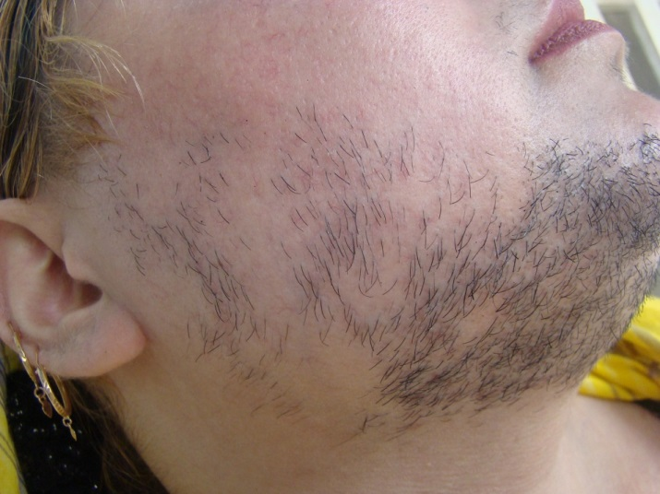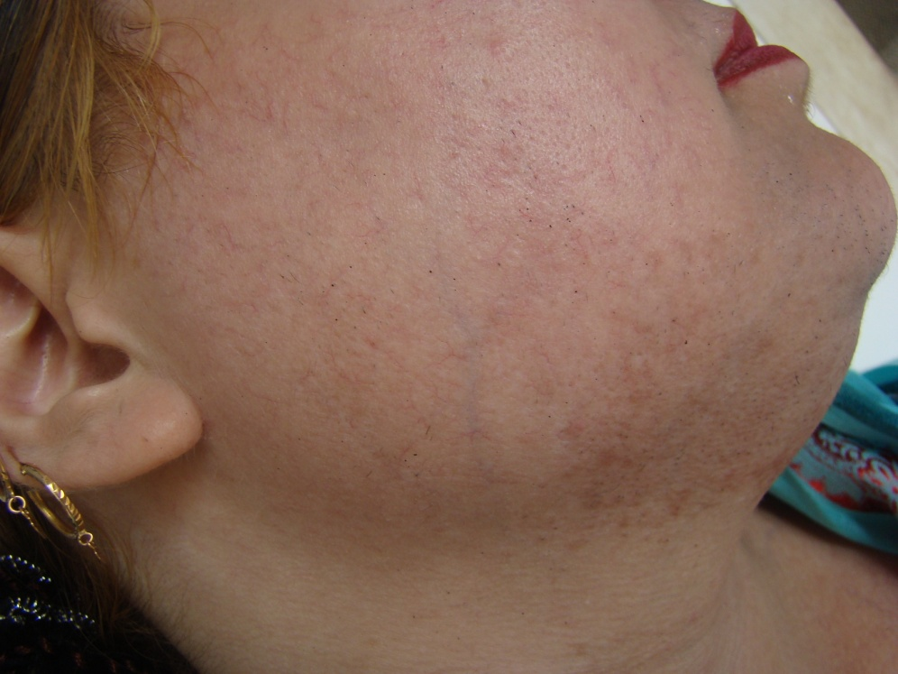
IPL group B pretreatment (Figure 2a) and after six treatment sessions (Figure 2b).

The mean percentage hair reduction at the last follow up in group A was 68.80±15.37, and it was 65.97±13.27 in group B (Table 1), (t=763, p=0.448). These results suggest that a difference of 65 nm wavelength in the emitted spectrum by IPL does not affect long-term hair reduction. Specifically these results suggest that 755-1200 nm wavelength cut off filter have no preference over 690-1200 nm wavelength cut off filter. Clinical photographs of patient belonging to group A and B are given in Figs. 1a, 1b and Figs. 2a, 2b.
In group A 20% patients developed side effects of whom 10% had folliculitis, 3.3% had hyperpigmentation, 3.3% had hypopigmentation and 3.3% had persistent erythema lasting for 2-3 days. In group B side effects appeared in 23% patients which included folliculitis in 10%, leukotrichia in 7%, hyperpigmentation in 3% and persistent erythema in 3%.
Discussion
In this study, optimal conditions for better results in percentage hair reduction in Asian skin were investigated. The same IPL device under the same clinical conditions was used with two different wavelengths i.e. filter A with a wavelength range of 755 to 1200 nm and B which emitted 690 to 1200 nm wavelength.
The mean age of patients in group A was 26 years whereas in group B it was 27 years. Age range in our study was comparable with other international and national studies.^{6,7,9} Mostly young females consult for permanent hair reduction because they are concerned about their looks and feel embarrassed by hirsutism.
The mean percentage hair reduction with 755-1200 nm wavelength filter was 68.80±15.37 in our study. The hair reduction by this filter was comparable to a study conducted by Gold et al.¹⁰ who achieved a hair reduction of 68%. They used a similar 755nm filter in 64 patients. Their patients also had a darker skin comparable to ours, which may be the reason for similar results. Jhonson and Dovale presented case report of a patient of skin type VI in whom they used a filter of 755 nm and after six treatment sessions patient showed 100% clearance at 2-7 months follow up.¹¹ The results of some of our patients individually were near 100% but as Jhonson and Dovale’s results were based on a single case, their observation may be different if more patients would have been enrolled.
The mean percentage hair reduction in group B treated with 690-1200nm wavelengths was 65.97±13.27. Jhonson and Dovale used 695nm filter in two of their patients having skin type VI and V and found 85% and 95% hair reduction after 5 and 7 treatment sessions, respectively. This is in contrast to our study. Sadick et al.¹² examined the long-term photo-epilatory effect of a combined IPL 680-980 nm radiofrequency light source and its efficiency for the treatment of multiple skin phenotypes and varied hair colors. An average clearance of 75% was observed in all body locations at 18 months follow up. Their results were better than ours, which may be because of the addition of radiofrequency or due to difference of skin types. There is a great variability in results achieved by IPL in different studies because results not only depends on IPL’s selected parameters but also on patients biologic variables.
The mean percentage hair reduction of group A and B, the difference was not significant in our study. Hee et al.⁶ conducted a study on somewhat similar pattern in Asian skin and used 600-950nm wavelength in one group and 645-950nm wavelength in another group. They concluded that excluding 600 to 645 nm shorter wavelength made a statistically significant difference in the study groups. Difference of percentage hair reduction in our study groups was not significant, and it could be because of varied reasons: 600-645nm wavelength was not used in any of our groups and there may not be significant difference in the penetration of wavelengths used in our study. It could be the pulse duration that caused noticeable difference in study groups of Hee et al. because they applied longer pulse duration in one of their groups. Another study in Asian patients by Feng et al.⁹ from China was published in 2009. They used almost same wavelengths as ours i.e., 640/695 nm filters for upper lips and 695/755 nm filters for axillae and gave an overall improvement of 83.8% after four treatment sessions. This difference from our study can be explained by the fact that response of treatment varies with the anatomical site, as response at axillae is better than face.⁹
IPL has proved beneficial and cost effective. Hair removal can be achieved with different wavelength range cut off filters. It may have even better results in Asian patients after modulating the other parameters as pulse duration and energy levels.
References
- Paus R, Olsen EA, Messenger AG. Hair growth disorders. In: Wolff K, Goldsmith LA, Katz SI et al. editors. Fitzpatrick’s Dermatology in General Medicine, 7th ed. New York McGraw-Hill companies, USA, 2008: 774-5.
- Yazdabadi A, Sinclair R. Hirsutism: from Brazil to a place near you. Expert Opin Pharmacother. 2010;11:177-83.
- De Berker DAR, Messenger AG, Sinclair RD. Disorder of hair. In: Burns T, Breathnach S, Cox N, Griffiths C, editors. Rook’s Textbook of Dermatology, 8th ed. London, Blackwell science publication; 2010. P. 66.80-9.
- Babilas P, Schreml S, Szeimies RM, Landthaler M. Intense pulsed light (IPL): a review. Lasers Surg Med. 2010;42:93-104.
- Muzaffar F, Akhtar SJ. Light assisted hair removal: facts, expectations and obligations. J Pak Assoc Dermatol. 2006;16:193-5.
- Hee LJ, Huh CH, Yoon HJ et al. Photo-epilation results of axillary hair in dark-skinned patients by intense pulsed light: comparison between different wavelengths and pulse width. Dermatol Surg. 2006;32:234-40.
- Kamal T. Long-pulsed Nd-YAG laser and intense pulse light therapy for idiopathic facial hirsutism. A comparative study. J Pak Assoc Dermatol. 2006;16:205-9.
- Amin SP, Goldberg DJ. Clinical comparison of four hair removal lasers and light sources. J Cosmet Laser Ther. 2006;8:65-8.
- Feng YM, Zhou ZC, Gold MH. Hair removal using a new intense pulsed light source in Chinese patients. J Cosmet Laser Ther. 2009;11:94-7.
- Gold MH. Lasers and light sources for the removal of unwanted hair. Clin Dermatol. 2007;25:443-53.
- Jhonson F, Dovale M. Intense pulsed light treatment of hirsutism: Case reports of skin phototypes V and VI. J Cutan Laser Ther. 1999;1:233-7.
- Sadick NS, Weiss RA, Shea CR et al. Long-term photoepilation using a broad-spectrum intense pulsed light source. Arch Dermatol. 2000;136:1336-40.

