Case Report
Blue rubber bleb nevus in zosteriform pattern: a rare case report
Parvaiz Anwar Rather, Iffat Hassan

Postgraduate Department of Dermatology, STD and Leprosy, Govt. Medical College, Srinagar Kashmir, India

Abstract | Blue rubber bleb nevus syndrome (BRBNS) is a rare condition with lesions in skin and/or other visceral organs, predominantly gastrointestinal tract. The condition is not fatal, unless associated with systemic involvement. BRBNS can also present as cutaneous lesions only. We report a classical case of BRBNS in zosteriform distribution, involving C6 and C7 dermatomes, in an adult Kashmiri male, a rare presentation.  Key words  Blue rubber bleb nevus syndrome, zosteriform.

Introduction
Blue rubber bleb nevus syndrome (BRBNS) describes a clinical entity that presents with cutaneous and visceral venous malformations, especially in the gastrointestinal tract.¹ BRBNS can also present as cutaneous lesions only without systemic involvement.²
Cutaneous lesions are often apparent at birth or manifest in early childhood as multiple, protuberant, dark blue, compressible blebs which progress in size and number with advancing age.³ We report a case of BRBNS with cutaneous involvement in zosteriform distribution in an adult Kashmiri male, which is a rare presentation.
Case report
A 50-year-old Kashmiri male from rural background, farmer by occupation, presented to our outpatient department with 15 days duration of a rapidly enlarging fleshy swelling on palmar aspect of 2nd finger of left hand, which bled easily on slight touch. This was preceded a few days back by trivial trauma with a thorn.
Address for correspondence
Dr. Parvaiz Anwar Rather
Postgraduate Department of Dermatology, STD and Leprosy, Govt. Medical College, Srinagar Kashmir, India
Ph# 09419129334
E mail: parvaizanwar@gmail.com
On examination, there was a fleshy exophytic mass well above the surface of skin, with a collar of skin around the base. It was tender, 3×3 cm in size, located on palmar aspect of 2nd left hand finger and bled easily on touch. With a clinical diagnosis of pyogenic granuloma, patient was planned for curettage and electrosurgery. At the time of procedure, as an incidental finding, we noticed multiple, bluish-black, bleb-like nodules and plaques, both discrete and confluent, in a segmental distribution on right arm, forearm and hand involving C6 and C7 dermatomes (Figure 1). The nodules were soft, non-tender and compressible with a sense of dermal herniation, and refilled rapidly on release of pressure. The surface was more or less verrucous, without any appendage changes (Figure 1). There was increased girth of the right upper limb, but no difference in length of the upper limbs on two
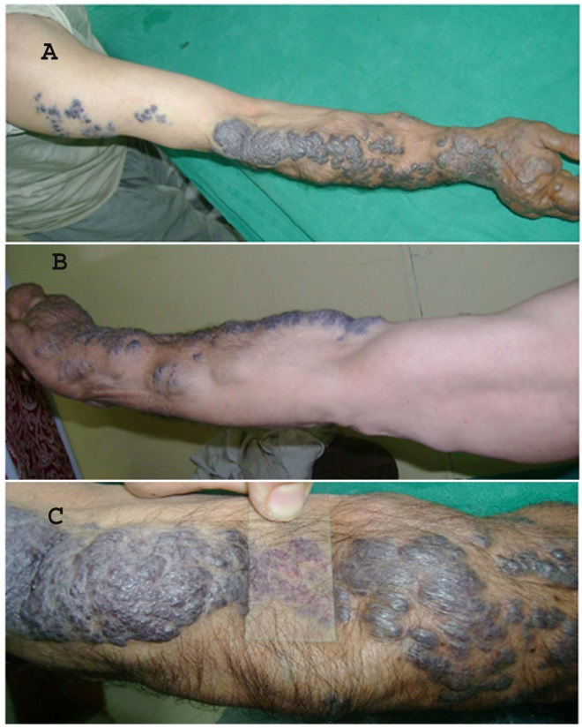
Figure 1 Bluish-black, nonblanchable, bleb-like nodules and plaques, on right arm, forearm & hand involving C6, C7 dermatomes.

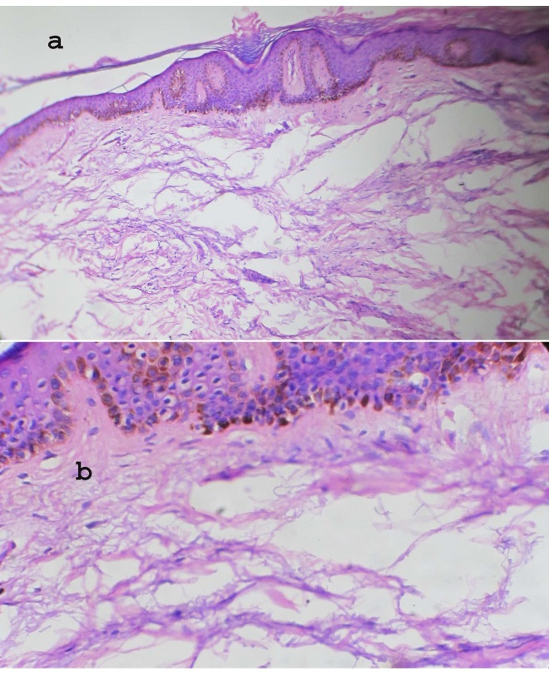
Figure 2 Histopathological examination shows hyperkeratosis, increased basal pigmentation and dilated thin walled vessels in dermis [H&E; 10X (a), 40 X (b)].
sides. There was complete emptying on keeping the arm against gravity, in c position. On probing, patient revealed that this type of skin involvement was present since childhood, associated with occasional pain and tenderness, but otherwise asymptomatic. The patient desired treatment for the increasing heaviness of limb. There was no other significant history. There was normal physical and systemic examination. With a clinical diagnosis of co-existing blue rubber bleb nevus (BRBNS), diagnostic biopsy of the suspected BRBN lesions was taken simultaneously. The histopathological examination of the punch biopsy under hematoxylin and eosin showed epidermal hyperkeratosis, increased basal pigmentation and multiple confluent dilated vessels in dermis with thin endothelium (Figure 2). Complete blood count, kidney and liver function tests, urine and stool examination, ECG and chest X-ray, ultrasound abdomen/ pelvis were normal. X-ray of limb showed soft tissue enlargement, without any osseous involvement. The upper and lower gastrointestinal endoscopy was normal.
Discussion
Blue rubber bleb nevus syndrome (BRBNS) was first described by Gascoyen in 1860 and in 1958, Dr. Bean coined the term BRBNS.^{4,5}
Three types of cutaneous lesions have been described: (1) blue, rubbery, blood-filled sacs with a smooth or wrinkled surface that are easily compressible and promptly refill when pressure is released; (2) large, disfiguring, deep cavernous lesions that may compress vital structures; and (3) blue irregular macules.⁶
It affects both sexes and is usually sporadic, although autosomal dominant inheritance has been reported.⁷ The pathogenesis of the disease is not clear. Recent analysis has identified a locus on chromosome 9 responsible for venous malformations.³
Cutaneous lesions are often apparent at birth or manifest in early childhood as multiple, protuberant, bleb-like, bluish nevi resembling soft, phlebectatic in appearance and consistency which refill promptly after being compressed with a feeling of dermal herniation and which progress in size and number with advancing age. It can be spontaneously painful or tender and may depict supralesional hyperhidrosis, found more commonly on the trunk and limbs.^{1,3} It is usually associated with systemic hemangiomas especially of the gastrointestinal tract and also, spleen, liver, stomach, brain, spinal cord, heart and kidney.¹ BRBNS can also present as cutaneous lesions only without systemic involvement.²
Histopathologic examination of skin lesions revealed vascular tissue with tortuous, blood-filled ectatic vessels, lined by a single layer of endothelium, with surrounding thin connective tissue.³
The differential diagnosis includes Maffucci syndrome, venous lakes, Osler-Weber-Rendu syndrome, hereditary hemorrhagic telangiectasia, disseminated hemangiomatosis, Kaposi’s sarcoma, glaomangiomas.⁶
Treatment of cutaneous lesions on cosmetic or functional grounds includes electrodessication and curettage, liquid nitrogen, carbon dioxide laser, radiation therapy, sclerotherapy or surgery. The sclerosant agents used are 5% sodium morrhuate, quinine urethrone, 5% ethanolamine oleate, 1% polidocanol and hypertonic saline.⁶
The prognosis depends on the extent of visceral organ involvement. Most patients particularly with cutaneous involvement only have a normal life span.⁶
Our patient presented with cutaneous lesions of BRBNS in zosteriform distribution, which is a rare presentation, along with coexisting pyogenic granuloma.
References
- Mittal RR, Pureet. Blue rubber bleb nevus syndrome. Indian J Dermatol Venereol Leprol. 2001;67:41-2.
- Mittal RR, Maninder. Blue rubber bleb naevus. Indian J Dermatol Venereol Leprol. 1995;61:150-1.
- Liu Q, Chen YP, Li YM. Blue rubber bleb nevus syndrome: a report of one case associated with recurrent epistaxis. Chin Med J (Engl). 2007;120:731-3.
- Gascoyen GG. Case of nevus involving the parotid gland and causing death from suffocation: nevi of the viscera. Trans Pathol Soc Lond. 1860;11:267.
- Bean WB. Blue rubber bleb nevi of the skin and gastrointestinal tract. In: Springfield IL, Charles C, Thomas CC, editors. Vascular Spiders and Related Lesions of the Skin. Oxford: Blackwell Scientific Publication; 1958. p.178-85.
- Suma GN, Ravi Prakash SM, Rao D, Goel S. Blue rubber bleb nevus syndrome: Prominent oral findings. Indian J Dermatol Venereol Leprol. 2010;76:168-71.
- Krishnappa A, Padmini J. Blue rubber bleb nevus syndrome. Indian J Pathol Microbiol. 2010;53:168-70.

