Case Report
Angiokeratoma corporis diffusum without systemic features in a young Kashmiri female: a rare occurrence
Iffat Hassan, Parvaiz Anwar Rather, Saima Aleem

Postgraduate Department of Dermatology, STD & Leprosy, Government Medical College Srinagar (University of Kashmir), J&K, India

Abstract | Angiokeratoma corporis diffusum (ACD) is a variety of angiokeratoma, characterized by diffuse cutaneous hyperkeratotic vascular lesions. ACD is usually associated with many lysosomal enzyme deficiencies, though it is not a rule. It is associated with systemic features along with skin lesions. It may also present as isolated cutaneous form. X-linked recessive form usually manifests in males and females act as carriers. We report a case of ACD without systemic features in a young Kashmiri female.  Key words  Angiokeratoma, angiokeratoma corporis diffusum, lysosomal enzyme deficiency.

Introduction
Angiokeratomas are characterized by asymptomatic hyperkeratotic vascular skin lesions characterized histologically by papillary dermal vascular ectasia and epidermal hyperkeratosis.¹ Angiokeratoma corporis diffusum (ACD) is a variety of angiokeratoma where lesions are usually symmetrically distributed and mostly concentrated between the umbilicus and knees.² ACD is associated with many lysosomal enzyme deficiencies, most important of which is the Fabry’s disease due to deficiency of α1-galactosidase enzyme. It may also present without any enzyme deficiency.^{3,4} It usually presents with systemic features along with skin lesions. ACD presenting without systemic features,⁵ or with normal physical, mental development and with skin lesions alone is a rare but specific clinical entity.⁶ We report such type of a rare case in a Kashmiri female and review the literature.
Case report
A 25-year-old unmarried female, product of consanguineous marriage, presented to our outpatient department with solid, dry, red skin eruptions since the age of 10 years. At that time she had started with bleeding per rectum and subsequently developed skin lesions initially over left hip area. The lesions gradually spread over a period of few years to other areas of body with predominant involvement of pelvic girdle, proximal limbs, lower trunk and external genitals. She did not have any more episode of gastrointestinal bleeding and all previous records are lost. This time she approached us because of recent increase in size and number of lesions around the external genitals, as she was to get married soon. The patient was otherwise asymptomatic. There was no other significant
Address for correspondence
Professor Iffat Hassan
Postgraduate Department of Dermatology, STD & Leprosy,
Govt. Medical College Srinagar,
University of Kashmir, J&K, India
Ph# 91-9419077667
E-mail: hassaniffat@gmail.com
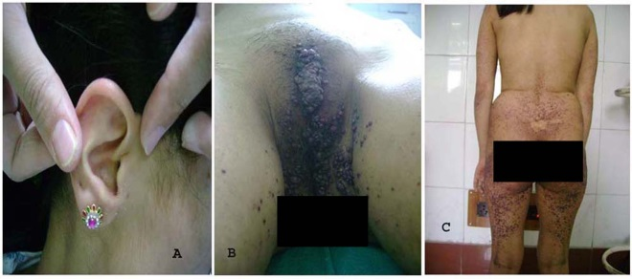
Figure 1 Red to purple angiomatous hyperkeratotic papules on external ear (A), external genitals (B) and on body (C).

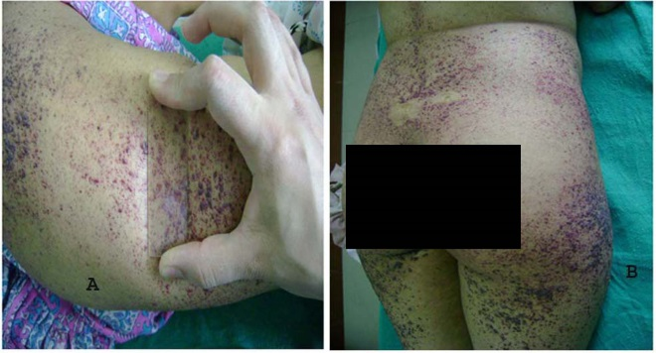
Figure 2 Diascopy showing non-blanchable lesions (A) and closeup view (B).

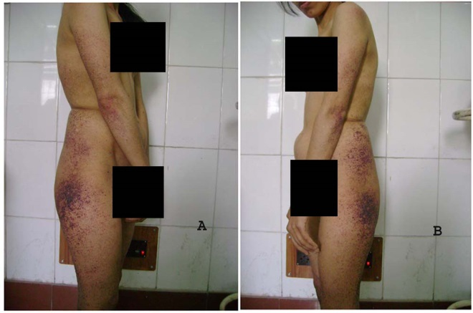Figure 3A, 3B Predominant involvement of lateral trunk and extensor aspects of proximal limbs with under developed mammary glands.
positive history. There was no significant trauma or drug history. There was no member in the family with such ailment. She was fourth in the order of birth, born by normal home delivery. The first conception of her mother was a male who died on 8th day of neonatal period of some unknown reason. All other four siblings, three females and one male, were normal. She had normal developmental milestones. Her menstrual history was normal.
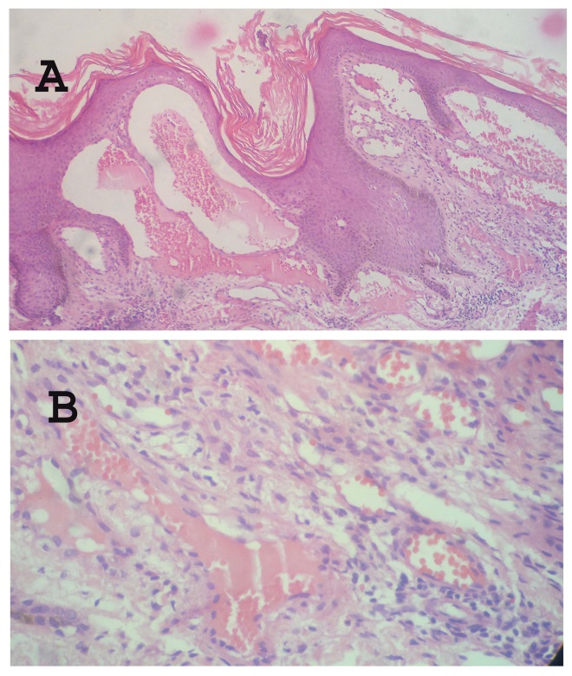Figure 4 Photomicrograph showing hyperkeratosis, irregular acanthosis and elongation of rete ridges in epidermis and ectatic dilated vessels with mild perivascular chronic infiltrate in dermis [H & E, X100 (A), X 400 (B)].
On examination, she had pallor and no lymphadenopathy. Rest of physical and systemic examination was normal. Her weight was 48 kilograms and height 5 feet. The mammary glands were not properly developed. Axillary and pubic hair was normally grown. On cutaneous examination, there were bilaterally, symmetrically distributed, discrete, as well as, confluent and grouped, solid, variable sized red-purple papules predominantly over extensor aspect of proximal upper limbs, lateral aspect of trunk, lower back, pelvic girdle, proximal aspect of lower limbs and knees, with more confluent lesions around external genitals and scattered lesions on external ear, chest, upper back, dorsa of hands and feet (Figure 1A, B and C). The lesions were nonblanchable on diascopy (Figure 2A and B). There was relative sparing of distal extremities, flexor aspect of limbs, scalp, face and complete sparing of palms, soles, flexures (Figure 3). Face showed melasma. Nail, hair and mucus membrane examination was normal. Her complete hemogram, liver function test, kidney function test, urine analysis, ECG, chest X-ray, USG abdomen/ pelvis was normal. With an impression of angiokeratoma corporis diffusum, skin biopsy was taken. Histopathological examination under hematoxylin and eosin stain showed hyperkeratosis, irregular acanthosis and elongation of rete ridges in the epidermis; dermis showed ectatic dilated vessels with mild perivascular chronic inflammatory infiltrate, confirming the clinical diagnosis of angiokeratoma (Figure 4A and B). Enzyme levels could not be assessed because of lack of facility. Her upper gastrointestinal endoscopy and colonoscopy were normal. Her ophthalmological, cardiac, neurological, nephrology and surgical consultations were sought and revealed no abnormality. We started with electro cauterization starting from external genital lesions.
Discussion
Angiokeratomas are a group of conditions characterized by asymptomatic hyperkeratotic vascular skin lesions and histological combination of superficial dermal vascular ectasia and epidermal hyperkeratosis.¹
The pathogenesis of angiokeratoma is not clearly known. Metabolic disturbance leading to vascular ectasia in the papillary dermis is considered to be the primary event with epidermal hyperkeratosis as secondary reaction.⁷ Five varieties of angiokeratoma are generally recognized: i) generalized systemic type - angiokeratoma corporis diffusum (ACD); ii) bilateral form occurring on the dorsa of fingers and toes - angiokeratoma of Mibelli; iii) localized scrotal/vulval form - angiokeratoma of Fordyce; iv) solitary papular angiokeratoma; and v) multiple unilateral papular and plaque like, usually on lower limbs - angiokeratoma circumscriptum (naeviforme).⁸
In the generalized form, angiokeratoma corporis diffusum (ACD), lesions are usually symmetrically distributed and are mostly concentrated between the umbilicus and knees.²
Our patient had diffuse variety of angiokeratoma because of typical distribution of lesions.
ACD was initially considered to be synonymous with Fabry's disease, first described by Anderson and Fabry independently in 1898.⁹ It is a rare X-linked recessive disorder, with an incidence of about 1:40 000,¹⁰ caused by the mutation in α-galactosidase, a gene on long arm of X chromosome¹¹ and subsequent deficiency of lysosomal hydrolase, alpha-galactosidase, which results in the progressive deposition of uncleaved neutral glycosphingolipids, predominantly α-galactosyl-lactosyl ceramide (trihexosyl ceramide) within the lysosomes of endothelial, perithelial, smooth muscle cells, autonomic nervous system, kidneys, eyes and heart.¹²
ACD is no longer regarded as specific to Fabry`s disease only. Widespread angiokeratomas also occur in patients with several additional enzyme deficiencies, which include α-fucosidase (fucosidosis), neuraminidase (sialodosis), aspartylglucosaminidase (aspartylglucosaminuria), β-mannosidase (β-mannosidosis), α-N-acetylgalactosaminidase (Kanski disease), and β-galactosidase (adult-onset GM1 gangliosidosis).¹³ Also, ACD may occur without recognizable enzyme deficiency,^{3,4} or as benign form without systemic features,⁵ or normal physical, mental development and with skin lesions alone.⁶
The cutaneous eruptions in ACD of lysosomal deficiencies usually first appear before puberty¹⁴ in the form of multiple vascular lesions over lower back, upper thigh, genitals and around umbilicus,¹⁵ with grouping of lesions over hips, limbs, buttocks, lower trunk and shaft of penis.¹⁶ As with most X-linked recessive disorders, males exhibit the full-blown disorder. Females are asymptomatic carriers or develop mild forms of the disease.
Our patient may be a heterozygotic carrier presenting without systemic features or an idiopathic form of ACD or a benign isolated form. We report this interesting case for its rarity.
References
- Bhargava P, Bhargava S, Mathur D et al. Angiokeratoma of tongue. Indian J Dermatol Venereol Leprol. 2001;67:270.
- Grevelink SV, Mulliken JB. Vascular malformations. In: Goldsmith LA, Katz SI, Gilchrest BA et al. editors. Dermatology in General Medicine, 8th edn. New York: McGraw-Hill; 2012. P. 2076-94.
- Kelly B, Kelly E. Angiokeratoma corporis diffusum in a patient with no recognizable enzyme abnormalities. Arch Dermatol. 2006;142:615-8.
- Crovato F, Rebora A. Angiokeratoma corporis diffusum and normal enzyme activities. J Am Acad Dermatol. 1985;12:885-6.
- Marsden J, Allen R. Widespread angiokeratomas without evidence of metabolic disease. Arch Dermatol. 1987;123:1125-7.
- Laxmisha C, Thappa DM, Karthikeyan K. Cutaneous variant of angiokeratoma corporis diffusum. Dermatol Online J. 2003;9(1):13.
- Schiller PI, Itin PH. Angiokeratomas: An update. Dermatology. 1996;193:275-82.
- Leung CS, Jordan RCK. Solitary angiokeratoma of the oral cavity. Oral Surg Oral Med Oral Pathol Oral Radiol Endod. 1997;84:51-3.
- Imperial R, Helwig EB. Angiokeratoma: A clinicopathological study. Arch Dermatol. 1967;95:165-75.
- Fukushima M, Tsuchiyama Y, Nakato T et al. A female heterozygous patient with Fabry's disease with renal accumulation of trihexosyl ceramide detected with a monoclonal antibody. Am J Kidney Dis. 1995;26:952-5.
- Larralde M, Boggio P, Amartino H, Chamoles N. Fabry disease: A study of 6 hemizygous men and 5 heterozygous women with emphasis on dermatologic manifestations. Arch Dermatol. 2004;140:1440-6.
- Morgan SG, Crawford MA. Anderson-Fabry disease, a commonly missed diagnosis. Br Med J. 1988;297:872-3.
- Vargas-Diez E, Chabas A, Coll MJ et al. Angiokeratoma corporis diffusum in a Spanish patient with aspartylglucosaminuria. Br J Dermatol. 2002;147:760-4.
- Julie KK, Elizabeth KH, Linglei M. Angiokeratoma corporis diffusum (Fabry disease). Dermatol Online J. 2005;11:8.
- Sharma VK, Kumar B, Kaur I, Kaur S. Fabry’s disease. Indian J Dermatol Venereol Leprol. 1985;51:105-7.
- Morris AAM, Breathnach SM. Fabry’s disease. In: Burns T, Breathnach S, Cox N, Griffiths C, editors. Rook’s Textbook of Dermatology, 8th edn. Oxford, UK: Wiley-Blackwell, 2010. pp. 59.36-59.39.

