Original Article
Autologous noncultured epidermal cell suspension in case of resistant segmental vitiligo: a preliminary study
Iffat Hassan, Syed Mubashir, Zubair Abdullah, Peerzada Sajad, Parvaiz Anwar, Gousia Sheikh, Abdul Sami, Atiya Yaseen

Postgraduate Department of Dermatology, STD & Leprosy, Govt. Medical College, Srinagar.

Abstract | Objective To assess the repigmentation efficacy of noncultured epidermal cell suspension (NCECS) in case of resistant segmental vitiligo.  Patients and methods Three patients having resistant segmental vitiligo were treated with noncultured epidermal cell suspension at the Department of Dermatology, STD & Leprosy, SMHS Hospital (associated teaching hospital of Govt. Medical College, Srinagar) and were followed up for six months.  Results Two patients showed more than 70% response, one patient more than 50% response. The pattern of pigmentation was uniform and aesthetically acceptable.  Conclusion Autologous non cultured epidermal cell suspension is one of the best modalities as far as segmental vitiliginous patches resistant to other treatment modalities are concerned and is one of the novel techniques as far as its outcome is concerned in the form of uniform pigmentation.  Key words  Vitiligo, autologous, noncultured epidermal cell suspension, melanocytes, trypsinization.

Introduction
Vitiligo is one of the common depigmentary dermatosis that remains one of the major dermatological challenges. It affects approximately 1% of the world’s population with highest incidence in Indian subcontinent.¹
The medical management of vitiligo has a role as far as expanding patches are concerned. Once the lesions become stable surgical modalities are best option alone or along with medical management. Vitiligo causes psychological problems leading to reduced self-esteem and confidence, stress, depression and even suicidal tendencies due to various social problems associated with it. Various surgical modalities like miniature punch grafting, suction blister grafting, Thiersch split-skin grafting, dermabrasion are done for vitiligo.² Autologous noncultured melanocyte-keratinocyte suspension has gained popularity recently.
Patients and methods
Address for correspondence
Prof. Iffat Hassan,
Postgraduate department of Dermatology, STD & Leprosy,
Govt. Medical College Srinagar,
University of Kashmir, J&K, INDIA
Cell no. 91-9419077667.
E mail: hassaniffat@gmail.com

Three patients aged more than 18 years were enrolled. The inclusion criteria were: 1. Segmental vitiligo patches resistant to medical management, 2. Vitiligo patches stable for at least more than one year (for assessment of
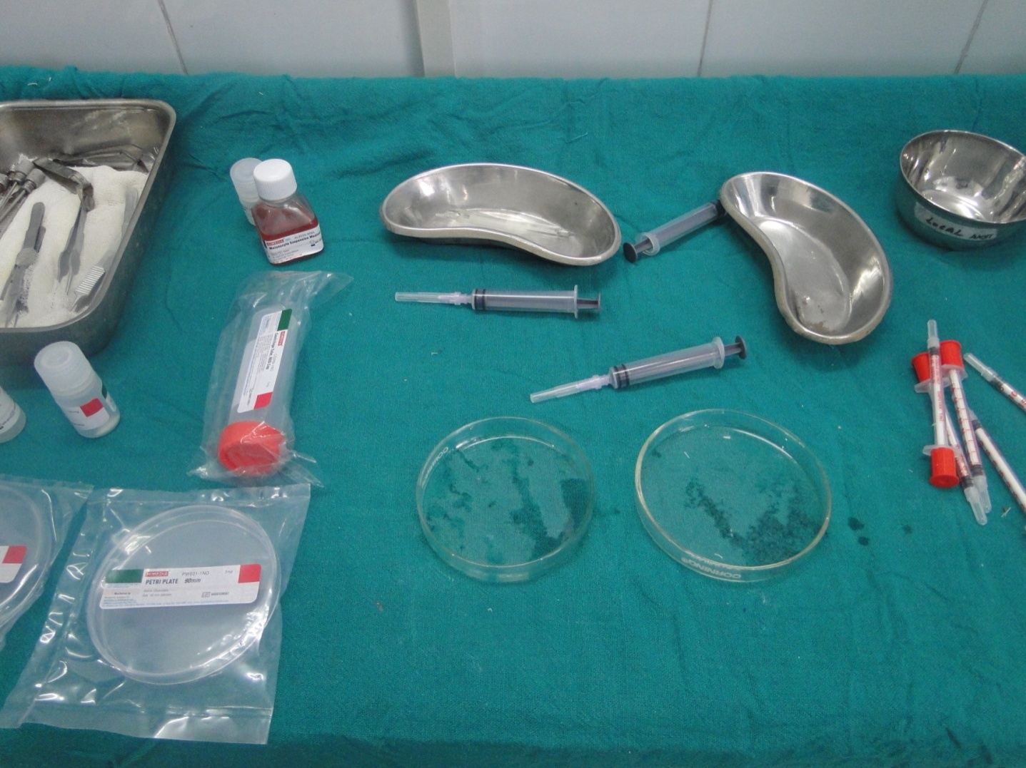
Figure 1 Various instruments of the procedure.

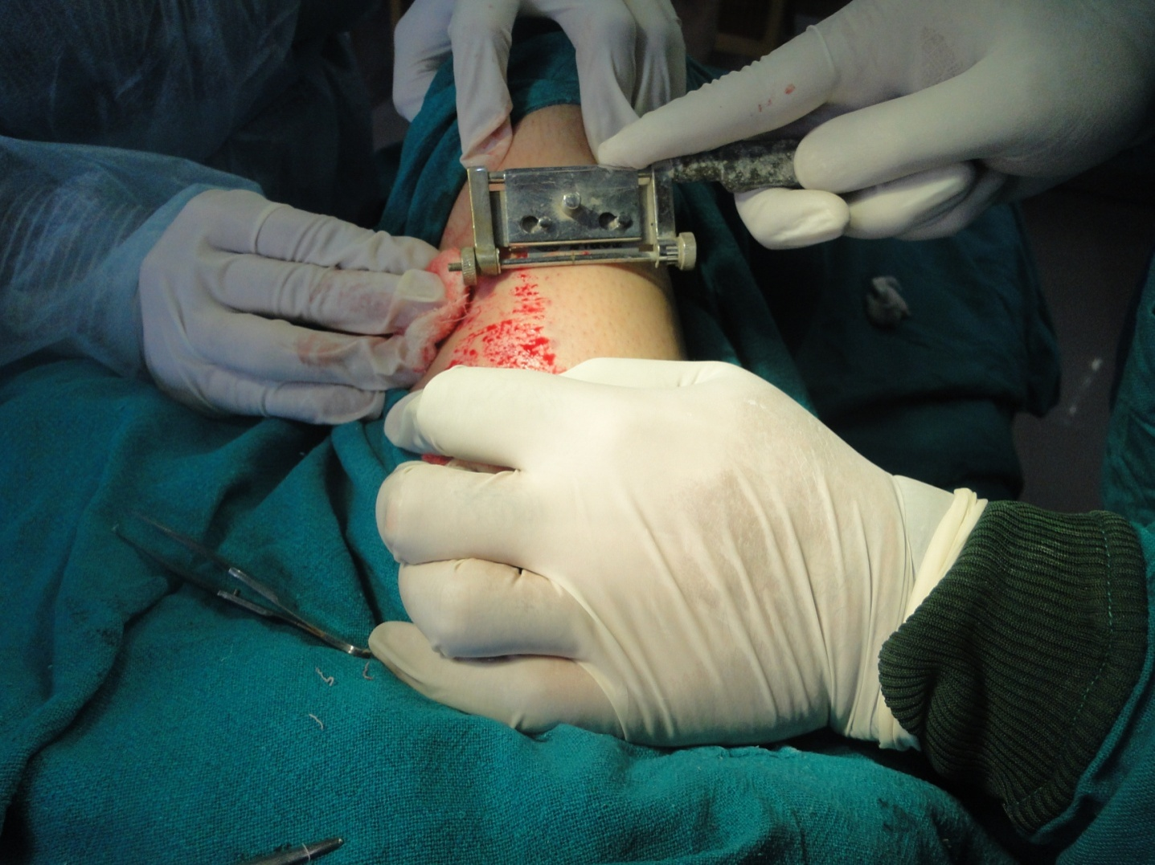
Figure 2 Taking a graft from the donor area.

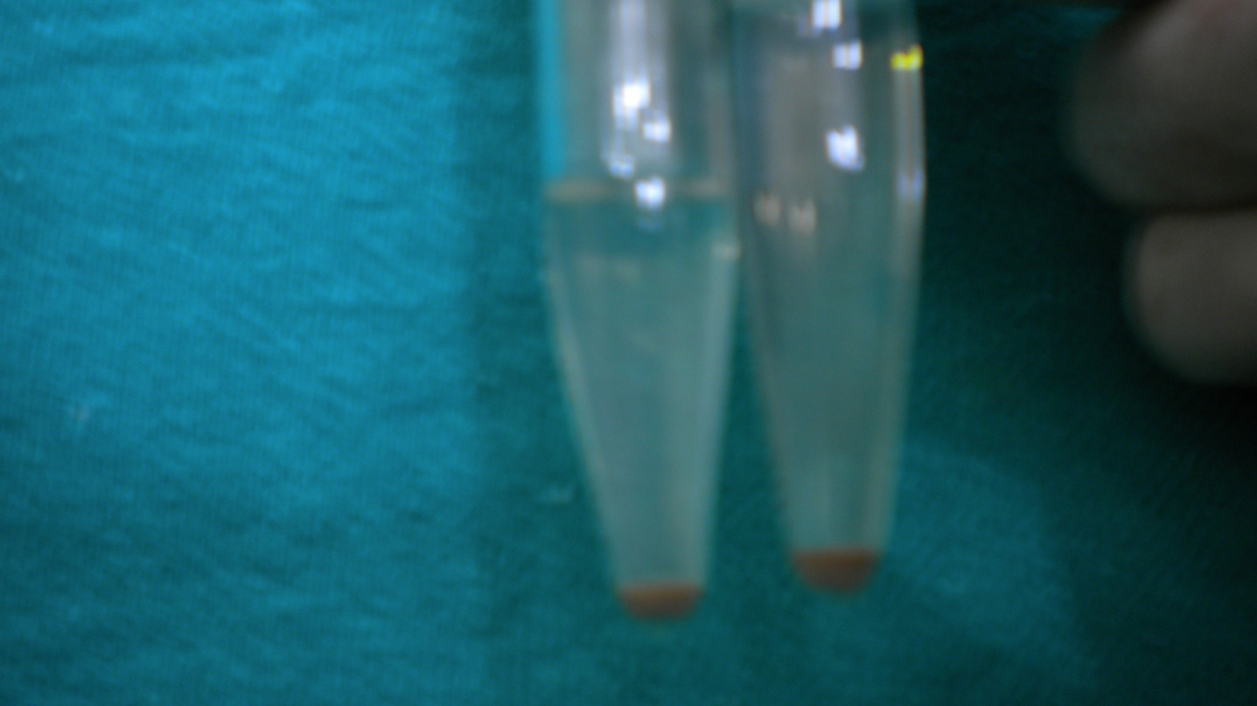
Figure 3 Cell suspension pellets.
stability Prasad and Gupta’s criteria were used which suggested the definition as absence of progression of disease for past one year and no new lesions during the same period).³
All the medications in the form of topical or systemic therapies were stopped before enrolling the patient. Well-informed written consent was
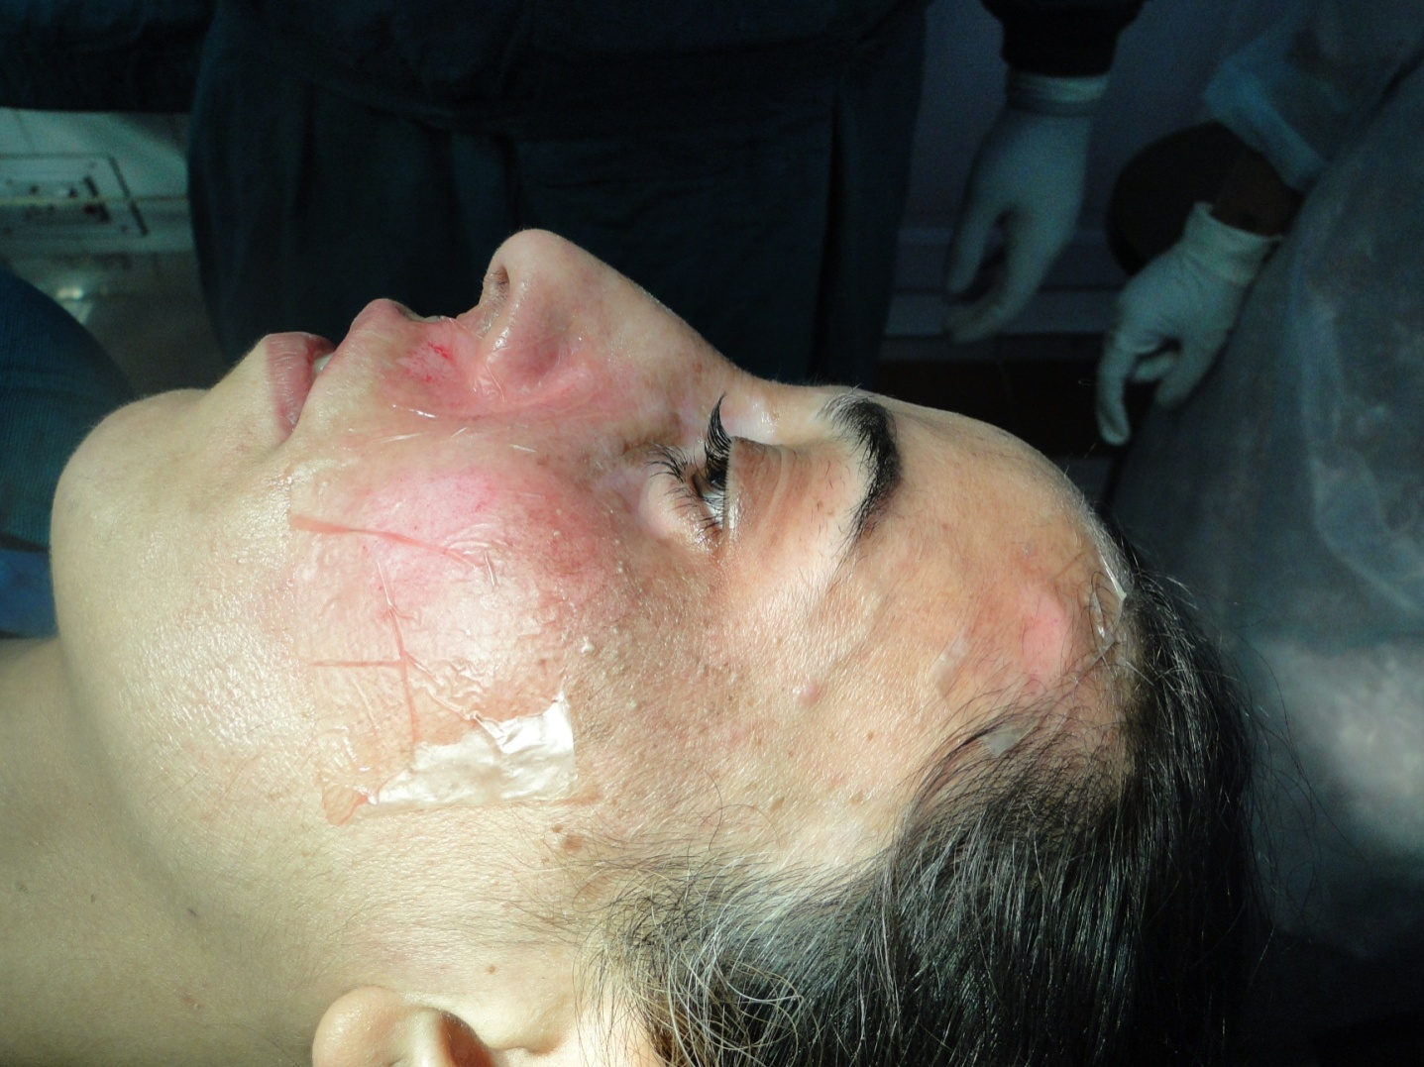
Figure 4 Putting the cell suspension over the recipient dermabraded area using collagen dressing.
taken from all the patients and the outcome of the surgery was explained. Carbon dioxide laser abrasion was done over the recipient area till pinpoint bleeding was observed and ultrathin split skin graft was taken under local anesthesia from anterior aspect of thigh using Silverman’s knife. The graft was divided into small pieces and was placed in trypsin EDTA solution such that the dermis facing downwards and was incubated at 37ºC for about 45 minutes. The trypsinized graft was then neutralized by using trypsin inhibitor solution and after 5 to 10 minutes Dulbeco’s modified Eagle’s medium (DMEM) was added. The teasing of the dermal tissue was done using blunt forceps till there was separation of the basal layers from the epidermis. Transfer of the basal layer along with DMEM and antitrypsin in centrifuge tube followed by centrifugation at 2500 to 3000 rpm for about 6 to 8 minutes was done. The supernatant was removed using a pipette and pellets suspended in the test tube were treated with 1 ml of fresh DMEM and was transferred to evenly dermabraded area (dermabrasion was done by carbon dioxide laser) under the cover of bovine collagen dressing and were padded up by using leukoband as pressure dressing (Figures 1-4). The patients were instructed not to remove the dressing and were advised that it should be removed in theatre on 7th postoperative day. All the patients were put on oral antibiotics and nonsteroidal anti-inflammatory drugs for 5 days postoperatively. The follow up was done weekly for first month and there after monthly up to six months. The donor area was padded up with sofratullae with firm pressure dressing and dressing was changed every 2 days.
Results were graded as per area of repigmentation as: 70 to 89% as excellent, 50 to 69 % as good, 30 to 49% as fair and < 29% as poor.
Results
Out of three, two patients showed excellent response and one patient showed good response after six months of follow up. The repigmentation appeared after four to six weeks postoperatively. The repigmentation observed in patients was uniform and aesthetically acceptable as compared to other surgical modalities (Figures 5 and 6).
Discussion
The finger tips, ankles, dorsum of hand, dorsum of foot, lips and vitiliginous areas with leukotrichia are difficult to treat medically. Various surgical modalities are available in case of resistant cases and can be combined with lights to obtain good results. An ideal surgical treatment is one which achieves excellent repigmentation of the vitiliginous recipient site areas with least altered pigmentation and scarring over the donor site. Punch grafting is

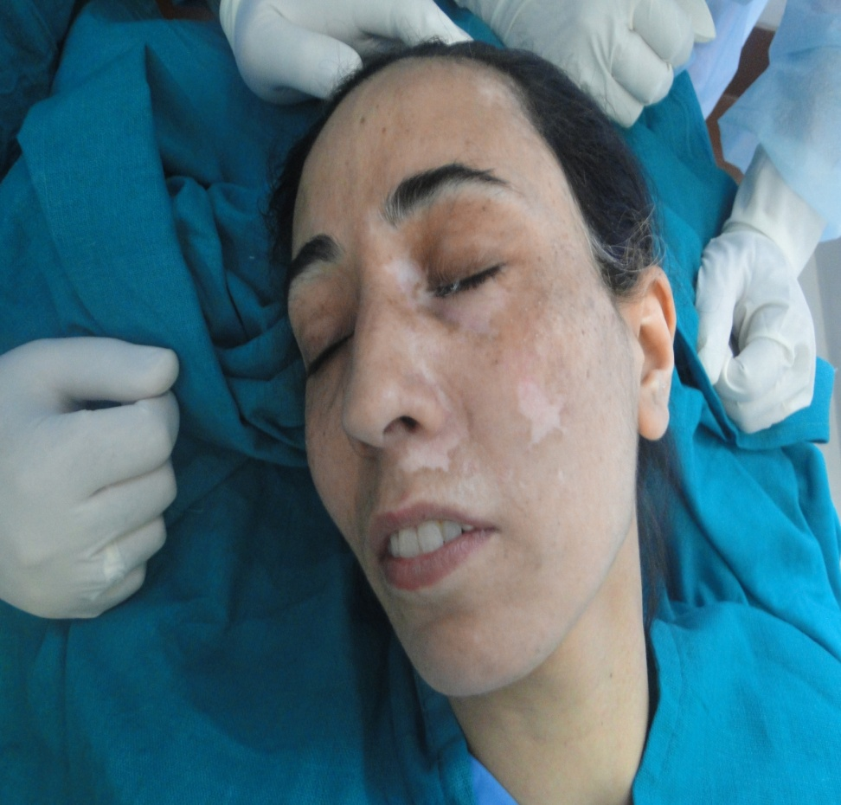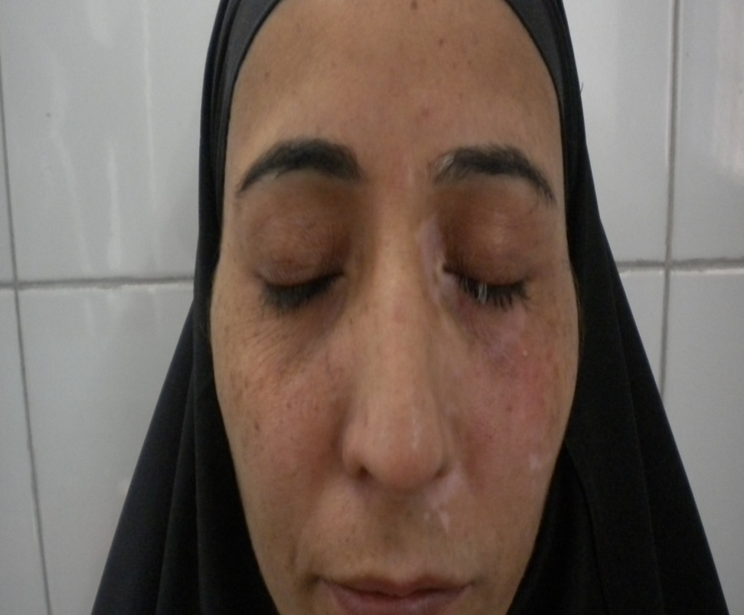
Figure 5 First patient before and after the procedure.

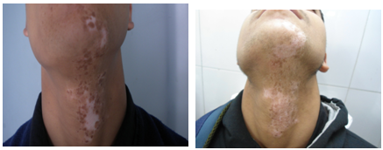
Figure 6 2nd patient before and after the procedure.

associated with a cobblestone appearance of the grafts. Split-thickness grafting may lead to milia formation, thickening of the graft margins, hyperpigmentation or stuck-on appearance in some cases. Also larger sized graft donor sites are required that are at risk for scarring or altered pigmentation.
The transplantation of cultured pigment cells involves harvesting of pigment cells from a shave biopsy from a donor area and then sending it to laboratory and expanding the cells in culture for about 3-4 weeks and finally transplanting them to an area devoid of pigment cells. This procedure requires a well-established hi-tech laboratory setup.
We studied the role of non cultured epidermal melanocytic cell suspension in resistant cases of vitiligo. Non-cultured epidermal suspension is indicated mainly for segmental vitiligo and for stable non-segmental vitiligo that does not respond to medical treatment. It is one of the best surgical modalities as the repigmentation achieved is uniform and aesthetically acceptable. With this modality, large area can be treated using only smaller donor area as 1 cm² of donor area can cover 10cm² of recipient area. It has given us encouraging results in case of resistant vitiligo patches. The thickness of the graft from the donor area, time of incubation and placement of the grafts in the media (dermal side of graft should be facing downwards) while incubating matters as far as results are concerned These cellular grafts are aimed to replenish melanocyte population in depigmented lesions. Best results were obtained by Mulekar^{4,5,6} in segmental vitiligo (84%). According to Olsson and Juhlin⁷ and Van Geel et al.⁸ significant repigmentation was obtained in 70% of patients.
Conclusion
The non-cultured epidermal melanocytic cell suspension is one of the novel surgical modality in the armamentarium of a dermatosurgeon. It is safe, simple and as far as results are concerned having edge over the other modalities. However, proper selection of the patient, proper technique in taking graft and good laboratory setup is required. Although this is a preliminary study and we have achieved good results, we hope to carry out more such procedures in future.
References
- Sehgal VN, Srivastava G. Vitiligo compendium of clinicoepidemiological features. Indian J Dermatol Venereol Leprol. 2007;73:149-56.
- Savant SS. Surgical therapy of vitiligo: current status. Indian J Dermatol Venereal Leprol. 2005;71:307-10.
- Parsad D, Gupta S. Standard guidelines of care for vitiligo surgery. Indian J Dermatol Venereol Leprol. 2008;74:37-45.
- Mulekar SV. Melanocyte-keratinocyte cell transplantation for stable vitiligo. Int J Dermatol. 2003;42:132-6.
- Mulekar SV. Long-term follow-up study of segmental and focal vitiligo treated by autologous, non-cultured melanocyte-keratinocyte cell transplantation. Arch Dermatol. 2004;140:1211-5.
- Mulekar SV, Al Eisa A, Delvi MB et al. Childhood vitiligo: A long term study of localized vitiligo treated by non-cultured cellular grafting. Pediatr Dermatol. 2010;27:132-6.
- Olsson MJ, Juhlin L. Long term follow-up study of leucoderma patients treated with transplants of autologous cultured melanocytes, ultrathin epidermal sheets and basal cell layer suspension. Br J Dermatol. 2002;147:893-904.
- Van Geel N, Ongenae K, Vander Haeghen Y et al. Subjective and objective evaluation of non-cultured epidermal cellular grafting for repigmenting vitiligo. Dermatology. 2006;213:23-9.

