Case Report
Papuloerythroderma of Ofuji - a case report
Iffat Hassan, Mashkoor Ahmad, Qazi Manaan, Sajjad Hussain, Qazi Masood

Postgraduate Department of Dermatology, STD & Leprosy, Government Medical College and Associated SMHS Hospital, Srinagar-Kashmir (J&K), India

Abstract | Papuloerythroderma of Ofuji is an uncommon skin condition seen in elderly patients characterized by pruritic eruption of infiltrating papules with sparing of large folds of skin. Very few cases have been reported in the literature and the frequent association of this rare entity with laboratory abnormalities and malignancy points towards its heterogenous nature. We report a case of papuloerythroderma of Ofuji having peripheral eosinophilia but not associated with any malignancy.  Key words  Deck-chair sign, eosinophilia, papuloerythroderma, PUVA.

Introduction
Papuloerythroderma of Ofuji (PEO) is a rare skin condition characterized by widespread eruption of intensely pruritic papules which later on coalesce to form plaques and erythroderma characteristically sparing the compressed abdominal body folds (the so called deck-chair sign). The condition is frequently associated with malignancy, particularly T and B cell lymphoma.¹ Lymphadenopathy, peripheral blood eosinophilia and raised IgE levels are common findings associated with PEO.² The treatment of PEO may be difficult and different treatment modalities used have shown a variable response. We report a 65-year-old male as a case of PEO having characteristic clinical features who had no underlying malignancy. The patient responded to PUVA therapy.
Address for correspondence
Dr. Iffat Hassan
Associate Professor & Head
Postgraduate Department of Dermatology,
STD & Leprosy
Govt. Medical College and Associated SMHS Hospital
Srinagar-Kashmir (J&K), India
Email: hassaniffat@gmail.com
Ph: 91-194-2441884

Case report
A 65-year-old male patient presented with a two year history of pruritic eruption involving scalp, trunk and extremities. The lesions first started on scalp and involved the above mentioned sites in a period of two years. There was no history of seasonal exacerbation of lesions. There was no personal or family history of atopy, drug reaction, diabetes mellitus and hypertension. On examination there were diffuse erythema, edema, scaling and excoriation marks on scalp, chest, abdomen, back and extremities. There were few isolated flat topped papules on face and dorsum of hands and feet (Figures 1-4). There were no lesions in body folds i.e. axillary, inguinal, popliteal and antecubital fossae. The compressed abdominal folds were conspicuous by their sparing (the deck-chair sign) [Figure 1]. The examination of nails, mucosa and hair was normal. There was bilateral axillary lymphadenopathy. Rest of the general physical and systemic examination was within normal limits. There were no cutaneous infarcts.

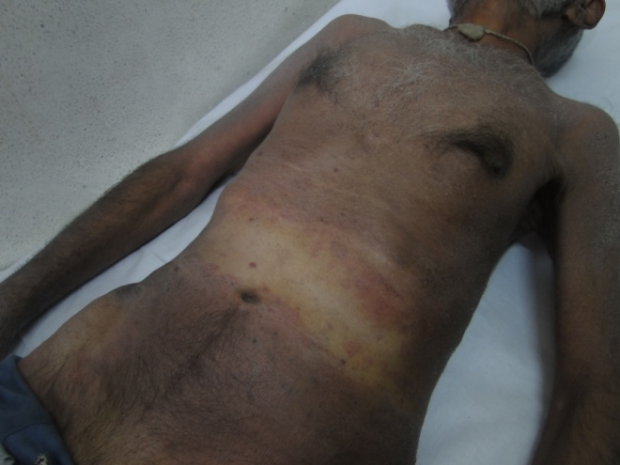
Figure 1 Deck-chair sign.

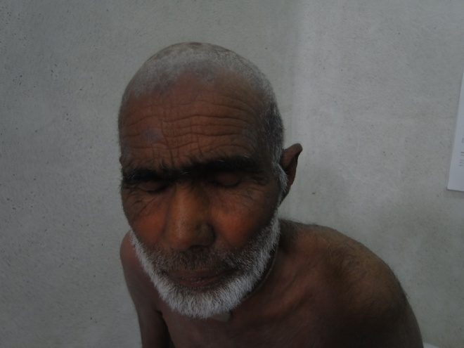
Figure 2 Crusting and scaling on scalp with involvement of face.
Skin biopsy from the lesion showed hyperkeratosis, acanthosis, spongiosis and lymphocytic infiltrate in the dermis. There was no evidence of vessel wall thickening and extravasation of red blood cells. The fine needle aspiration cytology from axillary lymph nodes revealed a reactive hyperplasia. Laboratory investigations showed eosinophilia of 8%, while serum IgE level was normal. Complete hemogram, liver function tests, and kidney function tests were normal. Chest X-ray and high resolution computed tomography scan of chest and abdomen were normal.
Based on the characteristic clinical features supported by laboratory investigations and histopathology a diagnosis of
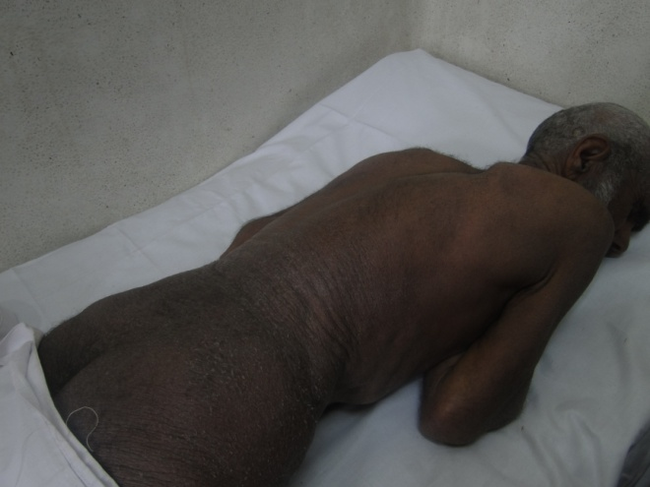
Figure 3 Generalized involvement of trunk and extremities.

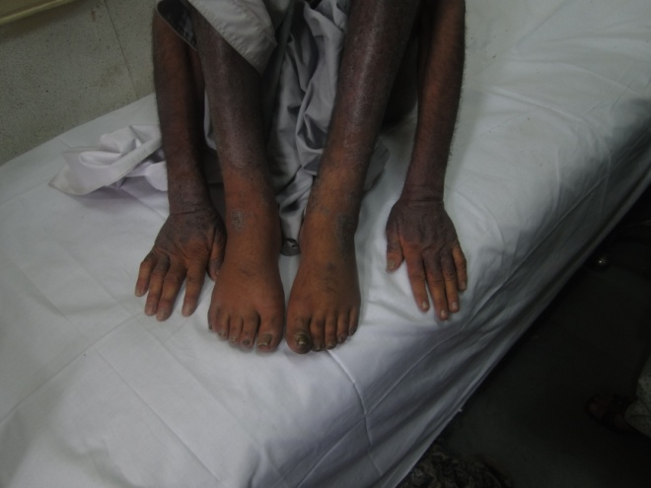
Figure 4 Generalized involvement of extremities.
papuloerythroderma of Ofuji was made. The patient showed good response to PUVA therapy after three weeks of treatment.
Discussion
Papuloerythroderma of Ofuji is a recently described rare condition of the skin present in elderly patients and most commonly described in Japan.³ The etiology of PEO is unknown. The initial lesions are diffuse red papules sparing the face, palms and soles. Later the papules coalesce to form plaques sparing the skin folds. There are several reports of association between PEO and malignancy. The various types of malignancy associated with PEO are T and B cell lymphoma, leukemia, adenocarcinoma of gut and cutaneous T cell lymphoma.^{1,4,5} There are reports of PEO associated with AIDS and drug ingestion.^{6,7} The association of PEO with malignancy and laboratory features like circulating Sezary cells, hypereosinophilia and raised IgE levels point towards the heterogenous nature of this entity.⁸ When associated with lymphoma, the dermatosis may appear several years before the diagnosis of malignancy or vice versa, so the association of two pathologies in a possible nosological overview has been stressed.⁹ Some authors have suggested that PEO may predispose to or is in fact an early form of cutaneous T cell lymphoma.¹⁰ The treatment of PEO is difficult and response to different agents is variable. PUVA, topical and systemic steroids, etretinate, cyclosporine and interferon are the main approaches in treatment.¹¹ In our case PEO was not associated with malignancy and it responded to PUVA therapy alone.
References
- Wong CL, Houghtan JB, Andrew S, Griffiths CE. Papuloerythroderma of Ofuji associated with acute myeloid leukemia. Clin Exp Dermatol. 2003;28:277-9.
- Michel S, Hohenleutner U, Lendthaler M. Ofuji papuloerythroderma: PUVA bath treatment. Hautartzt. 1999;50:360-2.
- Lacour JP, Perrin C, Ortonne JP. Ofuji papuloerythroderma: A new European case. Dermatology. 1993;186:190-2.
- Schepers C, Malvehy J, Azon MA et al. Papuloerythroderma of Ofuji: A report of two cases including the first Europian case associated with visceral malignancy. Dermatology 1996;193:131-5.
- Hur J, Seong JY, Choi TS et al. Mycosis fungoides presenting as Ofuji papuloerythroderma. J Eur Acad Dermatol Venereol. 2002;16:393-96.
- Garcia PV, Repiso T, Rodrigues CL, Castells A. Ofuji papuloerythroderma in a patient with acquired immunodeficiency syndrome. Dermatology. 1996;192:164-6.
- Kazunari S, Kenji K, Motonobu N, Yoshiki T. Drug induced papuloerythroderma: Analysis of T-cell population and literature review. Acta Derm Venereol. 2009;89:618-22.
- Gulati R. Papuloerythroderma of Ofuji-Is it a homogenous entity. Indian J Dermatol Venereol Leprol. 2003;69:S37-S38.
- Aster N, Fumo G, Conti B, Biggio P. Ofuji papuloerythroderma. J Eur Acad Dermatol Venereol. 2002;14:55-7.
- Shah M, Reid WA, Layton AM. Cutaneous T cell lymphoma presenting as papuloerthroderma a case report and review of literature. Clin Exp Dermatol. 1995;20:161-3.
- Mutluer S, Yerebakam O, Alpsoy E et al. Treatment of papuloerythroderma with Re-PUVA; a case report and review of therapy. J Eur Acad Dermatol Venereol. 2004;18:480-3.

